ISSUE #59
APRIL 2017
In this issue:
Message from the editor 1
International agricultural leaders in NT knowledge exchange 2
New study at the cutting edge of mango nutrient use 3
A day in the office (for an extension officer) 4
NT seasonal outlook 5
Climate in the Top End 6
Exotic psyllid outbreak in WA puts the NT on guard. 7
Pastoral Market Update 8
Wet Season crop and hay field walk 9
NT economic summits draw to a close 10
Livestock disease investigations 11
Toxic algal blooms 16
Upcoming events 18
Where to find more information 19

Message from the editor
It’s the first edition of a new year and with it we have a few changes. Arthur Cameron, who has been the editor of Top Paddock for 20 years, is having a bit of break from the newsletter. He is still working for the department, and will still contribute articles to Top Paddock. You can continue to contact him for advice and read about what is going on in the world of pastures.
Phil Hausler will be the temporary Director of Plant Industries Development for the next six months. Phil has been working in the minerals and energy division, but many may remember him from his time at Katherine, Douglas Daly and Berrimah Farm several years ago.
We’ve had a wonderful start to the Wet Season, and after a series of poor Wet Seasons it is a welcome relief. There have been some issues around access and bogging, but that comes with the Territory. Enjoy the storms and the cooler weather that the rain brings.
Cheers
Chelsea Moore, editor
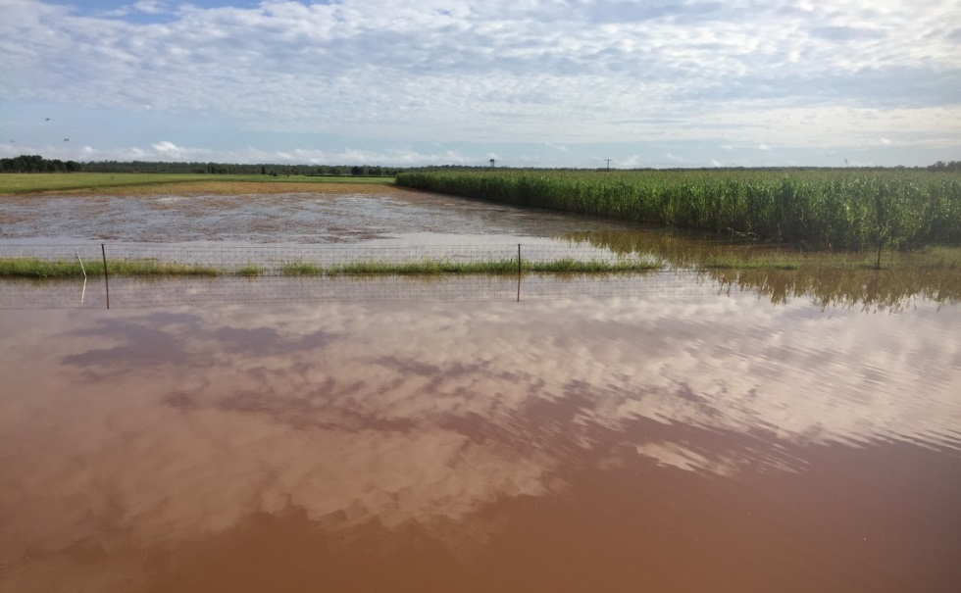
Katherine Research Station after 150 mm of rain in seven days (photo courtesy of Ian Biggs)

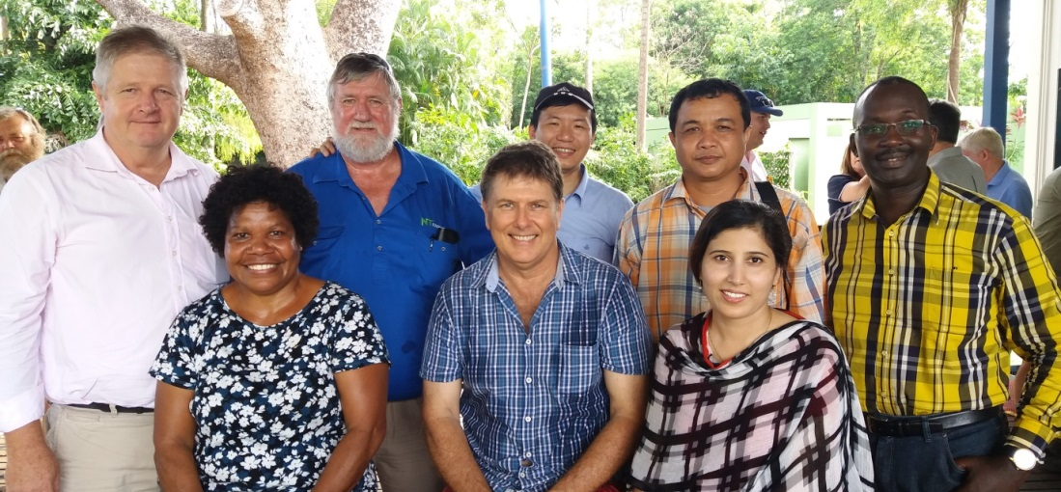
John Dillon Fellows meet with Alister Trier (DPIR CE) and Greg Owens and Simon Smith from NT Farmers

International agricultural leaders in NT knowledge exchange
Mila Bristow
Leaders in agricultural research from the Asia-Pacific region and beyond recently paid a visit to key research facilities in the Top End. The visitors from Vietnam, Cambodia, Pakistan, Papua New Guinea and Uganda visited Darwin as part of their John Dillon Memorial Fellowships.
These highly competitive fellowships are run by the Australian Centre for International Agricultural Research (ACIAR) and aim to develop leadership skills in agricultural, aquaculture and fisheries research management. As well as showcasing the Northern Territory’s (NT’s) primary industry research, the visit allowed for an exchange of knowledge and ideas between growers and research institutions.
Building these networks with international researchers can be extremely useful to the department as they provide insights into pest and disease threats in our neighbouring countries and enhance our exotic pest lists and biosecurity strategies. They can form the basis of joint international projects allowing us to access funding and research talent beyond our current funding scope.
The visits included a field trip to Berrimah Farm, Coastal Plains Research Farm (CPRF), Darwin Aquaculture Centre, and Beatrice Hill Farm. At Berrimah Farm the visitors toured the plant health diagnostics, insect and pathogen collections, and met with scientists and teams working in applied horticulture and agricultural research and development (R&D). They next visited the Darwin Aquaculture Centre to learn about the department’s R&D programs in aquaculture including oysters, giant clams and sea cucumbers.
Coastal Plains Research Farm showcased its R&D on bananas, tropical fruits, nutrition of mangos and a fabulous discussion about tropical livestock research with Barry Lemke and Grant Hamilton at both CPRF and Beatrice Hill Farm.
We rounded out the visit with refreshments at Berrimah Farm’s Bark Hut where they met with industry representatives and talked long into the afternoon about links with agricultural science leaders throughout the region into the future. A worthwhile couple of days for all involved.

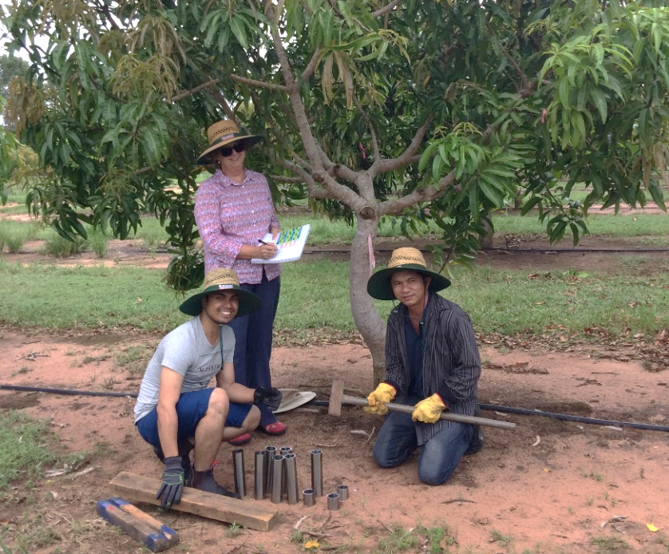
New study at the cutting edge of mango nutrient use
Project team begins soil sampling, Queensland University of Technology PhD student Hemant Pandeya who will work on the project with DPIR staff Project Scientist Dr Joanne Tilbrook and Senior Nutrition Scientist Dr Tony Asis
Mila Bristow
Northern Territory mango farmers will be kept at the cutting edge of nutrient use under a targeted research project examining the complexities of nitrogen. The Department of Primary Industry and Resources has secured $1.7 million for a four year research project into building a better understanding of how optimal nitrogen management can improve production outcomes for the Mango industry. Support for the project comes from an injection of $780,000 cash from the Australian Government Department of Agriculture and Water Resources as part of its Rural R&D for Profit programme, together with cash and in-kind contributions from the NT Department of Primary Industry and Resources, Horticulture Innovation Australia Limited, Queensland University of Technology and the Mango Industry Association.
This project is part of a broader collaboration, called “More Profit from Nitrogen”, between Australia’s four major intensive nitrogenous fertiliser users: cotton, dairy, sugar and horticulture. The Program is delivering outcomes from 10 research projects Australia-wide led by eight research partners and involving 23 collaborating organisations.
Nitrogen is an essential nutrient for plant growth, but much of our applied nitrogen fertilisers are not going toward productivity or profit. It’s important to get the balance right as nitrogen can end up being leached through soils into waterways, or lost in other forms as greenhouses gases contributing to Australia’s carbon accounts. The project will help build a better understanding of how nitrogen interacts with soil, climate, irrigation and the plant system. Nitrogen is converted into various forms as it circulates through the atmosphere, soil, plant and water, but it is hard to get a full picture of the nitrogen cycle as it is quite complex. This project will consider nitrogen within all the other elements of mango nutrition, focusing on how we can help growers increase productivity, fruit quality and therefore profit.
Over-fertilising with nitrogen in mango can also cause excessive vegetative growth, reduced yield, reduced quality and increased risk of disease, so better understanding is needed to give producers confidence that reducing their use of nitrogen fertilisers won’t impact on yield. Growers will then be able to fertilise at the most efficient levels, reducing costs of ‘wasted’ fertilisers as well as the risk of production impacts associated with over-fertilising.
With more than 6,500 ha of mango orchards, the NT mango industry produces about 3.5 million trays, or over 24 million tonnes of mangoes each year, representing about 50% of the national crop.
We will be discussing the project in detail at the upcoming 11th Australian Mango Conference with the Australian Mango Industry Association in Bowen (3-5 May), and look forward to meeting many NT growers there. For more information on nitrogen use in plants view our video here. To read our publications on understanding and improving nutrient efficiencies in agriculture, visit our webpage here.

A day in the office (for an extension officer)
Arthur Cameron, Principal Pastures Agronomist, Darwin
Extension Officers provide advice to clients in many ways these days. Much of our work is done remotely, by email and telephone, including smartphone. A smart phone allows us to send and receive images for identification of weeds and other plants. We maintain a body of information on the NT.GOV.AU website for those clients who are too busy to contact us.
Unfortunately, we cannot do everything from the comfort of an air-conditioned cubicle. To assess pastures and solve problematic issues we have to leave the office and travel to various, often remote locations, anywhere in the NT. During a good Wet Season, such as we are currently experiencing, access can be difficult, and my 2WD utility is reluctant to leave the bitumen.
On a recent extension visit to Katherine, I visited four separate properties in one day to inspect pastures, check establishment and identify seedlings and weeds. At the first property we had to walk through tall, wet grass to identify seedlings and inspect pasture establishment. At the second property, we travelled close to the newly-established pasture on a quad bike and then threaded our way across a creek on slippery rocks to check on the emergence of Jarra seedlings. At the third property, travel was in the comfort of a 4WD station wagon, but to get to the final property, I had to cross the flooded Leight Creek on Emungalan Road. We travelled in a small boat, then in a side-by-side all terrain vehicle to inspect seed crops in some very wet and sloppy paddocks. Luckily, Leight Creek was not running as it was backed up by the Katherine River.
Just another day in the office you might say. To top it off, the next day, I had to cross Leight Creek in another small boat to conduct inspections at another property. 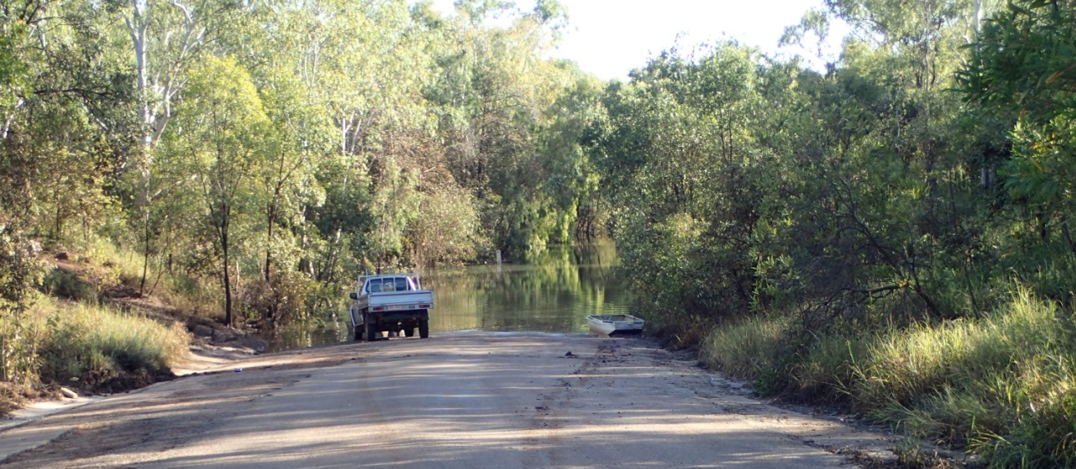
Flooded Leight Creek near Katherine on 17 February

NT Seasonal Outlook
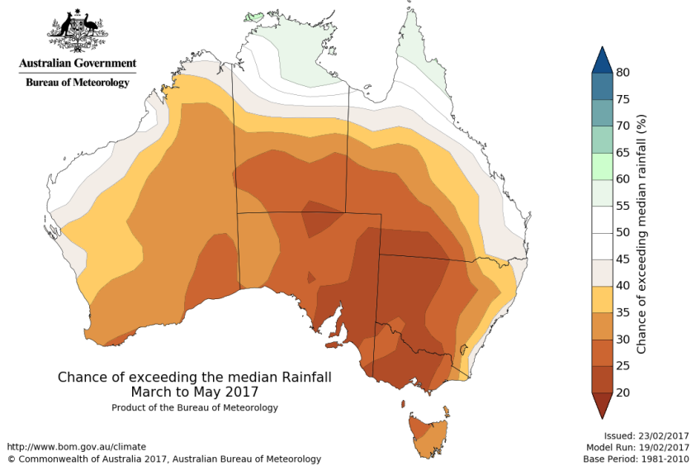
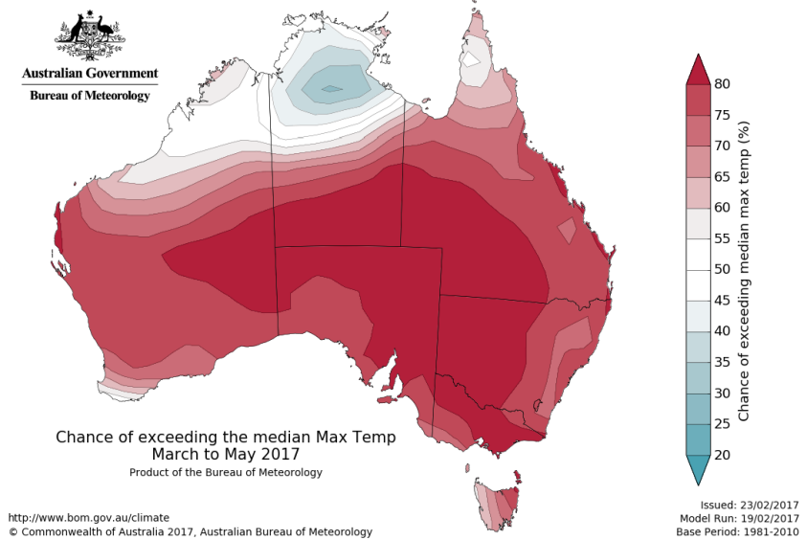
The national outlook for March to May 2017 period indicates that:

Temperature (left) and rainfall maps. Sourced from the Australian Bureau of Meteorology: http://www.bom.gov.au/climate/outlooks/
- Drier than average conditions are expected across the southern two-thirds of the NT, south of Elliott.
- Wetter than average conditions expected across the Top End, Katherine and Roper districts
- Warmer than average days and nights are more likely across the Southern NT.
- Cooler than average days and nights are more likely across the Northern NT.
Without a strong influence from the Indian or Pacific oceans, secondary climate drivers contribute more to the outlooks. Higher than average pressure is forecast over the Great Australian Bight and southern and Western Australia, meaning fewer rain-bearing systems are likely to cross the coast.
Although El Niño–Southern Oscillation (ENSO) is currently neutral, some indicators show an increased chance of El Niño developing during 2017. While recent changes in tropical Pacific Ocean sea surface temperatures and the Southern Oscillation Index (SOI) are typical of those expected prior to an El Niño, both these and other indicators remain firmly within neutral boundaries. All climate model outlooks show further warming of the Pacific is likely, with six reaching El Niño thresholds during the southern hemisphere winter of 2017.
El Niño WATCH means that there is approximately a 50% chance of El Niño developing in 2017, which is about twice the normal likelihood

For the Australian Bureau of Meteorology Climate Outlook, March – May 2017 video click here. For the full length March Pastoral Feed Outlook click here.

Climate in the Top End
We’d like to share with you what we’ve learnt about climate forecasts in the Top End.
We’d like to hear from you about what you need from a climate forecast.

What causes a ‘good wet’? Why was there a ‘bad wet’?
Can we forecast what this year will bring?
Why didn’t La Niña give me a good year?
Will there be a dry break in February for me to muster/move trucks/make deliveries?

We would like to invite you to a one day workshop to learn more about the climate of your region and to help us learn more about your climate-related decisions.
- Come and hear about El Niño, the Indian Ocean Dipole, and the Madden Julian Oscillation.
- Find out how they affect the weather on your property and access to roads around you.
- Learn where to get the most up to date climate forecasts for the wet season ahead.
- Discuss what climate change will mean for you.
- Talk to climate scientists about the sort of information you would like to know.
- Work with us to develop the sort of information tools you need to make your decisions.
Darwin - 6 April, Berrimah Farm 9 am-2 pm
Katherine – 7 April, Paterson room, Katherine Research Station
Douglas-Daly – 8 April

RSVP – Eva Zinkovsky
Eva.Zinkovsky@csiro.au
(02) 6246 4062

Exotic psyllid outbreak in WA puts the NT on guard
Wilting tomato caused by TPP
The tomato-potato psyllid (TPP) was recently detected in commercial crops and backyard gardens in Perth, Western Australia. TPP is a known host of zebra chip, a bacterium which causes significant impacts plant production. Neither TPP nor zebra chip have been found in the NT to date. Biosecurity officers are asking growers to keep an eye out for unusual symptoms on plants in the Solanaceae and Convolvulaceae families. These include potato, tomato, eggplant, capsicum, chilli and tamarillo, along with sweet potato and some weed species such as nightshade.
What should I look for?
- Damage on the underside of leaves.
- Insects jumping from the foliage when disturbed.
- Severe wilting of plants caused by high numbers of psyllids feeding.
- Yellowing of leaf margins and upward curling of the leaves caused by the injection of salivary toxins.
- A sticky liquid called honeydew, which coats plants, and can lead to the sooty mould.
- Stem death symptoms similar to other potato and tomato disorders.
What should I do?
- Check your clothes and hair after gardening for hitchhiking physllids.
- Regularly inspect crops for pests or diseases.
- Remove any weeds or unwanted plants from crops or garden beds.
- Disposing of any plant material in a way to prevent spread of pests and disease.
- Cleaning all equipment after use to remove soil and plant material.
- Report anything suspicious.
- Avoid using sprays or disturbing suspected plants until they have been inspected by an NT Plant Biosecurity Officer.
- Report any suspect pests or diseases to NT Quarantine on 1800 084 881 or via email quarantine@nt.gov.au. For more information of Farm Biosecurity visit www.farmbiosecurity.com.au.

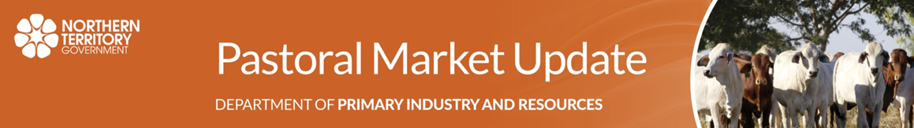
Pastoral Market Update
Live Cattle Exports via Darwin Port – February 2017
Please note: figures are for cattle exported through the Port of Darwin only; some NT cattle are exported through interstate ports.
February highlights:
- 13,752 cattle through the Darwin Port during February; 1,558 more than last month and 7,163 less than in February last year.
- 5,473 NT cattle through the Darwin Port during February; 2,831 less than last month and 5,821 less than in February last year.

Total Cattle, Port of Darwin |  |  |  |  |  |  |  | NT Cattle, Port of Darwin
2009 | 2010 | 2011 | 2012 | 2013 | 2014 | 2015 | 2016 | 2009 | 2010 | 2011 | 2012 | 2013 | 2014 | 2015 | 2016
347,314 | 295,605 | 269,617 | 246,990 | 359,616 | 493,958 | 487,568 | 355,656 | 304,818 | 272,749 | 253,797 | 234,249 | 308,784 | 324,477 | 287,892 | 235,625
Subscribe or unsubscribe to the monthly Pastoral Market Update.
Prepared by NT Department of Primary Industry and Resources. For further information contact PMU@nt.gov.au. This publication contains commodity market information prepared for DPIR staff use in strategic research and extension planning. While DPIR exercise care in the compilation and preparation of this information, no responsibility is taken for its accuracy or for the completeness of any information that is reproduced from other sources. DPIR denies any loss or damage to any person whether caused directly or indirectly by the use of any of the information provided.

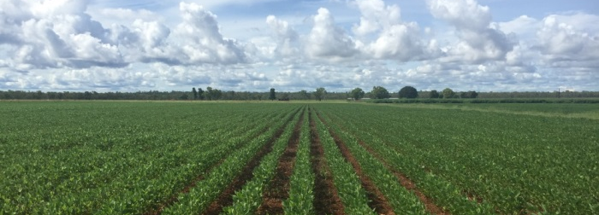
Wet Season crop and hay field walk
Crops grown at Katherine
Katherine Research Station is hosting Archer Daniels Midland (ADM) and Heritage Seeds. Come and gain an insight into the crop evaluation work conducted by the Department of Primary Industry and Resources (DPIR).
DPIR staff, together with speakers from Archer Daniels Midland (ADM) and Heritage Seeds will outline current work on the research station and explain how this field work may lead into future production systems.
Program:
- 9 am – Welcome/Tea and coffee Neil MacDonald DPIR
- 9.20 – Department of Primary Industry and Resources diversification program Callen Thompson DPIR
- 9.50 – Soybean Market potential Damian Bradford ADM
- 10.20 – Tropical pasture seed production potential Brent Scott Heritage Seeds
- 10.50 – Field walk
- Burgundy bean Arthur Salisbury Heritage Seeds
- Soybeans Damian Bradford ADM/Callen Thompson DPIR
- Cassava Ian Biggs DPIR
- 12.00 – Lunch
When: 4 April 2017 starting 9 am
Where Katherine Research Station, Paterson Building (Social Club)


RSVP By the 31f March to Teagan Alexander Teagan.Alexander@nt.gov.au 8973 9779



NT economic summits draw to a close
Helena Bott
After five months of significant work and consultation, the Northern Territory’s economic summits process is drawing to a close. The final meetings were held in Alice Springs and Darwin on 24 and 29 March, marking the end of a five month process involving meetings with business and industry, community groups, the non-profit sector, indigenous organisations, federal and local government representatives. These summits outlined the position of the Territory economy, the challenge of meeting the Territory’s future infrastructure needs and the discussion of long-term plans addressing issues such as job creation, and regional growth.
Agribusiness was one of the topics discussed, with over 100 people attending the summit in Alice Springs to provide input to the Territory’s draft Economic Development Framework (EDF), and 300 people attending the Darwin summit.
Some key messages around agribusiness during the summit included:
- the need for 10 year targets and the establishment of a baseline for these now
- discussions around the idea of developing precincts for development with pre-arranged approvals to expedite investment
- how industries could leverage each other, for example plant industries supplying feed for the emerging aquaculture sector
- support for Central Australia to leverage competitive advantage, for example organic cattle and fodder
- connectivity to market so growers remain in touch and linked.

Department staff not only participated in the sessions, but also co-facilitated several of the industry breakout sessions including agribusiness, environment services, renewable energy and mining and energy.
Comments on the Economic Development Framework and infrastructure plans closed on Monday 3 April. A final version of the Economic Development Framework is expected in the coming weeks.
For further information visit the economic summit website. The key messages from the Alice Springs summit and the Darwin summit can be found in Communique #1 and Communique #2.

Livestock disease investigations
The Department of Primary Industry and Resources (DPIR) provides a free disease investigation service to livestock owners for diagnosis of notifiable emergency, exotic and endemic disease, including zoonotic diseases. Berrimah Veterinary Laboratories provide free diagnostic testing for exclusion of notifiable disease for all disease investigations, and subsidies are available to private veterinarians for significant disease investigations in livestock.
During July–December 2016, 111 livestock disease investigations were conducted to rule out emergency diseases or investigate suspect notifiable diseases across the Northern Territory. Figure 1 shows the number of investigations by species of livestock.

Livestock disease investigations by species for July - December 2016
Berrimah Veterinary Laboratories processed 271 livestock sample submissions, including samples to substantiate proof of disease freedom certifications, for accreditation programs and targeted surveillance to support market access.
The following case reports are a selection of field investigations of livestock disease incidents during the quarter.
Bovine ephemeral fever causes mortality in cattle during Dry Season muster
Bovine ephemeral fever (BEF), also known as three day, is a disease found in cattle. BEF is spread by flying insects and is most commonly seen during the wet season in the Northern Territory. Cattle that have been exposed to the disease will usually build up immunity. Young cattle or cattle not previously exposed to BEF are more likely to be affected by the disease.
A manager on a flood plain property in Arnhem Land noticed approximately 30 head of two-year-old cattle from a mob of 450 showing signs of lameness, lack of coordination and lying down during the muster.
Samples taken from two of the affected animals by DPIR regional veterinarians showed no abnormalities. Although unseasonably early, laboratory tests on the blood samples taken detected BEF in blood samples from all animals sampled. Early rain resulting in increased insect activity likely contributed to illness and deaths in naïve cattle.
Sudden death and preputial swelling in steers caused by poor castration hygiene
Following castration, station staff noticed a dead steer and a further 12 steers were noticed to have massive swelling in the preputial area (in the front of the genital area). Despite swelling, all steers appeared to be moving and urinating normally.
An autopsy on one steer found no remarkable changes in the ureter and urethra. The greater omentum was found to be congested, inflamed and had migrated into the lower pelvic cavity. There was a hard mass in the prepuce (pizzle) which appeared to be a mass of dead tissue.
The poor hygiene at castration likely contributed to an opportunistic bacterial infection of the castration wound. The 12 steers were given antibiotic therapy, and all recovered rapidly.
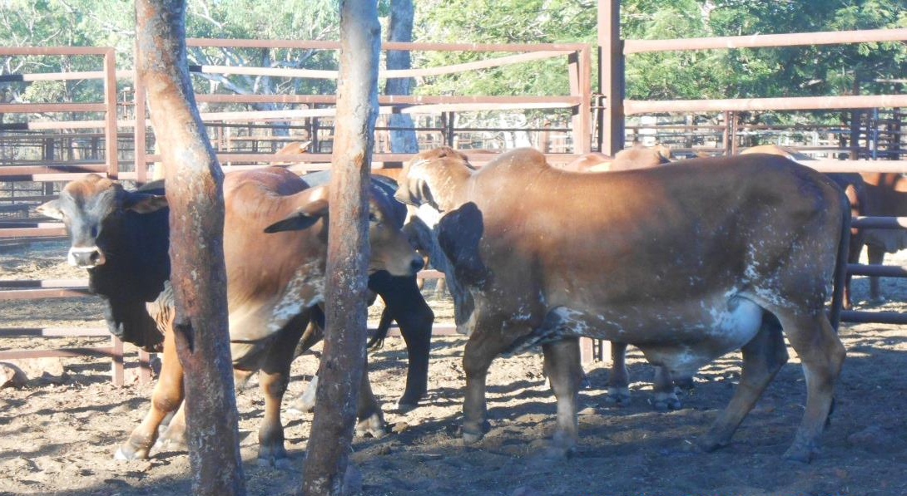
Steers with swollen preputial area
Suppurative cholangiohepatitis in a steer
A station manager found an eight-month-old Brahman bull calf lying down, unable to stand and moderately dehydrated. The calf was without a fever, and appeared to be fairly bright.
Tests conducted on the live animal did not reveal significant internal parasites, persistent infection with pestivirus, or evidence of bovine ephemeral fever. Mild muscle damage was found, likely due to the calf being unable to stand. The calf received supportive care for a week without improvement and was then euthanized.
A DPIR regional veterinarian conducted an autopsy on the calf. The most notable of the samples taken was the enlarged haemorrhagic gall bladder containing thickened bile. It was also observed that the liver was enlarged. All other organs appeared to be normal. Laboratory tests found that a bacterial infection had ascended through the bile duct from the intestine through to the gall bladder and on to the portal areas of the liver. In the lab, the bacteria E. coli was grown from the samples collected from the liver, spleen and bile. In this case, the final diagnosis was suppurative cholangiohepatitis, which is a blockage of the biliary ducts by bacteria which prevents a suppression of the flow of bile into the intestine.
Various conditions cause mortality in mixed age poultry flock
The sudden death of five chickens out of a flock of 60 was investigated by DPIR regional vets in the Darwin region.
A number of birds in the flock showed signs of sneezing, nasal discharge, swollen faces and ruffled feathers following the introduction of a new bird into the mixed age flock approximately one month previously.
Post mortem and laboratory investigations of the dead birds revealed a moderate to mixed gastrointestinal parasite burden in two juvenile chickens. One adult layer was found to have moderate to severe uveitis (eye inflammation), moderate keratitis (inflamed cornea), mild conjuctivitus and a concurrent yolk peritionitis was diagnosed. A lymphatic neoplasia affecting the lung, kidney, ovary and intestinal serosa was found in another adult layer hen, likely due to infection with lymphoid leucosis. Avian influenza and Newcastle disease virus were ruled out in all birds. Given the varied range of conditions in this case, DPIR veterinarians provided the owner with management and biosecurity advice, and the owner has not reported any further losses.
Lead toxicity in a dog
An eight-year-old dog was examined by a private veterinarian after it began having acute seizures, along with a rapid heart rate and hyperthermia. The dog failed to improve with treatment and was euthanased. The dog was sent to to Berrimah Veterinary Laboratories (BVL) for post-mortem.
The post-mortem showed that the dog was in good condition. There was evidence of diarrhoea, along with water and mucus mixed with small stones and plant material. BVL staff examined a wide range of tissues, including the brain; however, no significant findings were made.
Further discussion with the dog owner revealed that two other dogs had showed similar symptoms and died over the previous couple of months. The owners reported that the dogs had access to an area on the property where people had been making lead sinkers by the smelting of old car batteries.
Toxicology results showed that the liver had a markedly elevated level of lead (110 umol/kg wet wt., ref <2 umol/kg), confirming a diagnosis of lead toxicity in the dog.
Pregnancy toxaemia the cause of sudden death in mustered cattle
Department of Primary Industry and Resources veterinary officers received a call regarding sudden deaths in a mob of 50 previously unhandled Brahman cross cattle that had been mustered by a helicopter. Staff held the cattle for a time before trucking them to the station yards for processing. Several of the heifers displayed signs of panting, agitation and varying degrees of lameness and lack of control over body movements. Three heifers died over the following two days.
Post-mortem examination revealed that one of the heifers was approximately 30 months old, in moderate to poor body condition. There was extensive carcase bruising and bones were unusually brittle, the liver was diffusely pale, gall bladder enlarged and the omasum was dry and hard. The heifer was approximately seven months pregnant with a bull calf.
Laboratory tests showed that the heifer had elevated muscle enzymes and raised ketone levels and a diagnosis of pregnancy toxaemia was made.
Pregnancy toxaemia, or fatty liver disease, occurs when the body begins breaking down fat for energy and produces ketones. A build-up of ketones in the bloodstream is toxic to the brain, which is fatal and difficult to treat once it has progressed. Post-mortem will often show a characteristic enlarged, soft, pale yellow liver and a later-term pregnancy.
Pregnancy toxaemia occurs most commonly in fat pregnant cows when feed is limited or of poor quality. Stress, such as transport and yarding and time off feed and water, can also induce the disease, and a number of cows can be affected at the same time. While it can be difficult to identify late-pregnant cattle in a muster situation, stress should be minimised where possible and good quality feed should be available at the destination. When trucking cattle in late pregnancy, avoid transporting cattle which are due to calve within four weeks (unless the journey is less than four hours and directly to another property), and minimise time off water.
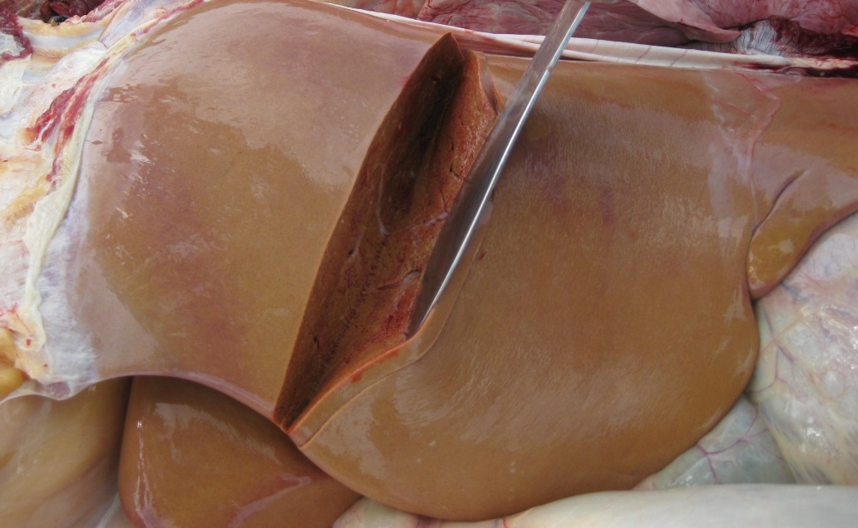
Characteristic soft, pale yellow liver in a cow with pregnancy toxaemia
Australian bat lyssavirus exclusion in a dog
A one-year-old crossbreed dog was taken to a private veterinarian after the owners noticed it had been fitting and acting unusually for the past day. The veterinarian found that the dog was hyper-sensitive to light and movement, had stiff limbs and a head tilt. Differential diagnoses included tetanus and rabies. The dog was euthanased after it failed to improve with treatment.
Post-mortem examination found the dog was underweight and dehydrated, with pale gums.
Laboratory testing showed there was mild inflammation of the brain. There was also inflammation of the lungs and the tissue of the paw pads, which suggests the dog may have inhaled or had contact with of some kind of irritant. Severe bleeding in the gastrointestinal tract may have been due to a blood clotting disorder.
A number of tests were conducted at the Australian Animal Health Laboratories and Australian bat lyssavirus, rabies and morbillivirus (canine distemper) were excluded. Tests were also run to check for lead, metaldehyde and snake venom levels, but levels did not provide a diagnosis. The signs seen in this dog are consistent with exposure to a toxin which could not be confirmed.
Nervous signs in a bovine viral diarrhoea virus persistently infected steer
A producer called Department of Primary Industry and Resources field veterinary officers to have a look at a three-year-old Brahman cross steer on a property just out of Darwin. The steer was apprehensive of people and extremely sensitive to noise and contact. The steer was in a mob of 100 cattle that were not exhibiting any of the same behaviour. The manager of the property also mentioned that the steer was significantly stunted compared with other steers on the property that were of similar age. The steer was euthanized and submitted as a transmissible spongiform encephalopathy (TSE) exclusion case to Berrimah Veterinary Laboratories.
Post-mortem examination found no abnormalities other than the spleen being smaller than expected. Tests proved that the steer was persistently infected with bovine pestivirus.
Bovine pestivirus is endemic in the Northern Territory and if a cow is infected while pregnant, the calf will also become infected. If the pregnancy is not aborted and the calf survives, it will shed the pestivirus for life (which is why they are known as persistently infected or ‘PI’). PI cattle can grow well, but are generally unthrifty with a rough coat compared to other cattle the same age. They are a source of infection for other cattle which have not been exposed to the virus. PIs usually have a reduced life expectancy.
Sudden death in a mixed poultry flock
A hobby farm reported the sudden death of 11 birds from a free range mixed poultry flock of 15 birds outside Darwin. There had been no recent management changes or introduction of new birds.

Eight chicken, duck and guinea fowl carcasses of mixed ages and sexes were found in varying degrees of decomposition and covered with maggots. Post-mortem examination showed all birds were in good condition, and four had maggots present in the upper gastrointestinal tract. Internal parasites were found in the faeces and there was no histological evidence of systemic infectious disease. Newcastle disease and avian influenza was excluded in all of the birds and the maggots were not those of the screw worm fly.

Warm, humid weather and rotting vegetable matter favour the grown of the Clostridium botulinum toxin in maggots. The presence of ingested maggots in the birds in this case is highly suggestive of botulism as the cause of disease. Cases of botulism in poultry occur annually during the wet season in the northern part of the Northern Territory. Poultry owners should prevent birds from having access to possible sources of the toxin by removing decaying food scraps, animal carcasses and rotting vegetation.

Toxic algal blooms
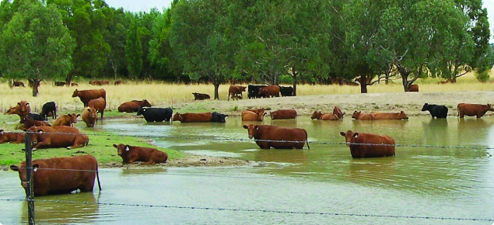
Cattle in a dam containing algal bloom
When a body of water becomes discoloured with a super abundance of free-floating, microscopic plant or, in rare cases, animal life, it is said to develop a ‘water bloom’ or algal bloom. Algae are primitive plants and include seaweeds, fine hair-like green forms and microscopic single cells or colonies. Some of the microscopic species are the most dangerous and can multiply rapidly to produce prominent green, red, yellow and other discolouration of water. A group of algae known as blue-green algae produces the most spectacular blooms in fresh water dams and several of these can produce toxins when conditions are favourable.
Livestock losses on stations in the Victoria River district of the Northern Territory have previously been associated with algal blooms.
Poisoning of livestock
Blue-green algae (cyanobacteria) blooms thrive in warm, calm, shallow bodies of water where the water is hard, alkaline, and rich in nitrogen, phosphates, carbonates, and organic matter. These algal blooms can pose a threat to livestock as poisoning can occur if they swallow the algae while drinking the contaminated water. Fish are often safe until a pond or dam dries or is drained, bringing them into contact with floating algae.
Poisonings attributed to blue-green algae usually occur in the dry season. Runoff from arable land and animal droppings greatly increase the likelihood of algal blooms ponds or lakes.
Blooms of the blue-green alga Nodularia spumigena form a scum on sheltered shorelines when concentrated by winds or currents and can form a suspension in the water. The blue-green algae species most commonly associated with the deaths of livestock, waterfowl and fish are Microcystis aeruginosa and Anabaena circinalis. Anabaena and Nodularia have been implicated in skin and eye irritations in people and dogs, while Microcystis, Anacystis, and another less commonly encountered alga, Lyngbya, have been reported to cause hay fever symptoms.
Symptoms of poisoning
The most common sign is finding a dead animal near affected water. In some cases, the forelimbs, lips and muzzle of the animal will show traces of algal scum.
Post-mortem examination will sometimes reveal bleeding from the tiny blood vessels under the skin and between the muscles. However, it can be difficult to make a confident diagnosis of algal poisoning, since the clinical signs and post-mortem findings can resemble a variety of diseases.
If stock must be moved to another paddock, do it at a very easy pace.
Identification of algae
Once livestock have been moved, seek veterinary advice to confirm the diagnosis and send a sample of the bloom for identification to the Berrimah Veterinary Laboratories where it will be viewed under high magnification to identify the algae.
Algae submitted for identification should preferably be fresh and healthy and the water sample is to be submitted in a small (100 millilitre) screw-topped jar fresh, or, if possible, with sufficient formalin added to make up a three per cent solution.
Treatment and prevention of contamination of farm water supplies by algal blooms
Station water supplies
Algae in water tanks may be controlled by covering the tank to exclude light and reduce the temperature.
Deep dams are better than shallow dams as they reduce algal use of the sun’s energy. The nutrient levels in station dams may be reduced by screening systems. These screening systems reduce fouling of dam water by stock excreta and plant debris, and ensure the restriction of fertilisers in the immediate catchment area. The screens also ensure that the size of the catchment area is large enough to cater for sufficient runoff to cause an overflow in most seasons.
Chemical control
Dosing dams with alum and gypsum has proven to be an effective means of removing phosphorus from the water. As the phosphorus is the most important nutrient for blue-green algae, the removal of this can prevent the algae from forming. For the best results, dams should be dosed prior to the formation of the bloom. If the dam is dosed after the bloom has started to form, stock should be excluded from the water source for five days as algae are at their most toxic as they are dying off.
It is recommended that the alum and gypsum should be applied at a rate of 50 kilograms of alum and 50 kilograms of gypsum per megalitre of water. The alum crystals are to be added first and should be mixed in to the water. The water should be left to stand for a few hours prior to adding gypsum. Once the gypsum has been added, let the water stand for at least 24 hours, or until clear. If the water has not cleared in two to three days, add an additional 25-30 per cent of the recommended dosage of the alum and gypsum.
A preliminary trial can be conducted by filling a 44-gallon drum with the dam water to ensure that the dosage is correct. Once the dam has been dosed and becomes clear, a pool pH test kit can be used to ensure that the pH is between six and nine. If the pH is not in the right range, allow the water to stand two days and check again.
Please note that older algal treatments are not environmentally friendly and should not be used.
Reference:
New South Wales Department of Primary Industries 2013, viewed 21 December 2016, http://www.dpi.nsw.gov.au/__data/assets/pdf_file/0006/103785/Managing-blue-green-algae-in-farm-dams.pdf.

Upcoming events
Katherine Research Station field walk “heritage seeds”
4 April, Katherine
More information
Bureau of meteorology/ CSIRO “Climate in the Top End”
6 April, Darwin
7 April, Katherine
8 April, Douglas Daly
More information
11th Australian Mango Conference
3-5 May, Bowen
More information
AusVeg Hort Connections 2017
15- 17 May, Adelaide
More information

Where to find more information
Chelsea Moore
The internet is a vast space with so much information, it can be both a useful tool as well as an incredibly frustrating one at times. The NT Department of Primary Industry and Resources has nearly 600 web pages and over 4,000 information sheets and documents on the internet. So how can you access all of this information? In 2015-16 all NT Government websites were merged and updated to be user-friendly and compatible with smart phones.

If you work best from a single landing spot for all things agriculture, try our website https://dpir.nt.gov.au/ . This has links to current initiatives, our publications page (which holds all of our information sheets and documents), as well as our agriculture webpages.

it? Of course these days one of the fastest ways to find information is to use either a search engine such as Google or Yahoo, or the NT.GOV.AU search function. The NT.GOV.AU website has a search function optimised to work with Google, making it easier to find exactly what you are looking for. If you are using a search engine such as Google, try adding “nt.gov.au” to the search terms to direct it to our websites.
We also have a YouTube channel which features videos on weaner education, and plant industry tips and tutorials. You can find and follow our YouTube channel here: www.dpif.nt.gov.au/youtube
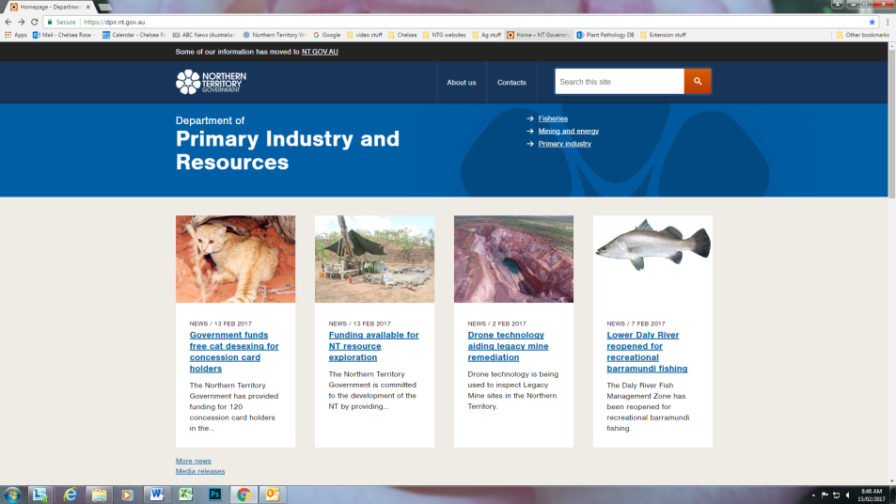
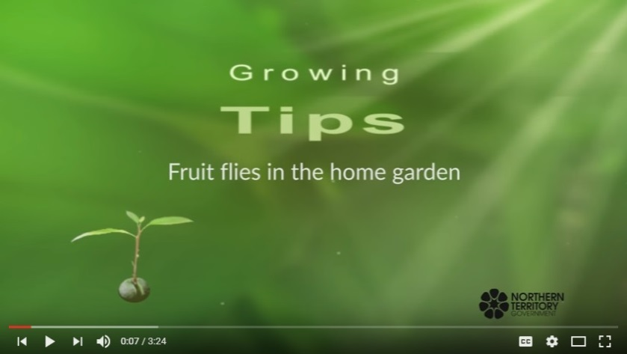
So have a look, see what’s new, and let us know what you think.
DPIR Youtube videos and information on the internet


https://dpir.nt.gov.au/
www.dpif.nt.gov.au/youtube

