Optimising nutrient management for improved productivity and fruit quality in mangoes

Project Update - May 2019
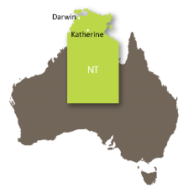
We are now approaching three years into a five year project which forms part of one of ten national research projects collaborating under the umbrella of the More Profit from Nitrogen Program across the horticulture, cotton, dairy and sugar industries to seek improved nitrogen use efficiency (NUE).

Led by the Northern Territory Government Department of Primary Industry and Resources (NT DPIR), in partnership with Queensland University of Technology (QUT), this mango industry research uses an integrated approach to quantify plant nitrogen (N) demand and cycling through the soil-plant-atmosphere system of crops. The outcome for mango growers will be the development of scientifically supported NUE management strategies to increase the quantity and quality of mango yields, while effectively mitigating costly loss of N to the environment, improving overall productivity, profitability and providing good environmental management.
The team…
NT DPIR
Dr Tony Asis
Dr Joanne Tilbrook
Alan Niscioli
Dallas Anson
Heather Wallace
Dr Danilo Guinto
Heshan Jayasekara
Frank Lunguna
Dr Matthew Hall
Dr Mila Bristow

QUT
Dr David Rowlings
Hemant Raj Pandeya
Benjamin Vickery
While N is essential for mango tree development, fruit production and quality, prior to the commencement of this research, only limited data has been available on the relative importance of soil N processes, total N loss from current management practices and profitable use of N in the plant for Australian mango growing regions.

This research is using a stable isotope of N, called ¹⁵N, to trace N movement as it is taken-up by the plant and moves from the soil to the different parts of the tree. Through this method, we can quantify a plant’s demand for N and the amount of N supplied by the soil. The project is developing best management practices for optimising N fertiliser use, including the potential of enhanced efficiency fertilisers (EEF).

Research framework
To optimise nutrient management for improved productivity and fruit quality of mangoes, research activities are involved in understanding complex processes and interactions. This will bridge the knowledge gaps on nutrient management at grower and researcher levels. We also need to quantify the different pathways of N transformations be it crop uptake, soil immobilisation, leaching or gaseous loss. Lastly, we will evaluate NUE of mango as influenced by the amount, time, form and place of N application (Figure 1).

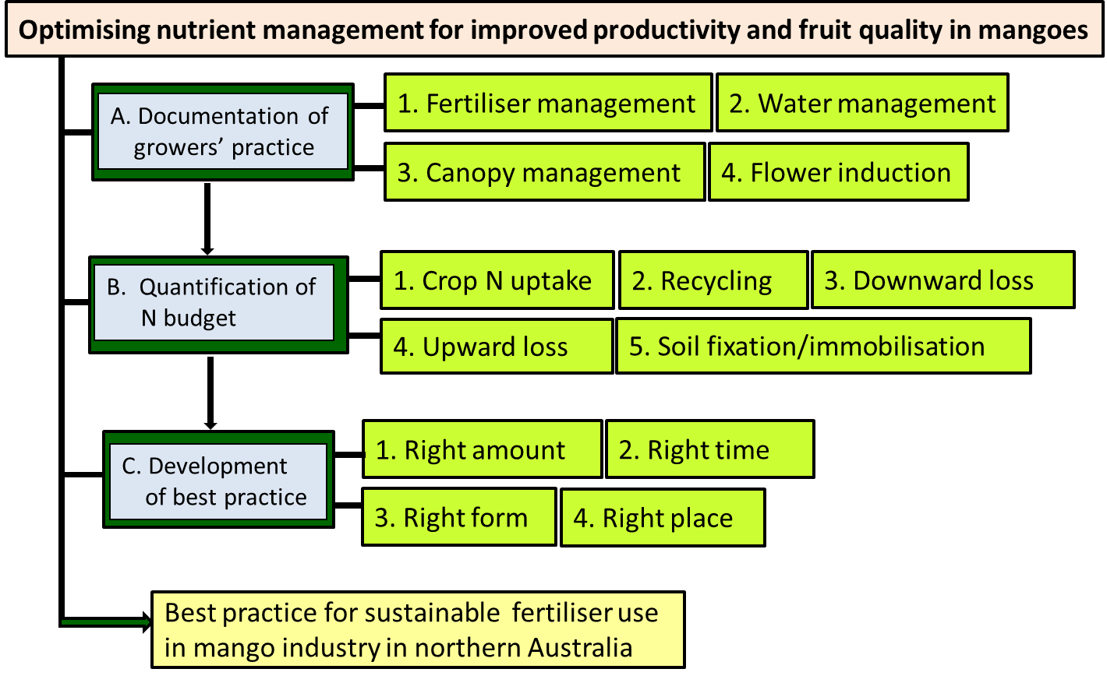
Figure 1. Conceptual framework for research approach in mango nutrient management project

What is the research investigating?

The key questions being answered, using primarily field based research, are:
- What are the dynamics of N concentration in the different parts of the tree crop plant-soil-atmosphere system across multiple seasons? Where does the applied N go? How can we reduce losses and use N to drive more profitable outcomes for mango growers?
- What is the measured utilisation, availability and timing of N released from crop residues and soil organic matter mineralisation? What is the contribution of N mineralisation to the total N demands of mangoes?
- How does this affect overall mango nutrition? How does this differ between the regions and different soils?
- What technologies can growers use to access better information regarding N dynamics and seasonal availability to inform decisions for a better economic outcome?
- What is the cost effectiveness of EEFs for NT mango soils under a range of temperature and moisture conditions?

What are the current activities in the research project?

Using ¹⁵N tracer technique to monitor N uptake at different growth stages of mango

Understanding the dynamics and mobilisation of N is important in managing N nutrition for optimum fruit yield and quality. The ¹⁵N technique is an effective method to estimate the uptake and mobilisation of N. This is done by applying both ordinary and tracer N fertiliser as a solution onto the soil. These N sources have equal chances of being taken up by mango trees as plants do not distinguish the tracer from the ordinary N source. At sampling, both sources of N will be homogenously integrated into the different parts of the plant and can be differentiated by an N analyser where the proportion of tracer N is calculated (Figure 2).
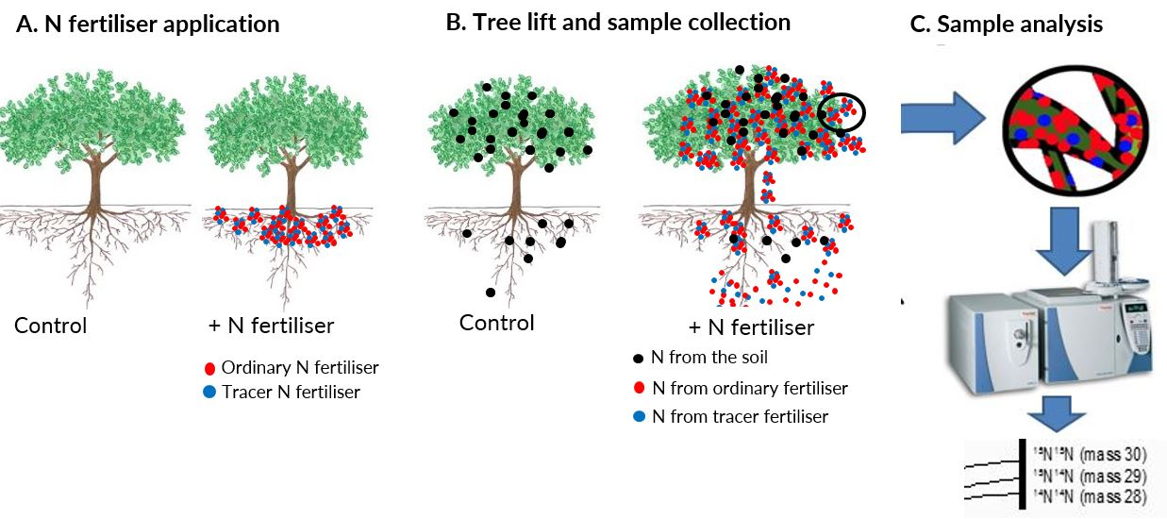
Figure 2. Principle of tracer N technique to determine the N uptake, mobilisation and NUE of mango.

A field experiment was conducted to determine the internal tree N accumulation over time, quantify the annual and inter-annual dynamics of N through the different parts of mango tree, and estimate the NUE of mango as influenced by applying different amounts of N. The Kensington Pride (KP) trees were planted at the Coastal Plains Research Farm in 2015. This year, the trees were pruned and equalised in size and density for the first time. Both yield and fruit quality will be assessed in this coming harvest season (Figure 3).
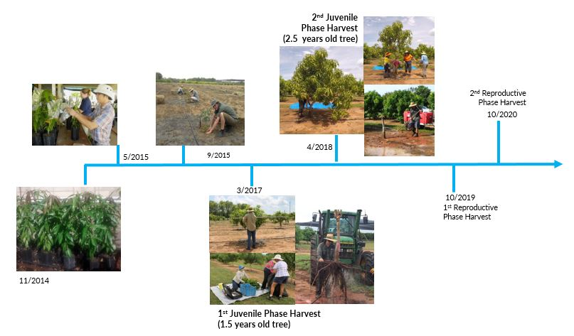

Figure 3. Timeline for monitoring of N uptake at different growth stages of mango.

- Developing a method to introduce labelled N into mango xylem, the water transport system of trees
Understanding the turnover of N from mango litter decomposition in to the soil requires application of tracer N. The tracer N in mango tree tissues will provide information about N use and transport within the tree and the surrounding soil. This is usually achieved through soil or foliar application of fertilisers, but for trees such as mango, the process is slow and a significant amount of expensive ¹⁵N fertiliser is lost to the environment.
We developed a rapid ¹⁵N application method to obtain direct and quantitative information on leaf uptake of N derived from fertiliser (Ndff). In this study, we tested a xylem infusion technique to rapidly create mango litter with tracer N. While there are risks to the tree (N toxicity, phloem death or infections), the risk mitigations in the method have been successful so far. Total leaf N of a tree is estimated and a calculated amount of tracer N fertiliser in solution is infused into branch xylem over several hours. At 10 days after infusion of 40 g N, highly enriched (more than 4atom¹⁵N tracer) leaves fell off but the attached leaves still had 2% enrichment. Further infusion successfully labelled the mature leaves to 3atom%¹⁵N while the new leaves where enriched with 5atom%¹⁵N (Fig. 4).

Figure 4. Changes in the N tracer enrichment of mango leaves with several infusions of 10atom% ¹⁵N-NH₄SO₄, Katherine Research Station, Northern Territory, 2017.

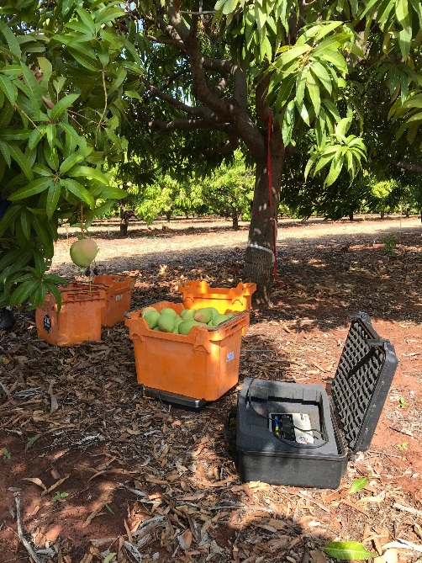
- Quantifying the effect of N dose on yield and fruit quality of mango
It is well known that too much N based fertiliser applied in mango orchards results in fruit with skin that stays green rather than ripening to an appealing blush over golden skin. The question in Northern Territory orchards, as opposed to orchards in New South Wales and Queensland with very different soils and climate is, how much N is too much?
During 2018 we conducted a trial on a commercial orchard in the Katherine region, applying varying amounts of N fertilizer in the form of ammonium sulfate after pruning and during active growth. The trees and developing fruit were tracked through the season and data collected. Flowering continued over a number of weeks last year and picking occurred over a two week period. Fruit was fully mature at 15-20 % dry matter at harvest (measured with a Near Infra Red (NRI) instrument) and was weighed and categorized as it was picked (Figure 5). Sub-samples of fruit from each treatment were selected and skin colour was measured as the fruit ripened (Figure 6). When ripe, fruit quality was further assessed by measuring the texture and sugar content of the mango flesh (Figure 7).
It was found that N applied at 50 kg/ha on a mature orchard of Kensington Pride with a planting density of 250 trees/ha caused fruit to have a darker skin colour which stayed green when fully ripe. The result was cosmetic as this level of N had no effect on the sugar content or the texture of the fruit. While the skin colour was not acceptable in the fresh fruit markets, our data suggest that flesh quality is maintained for juicing, drying or otherwise processing.
Figure 5. At harvest the fruit in a mature Kensington Pride orchard was categorized as commercial or non-commercial and weighed in the field. We weighed almost four tons of fruit using this method for every experimental tree.
We are planning further work to verify the other effects of N on fruit skin colour, and to measure how skin colour changes over time during ethylene treatment compared to natural ripening.

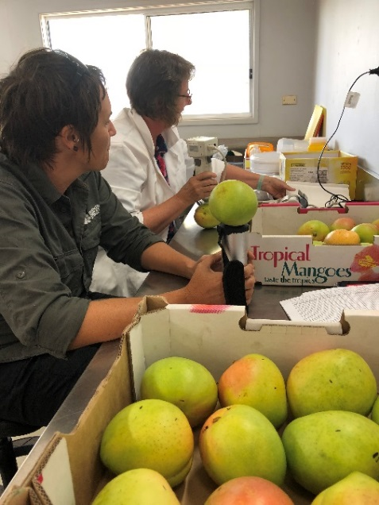
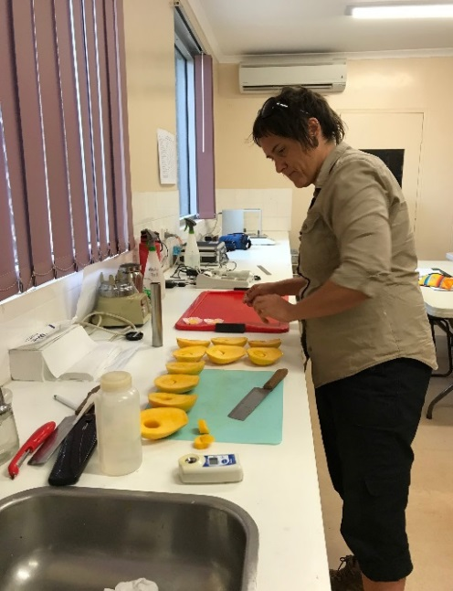

Figure 6. Dallas Anson and Jo Tilbrook measure the % dry matter using an NIR gun and skin colour with a colorimeter on newly harvested Kensington Pride fruit.
Figure 7. Dallas Anson cuts a careful section of flesh to place under the probe of a texture analyser, then extract juice from the remaining flesh to measure sugar content.

Characterising N accumulation of mango over a cropping season
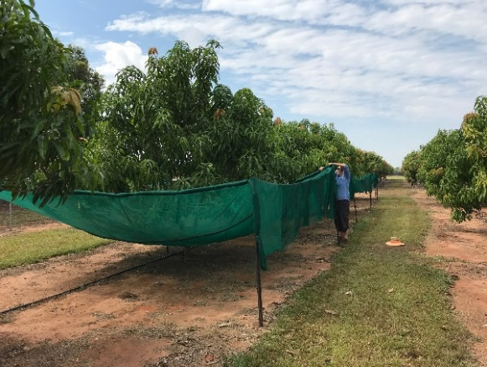
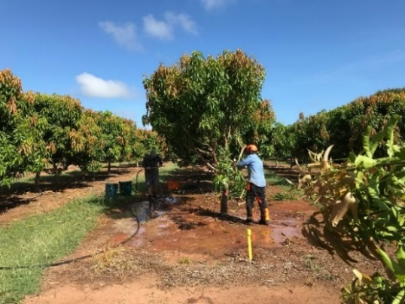
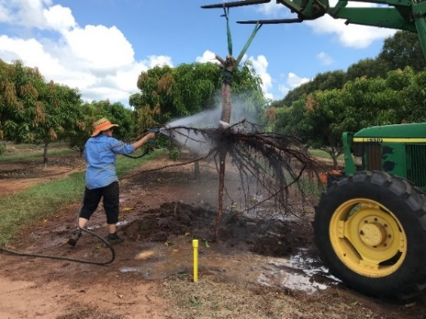
Following on from N cycling within the orchard, we are also characterising N movement within mango trees at key developmental time points over a season. The annual changes in N uptake, movement and storage in mango trees have not been investigated in tropically grown mangos. To achieve this, trees have been applied with ¹⁵N infused into the xylem which alters the naturally occurring ratio of ordinary and tracer N in the trees. We are examining any ratio changes over a year in the tree components to understand if and when the tree moves N and how it relates to the timings of shoot growth, flowering and fruit development. To do this, we are harvesting whole trees during their growth, quiescent, flowering and fruiting and post-harvest stages. In March this year, we lifted three 3.5 years old trees at Coastal Plains Research Station, Darwin. The low wet season rainfall made site preparation far more difficult than the previous tree lifts. Using a water spear attached to a fire trailer with a pump and 800 L water tank, we needed to introduce 4000 L of water into the soil under and around the canopy perimeter of the trees to loosen the grip of tree roots in the soil. Last year only 1200 L was needed to facilitate lifting the entire tree out of the ground using a snatch strap attached to a tractor with a forklift.
Figure 8. Dallas Anson constructing the litter traps to collect and measure the volume and N content of litter dropped in orchards.

The work aims to reassess the N budget in tropically grown mangoes over a cropping season by measuring N mobility, cycling and losses to provide alternative, quantitative measures of N use efficiency. The re-evaluation of NUE will identify cost efficiencies for growers and evidence based strategies to reduce N losses to the environment.
Figure 10. To lift the remaining parts of the tree, a snatch strap is attached to the trunk using the branch remnants as an anchor. The strap is hooked up to the forklift and Alan Niscioli operates the tractor while Dallas Anson hoses off the remaining dirt and mud from the roots.
Figure 9. Alan Niscioli operating a water spear to soften the ground surrounding a 3.5 year old mango tree, preparing to lift it from the soil in March. Dallas Anson is removing the canopy branches using a chainsaw. All trees components are weighed and sampled for ¹⁵N:¹⁴N ratio analysis.

- Estimating how much N is cycled in the orchard during mango production
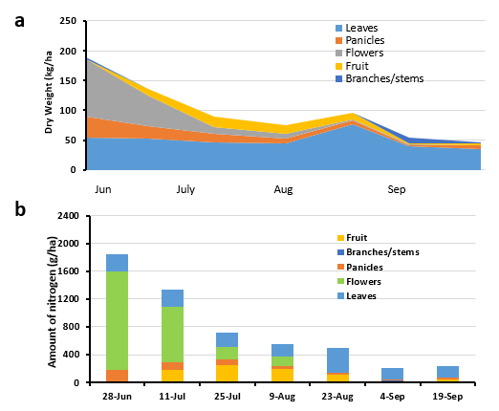
While constructing an N budget for commercially grown mangoes in the Northern Territory, we posed the question, “What tree biomass and nutrients are recycled in the soil-plant system over a season?” To measure this we set up traps at several commercial orchards to collect leaves and other litter that fall from the trees over an extended period of time. In a mature, commercial Kensington Pride orchard in the Darwin region, plant materials falling from trees were collected and processed over the flowering and fruiting period of approximately ten weeks (Figure 11a and b). Mango, like a number of other fruit trees, produce thousands of flowers that are not fertilised or maintained on the tree. Although tiny, the flowers contain high concentrations of N which, along with leaf and flower spike litter, fall to the ground. The dropped flowers alone contribute more than one kg of N per hectare. Over the ten weeks, material containing over five kg of N per hectare fell to the ground. Postharvest pruning also contributes a significant volume of material to the orchard floor. In one year in a commercial Calypso orchard, the plant material that fell to the ground naturally, combined with pruned material, adds up to about two tons/ha on a dry weight basis. Over a complete season, plant material containing around 13.5 kg/ha of N falls onto the ground or is mulched after pruning (Figure12). Annual data is being collected in both the Darwin and Katherine regions to quantify the N cycling in mangoes in Northern Territory tropical conditions.
Figure 11. Dry weight (a) and nitrogen content (b) of leaf, flower, panicle, fruit and branch material falling to the ground over a 10 week flowering and fruiting period in a commercial Kensington Pride orchard.

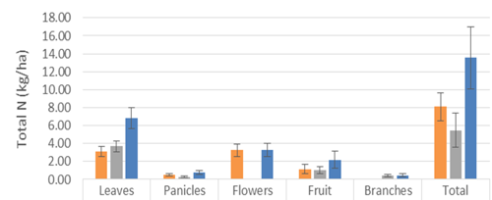
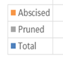

Figure 12. Plant material falling (abscised) and pruned canopy material from mature Calypso mango trees were collected, dried and weighed to quantify the amount of N that cycled in the orchard over time.

Determining water infiltration of soils and leaching of nitrate and organic nitrogen
Intact soil cores (15 cm in height) taken from three different NT mango farms were incubated at 30° C with water content at field capacity. A lab incubation was carried out to measure the leaching of nitrate, dissolved organic carbon (DOC) and dissolved organic nitrogen (DON) through intact soil cores (Figure 11). 100 mL of water (representative of rainfall conditions at the sampling sites) was applied twice (on day 7 and day 14) on the cores and the leachate collected after 1, 4, 8 and 24 hours separately. The volumes were recorded before bulking to calculate the associated losses of nitrate and DOC/DON.
Figure 13. Intact soil cores were taken from Northern Territory mango orchards and transported to conduct laboratory controlled incubations, measuring the leaching of compounds through different soil types.

Preliminary results suggest that the rainfall infiltration rate of Rudosols (79% sand) and Hydrosols (74% sand) are different to Kandosols (58% sand) an hour after water application (Figure 12). However, the total infiltration rate after 24 hours doesn’t differ between soil types, they are all high. The free draining nature of soils which have high infiltration rates is likely to lead to high N leaching. Interestingly, NO₃-N leaching from the Kandosols was highest in the leachate, indicating higher quantities of readily available N in the soil (Figure 13). Nitrification led by rapid hydrolysis of urea significantly increased the nitrate leaching losses in the Kandosols and to a lesser extent in the Rudosols. In contrast, Hydrosols are N limited, resulting in soil nitrate immobilisation.
The analysis for DOC/DON and complete recovery of Urea and leaf litter supplied N from the cores is underway and it will be interesting to see how those results support our understanding of the ongoing interrelated soil processes in the field.

Figure 14. Average rainfall infiltration rate of the three mango soils from NT. Vertical bars represent standard error (n=12).
Figure 15. Average volumes of NO₃-N (mg/L) from leachate collected during two collections from three mango soil types. Vertical bars represent standard error (n=4).

What has been achieved so far?
Project activities continue at field sites on nine participating commercial orchards across the Darwin and Katherine growing regions, the NT DPIR’s Coastal Plains Research Station (Darwin) and Katherine Research Station (KRS). They include:

- Sampling of mango soils that have been analysed and used for laboratory based incubation experiments, including the performance of different EEFs;
- Quantifying greenhouse gas emissions over time from soils underneath trees in mango orchards;
- Measuring the rates of decomposition of leaf litter and mineralisation of N in soils under field and laboratory conditions;
- Laboratory measurement of water infiltration into NT soils to estimate nitrate loss and dissolved organic carbon and N in the collected leachates;
- Designing and implementing multi-year, whole tree biomass harvests to quantify N uptake efficiency from soil applied fertilisers in tropical environments using ¹⁵N. Lifting mango trees with N tracer allows measurement of above and below-ground biomass. Moreover, the amount of N coming from both fertiliser and soil sources is being calculated and will generate an estimate for NUE of mango as trees transition from the juvenile to the mature, fruit bearing phase;
- Initiating a one year trial of young, productive trees to characterise N movement and cycling in a range of plant tissues, including litter and prunings, at major developmental time points;

- Determining the effect of varying amounts of N on fruit yield and quality of mango. A range of N application rates have been trialed in a mature commercial orchard to identify the level at which N significantly affects fruit appearance and quality when grown in local soils. In addition to in-orchard sampling and collecting yield data, post-harvest ripening was tracked over time using skin colour measurements, as well as sugar content and texture analysis when fully ripe; and,
- Preparing planting materials for a foliar N experiment. B74, Kensington Pride and three National Mango Breeding Program varieties have been grafted onto KP rootstocks and are being prepared for measuring how much N is taken up by mango leaves when trees are sprayed with potassium nitrate during flowering and fruit set. The uptake of N across the leaf cuticle and into other tissues of the mangoes will be followed over time and quantified using tracer N solution.

How have we communicated the research progress and findings?
Figure 2 NT DPIR Senior Technician Alan Niscioli removes soil from mango tree roots following whole tree extraction of 1.5 year old trees in labelled ¹⁵N trial, Coastal Plains Research Station, Darwin.

Dr Tony Asis presented data and analysis at the More Profit from Nitrogen Partner forum, hosted by our research group in Darwin in July 2018. During the past year, DPIR staff and QUT students have spent a significant amount of time in orchards as trials are hosted by a number of commercial growers in the Darwin and Katherine regions (Figure 15). We’ve also attended the mango pre- and post-harvest meetings and at NT Farmers Association events to talk to growers and commercial service providers about the project and results. Articles have been published in Top Paddock, the NT DPIR online magazine.
Figure 4 (Left) QUT PhD student Raj Pandeya sieves a ‘mango’ soil from the Darwin Region

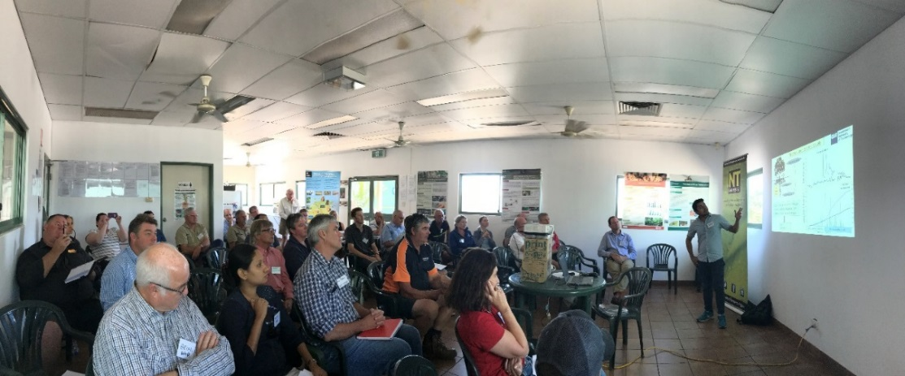

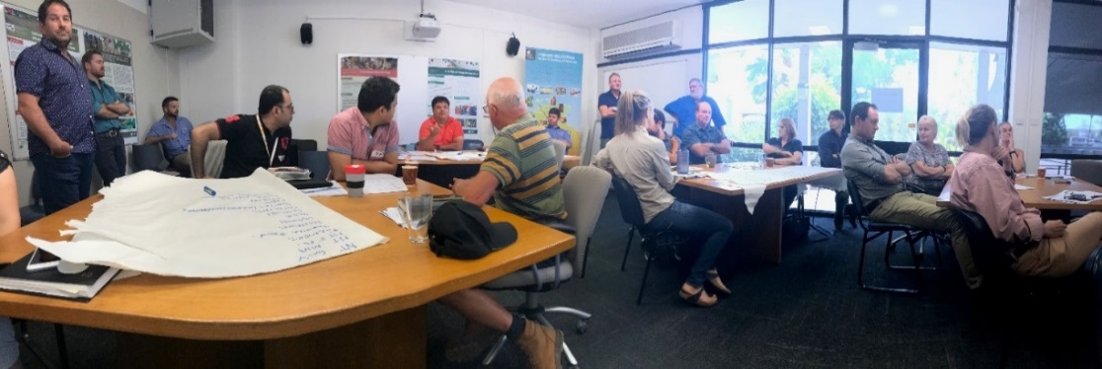
Figure 15. Raj Pandeya delivering his results to commercial growers and other interested people at the Research and Development workshop in Katherine (above photo) and Darwin (below photo) in May 2018.

Many thanks to all growers who have allowed us onto your properties to conduct this research. All the results we generate will be reported and returned to you as soon as possible.

This project is supported through funding from the Australian Government Department of Agriculture and Water Resources
as part of its Rural R&D for Profit program, the Northern Territory Government Department of Primary Industry and Resources, Queensland University of Technology’s Institute for Future Environments and Hort Innovation Limited. In-kind support is also provided by the Australian Mango Industry Association Inc.





For all grower inquiries on the project, contact:

Dr Tony Asis, Senior Research Scientist
Plant Industry Development, NTDPIR
T: +61 8 8999 2041 E: Constancio.Asis@nt.gov.au

