Industry update
  - Mango Twig Tip Dieback summary (2017-2023)
This summary is a compilation of the work by Jose` Liberato, Sharl Mintoff, Merran Nielsen, Sajal Zia, Sonu Yadav, Stan Bellgard, Tony Asis, Alan Niscioli, Chelsea Moore, Anne Walters, Sachi Kithulgoda, Upendra Shekhawat, and Lorenzo Meschiari.

Background
Since 2017, Darwin mango growers have been reporting an increasing number of plants with unusual dieback symptoms that have caused the death of entire branches and trees. The first sign of the condition is the death of a leaf or twig, leaving a clear division between dead and healthy tissue. It differs from the widespread Common Dieback of mangoes, which lacks a clear healthy/dead transition. To distinguish these new symptoms from the Common Dieback, the condition was labelled Mango Twig Tip Dieback (MTTD).

It is important to note that NO exotic pathogens have been identified as the cause of MTTD.

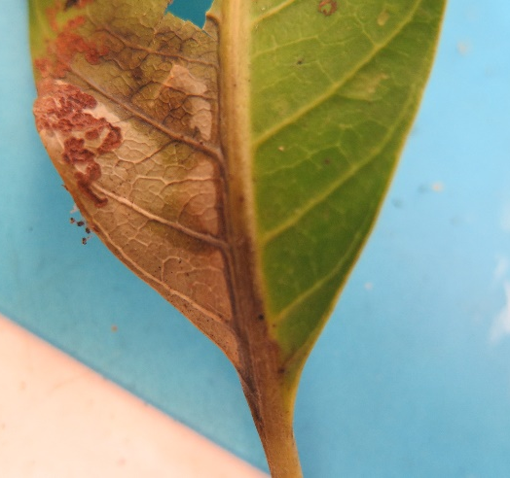 | 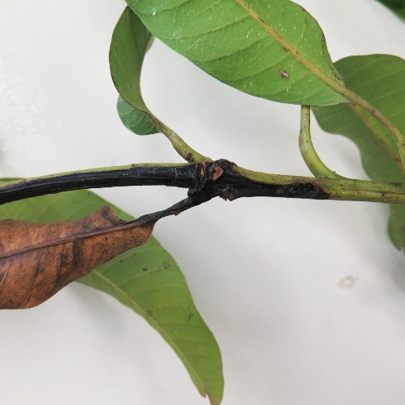 | 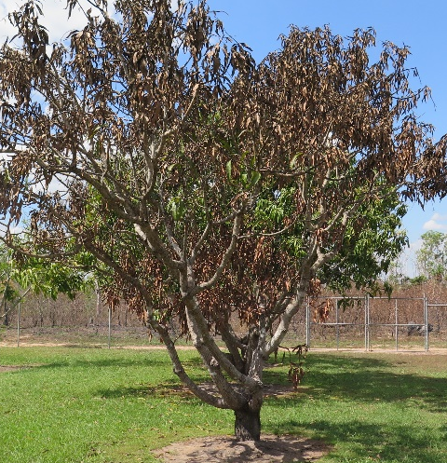
Image 1: MTTD infects a leaf, travels through the twig and can eventually kill the entire plant.

Objectives of the work
- Screen plants to rule out known exotic pathogens and maintain market access.
- Identify the scope of the issue through surveys and mapping.
- Identify the cause of MTTD.
- Set up a MTTD working group to improve communication from NT DITT to NT growers.
- Identify possible chemical controls for Common Dieback.
- Identify avenues for externally funded research.

Outcomes

What has been done so far?
A substantial amount of work has been conducted over several years:
$500K  Invested into research and diagnostics. | 200+  Cultures grown for identification purposes | 39  Different species of fungi and bacteria isolated | 1000+  cultures analysed to examine the impact of a number of fungicides

Screen samples to rule out known exotic pathogens
The NT DITT Plant Pathology and Molecular Biology branches tested every sample submitted for known exotic mango pathogens, to ensure that this was not a threat to market access:
- DNA tests were carried out to look for organisms that cannot be cultured in traditional ways.
- Field samples of infected soil were tested for soil - borne pathogens.
- Field trials of potted plants confirmed that the condition was transferrable from an infected plant to an uninfected plant without soil being in contact, proving that this is not a soil pathogen.
No exotic “market access limiting” pathogens were found.
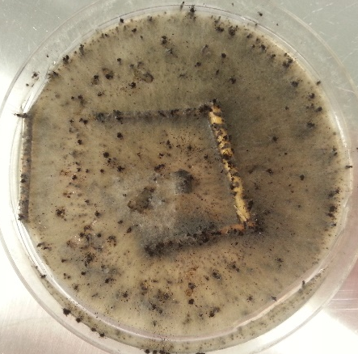 | 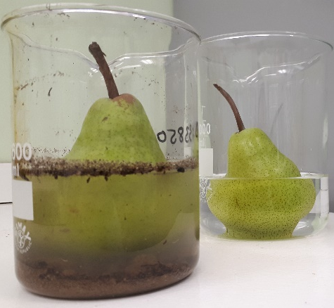 | 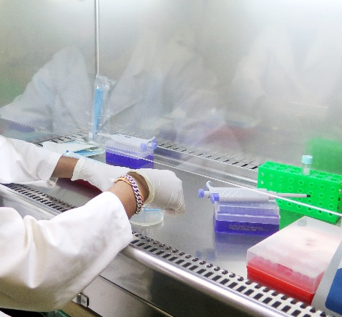
Image 2: In order to identify what fungi are present, plant pathologists cut a small portion of the affected plant and place it in a nutrient agar (like jelly). Bacteria and fungi grow out of the plant tissue onto the agar, where they can be separated and identified; these are referred to as cultures (left). Soil tests can use fruits that are sensitive to “bait” out diseases that grow too slowly in other tests (middle). DNA can be extracted either from the cultured fungi or bacteria or directly from the plant (right).
Many organisms are found in mango orchards without causing disease: some live on the plant without affecting it, some only affect the plant when it is stressed, and some can only invade the plant when it is already dying back but don’t actually cause the problem. This means that for every sample taken, lots of different organsims are present. The trick is to figure out which one is actually causing the problem. NT DITT cultured out 39 different types of fungi and bacteria from the samples and still has to narrow them down to a single culprit.

Identify the scope of the issue
The locations of the samples were mapped in 2019 to identify if there were any overlaps in the fungi/bacteria present, geographical location, or other points of interest. Nearly forty different types of fungi and bacteria were isolated from the different MTTD samples, but no single organism was consistently found in every sample. There have been no MTTD samples from Katherine, and all of affected plants came from the Darwin rural region.
The same year, NT DITT and AMIA surveyed growers in the Darwin rural region to establish how widely spread the issue was and if there were any similar themes in terms of varieties affected, timing and orchard hygiene controls. Growers were not able to differentiate between Common Dieback and MTTD, so the results include both.
55%  Said dieback was a production issue | 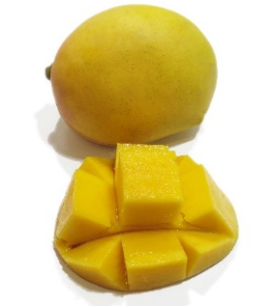 | 100%  Experienced some level of dieback in 2019
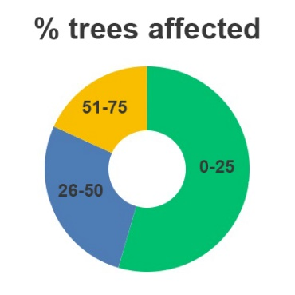 | Growers experienced dieback over the last  2- 5 years | 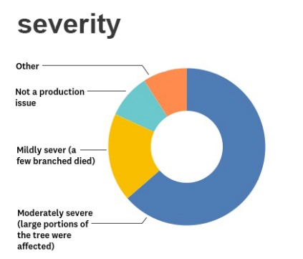
81%  prune out dead branches | 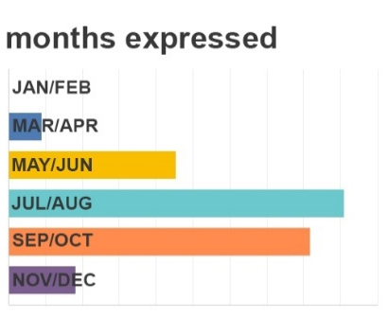 | 90%  do not disinfect pruning tools
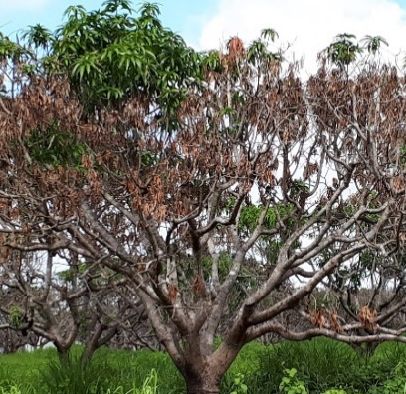 | 64% of affected trees are over  15 years old | 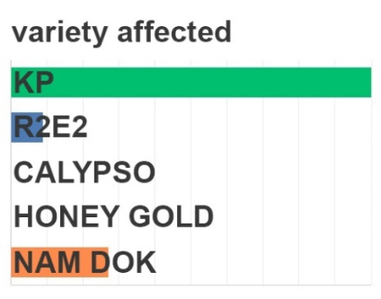
Image 3: Results from the 2019 grower survey on all types of dieback.

Identify the cause of Mango Twig Tip Dieback.
Both fungi and bacteria are present in the DNA and cultures -of many of the samples. Detached mango leaves were infected with the bacteria, suggesting that it can affect mango plants, but it does not confirm that it is the cause of MTTD.
Pot trials were carried out by infecting small mango plants under controlled conditions to confirm the cause of MTTD. These plants have remained symptomless, suggesting that the transmission from one plant to another requires either specific environmental stress or an insect or other vector.
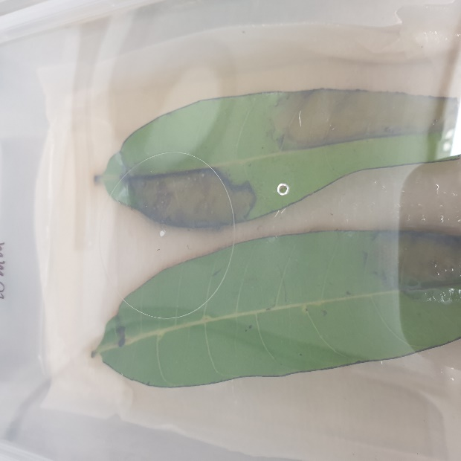 | 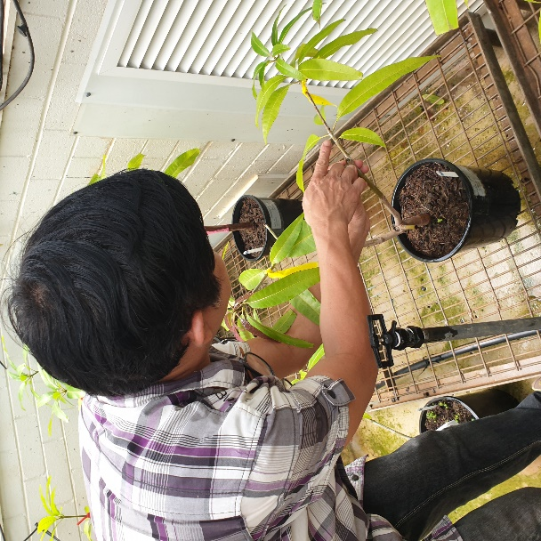
Image 4: Detached mango leaves showing a reaction to the bacteria (left) and Tony Asis checking the potted mangoes for symptoms (right).

Set up a MTTD working group to improve communication from NT DITT to NT growers.
In order to improve communications between mango growers and the department, a working group was established between representatives from NT DITT, NT Farmers, AMIA and mango growers. The group held monthly meetings until December 2022 to discuss the results of the research and diagnostics and identify avenues of investigation.
Grower updates were provided at the annual AMIA roadshow and the NTMIA meetings to keep growers up to date, along with newsletter articles and Facebook posts on AgricultureNT.

Identify possible chemical controls for Common Dieback.
Although MTTD was the main focus of this work, Common Dieback has also been an increasing problem in the Northern Territory. Laboratory trials were carried out as a small scale study to assess if anything currently registered for use in mangoes might be an effective control for Common Dieback. The fungicides included Aero, Scholar, Mancozeb, Copper Oxychloride, Amistar, Sportak and Octave. Scholar, Aero and Octave were the most effective at inhibiting growth at small doses.
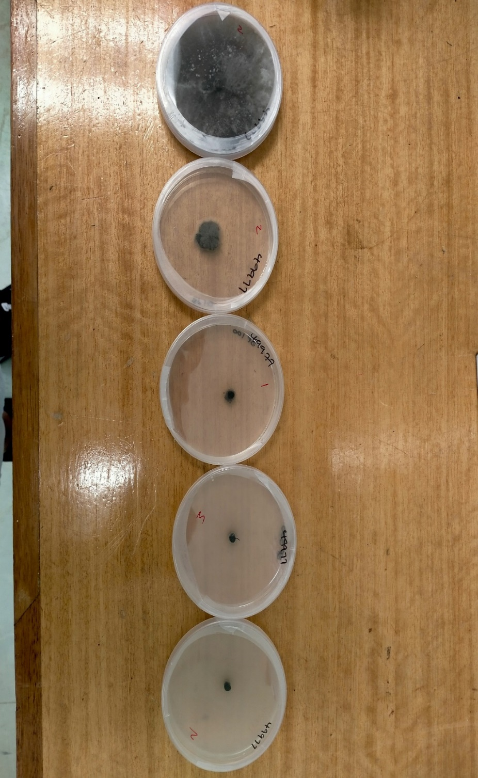
Image 5: The laboratory trials involved mixing each fungicide into the agar plates and then infecting the plates with the fungal isolates to see whether they could grow. The trial looked at different dosages of chemicals to identify which concentrations were the most effective (from the lowest concentration on the left to the highest concentration on the right).
These results are only the first stage of proving whether they are truly effective at controlling Common Dieback. They need to be tested in the field on mango plants to verify that they work in field conditions.

Next steps.
Known or previously identified diseases generally have a long history of chemicals that have been trialled, an understanding of how the disease spreads, and management strategies for growers to try. For example, the grapevine industry invested $3.4 million over 10 years on 15 projects to understand how to manage grapevine dieback. Unfortunately, with new diseases such as MTTD, there is no information to fall back on.
There are a number of immediate, and long-term questions that could provide useful next steps:
- Continued research into the identification of what is causing MTTD and how it is transmitted from plant to plant.
- If the cause of MTTD is verified, laboratory based trials will be conducted to investigate whether any chemical controls are effective.
- Field trials to verify whether the chemical controls for Common Dieback perform as effectively in the field as they do in the laboratory.
- Investigate whether it is possible to identify dieback early in its progression in order to improve the chance of successfully managing the disease.
- Investigate whether wound sealants are effective at reducing the spread of both Common Dieback and MTTD.
- Research is needed to identify whether plant health activators can provide a boost to plant immunity as part of an overarching management strategy.

Appendix: Comparing MTTD to Common Dieback
Mango Twig Tip Dieback | Mango Common Dieback
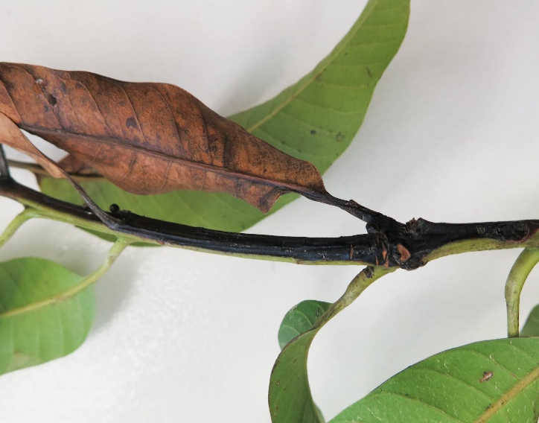 | 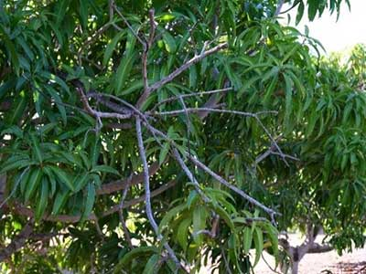
Symptoms include partial twig death, which can continue to spread through the plant until the plant dies. | Symptoms are generally restricted to the death of a branch.
Reported on 15 properties in the Darwin rural region only. | Found throughout the NT.
Unknown cause. | Caused by the same organisms responsible for Stem End Rot.
Controls include:  - Reduce plant stress caused by drought and nutritional deficiencies.  - Prune dying branches by cutting the branch back to below the edge of the dead or symptomatic areas. Disinfect the pruning tool after each plant. Remove the symptomatic pruned branches from the orchard.  - Follow the ‘come clean go clean’ practises, and make sure to clean and disinfect any tree pruning machinery when moving it between farms. | Controls include:  - Avoid mechanical injuries to the plants.  - Prevent termites and longicorn beetles.  - Reduce plant stress caused by drought and nutritional deficiencies.  - Reduce sunburn on the trunk and branches when severely pruning the trees.  - Prune dying branches by cutting the branch back to below the edge of the dead or symptomatic areas. Disinfect the pruning tool after each plant. Remove the symptomatic pruned branches from the orchard.  - Avoid pruning mango trees when the canopy is wet or during rainfall.  - Follow the ‘come clean go clean’ practises, and make sure to clean and disinfect any tree pruning machinery when moving it between farms.

