Kerry Walsh and Nick Anderson, CQUniversity
k.walsh@cqu.edu.au
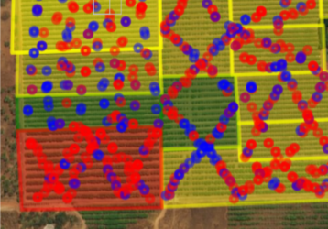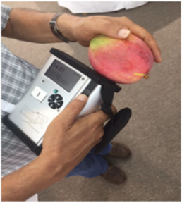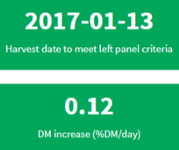
F750 – ‘Fruit quality meter’, for assessment on fruit dry matter content. This technology is of use in context of gauging fruit harvest maturity, and to ensure that the eating quality DM specification is achieved.
Fruitmaps.com - this web app allows display of DM records on a farm map and offers a project to when a crop will be ready on a user set DM specification. The web app also allows for display of heat sums, input of block flowering time, and crop load estimation.
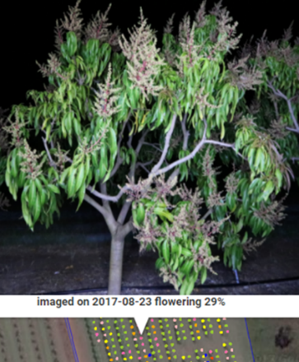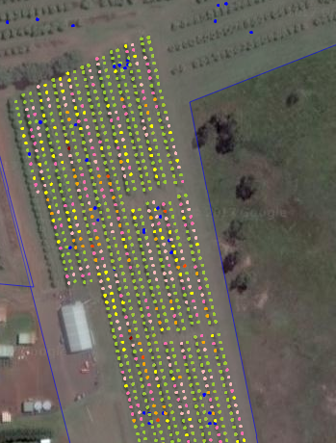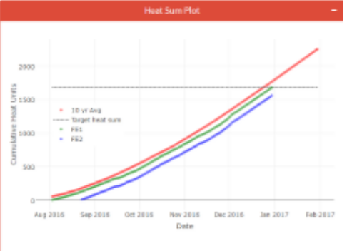
In-field machine vision – prototype technology is available for imaging and mapping of flowering and fruit load across orchards. Sizing of fruit on tree is also possible.
With a capability to ‘see’’ fruit and estimate distance to fruit will come the ability to robotically harvest fruit. Expect this soon!
WHERE DOES VALUE LIE FOR THE MANGO INDUSTRY?



