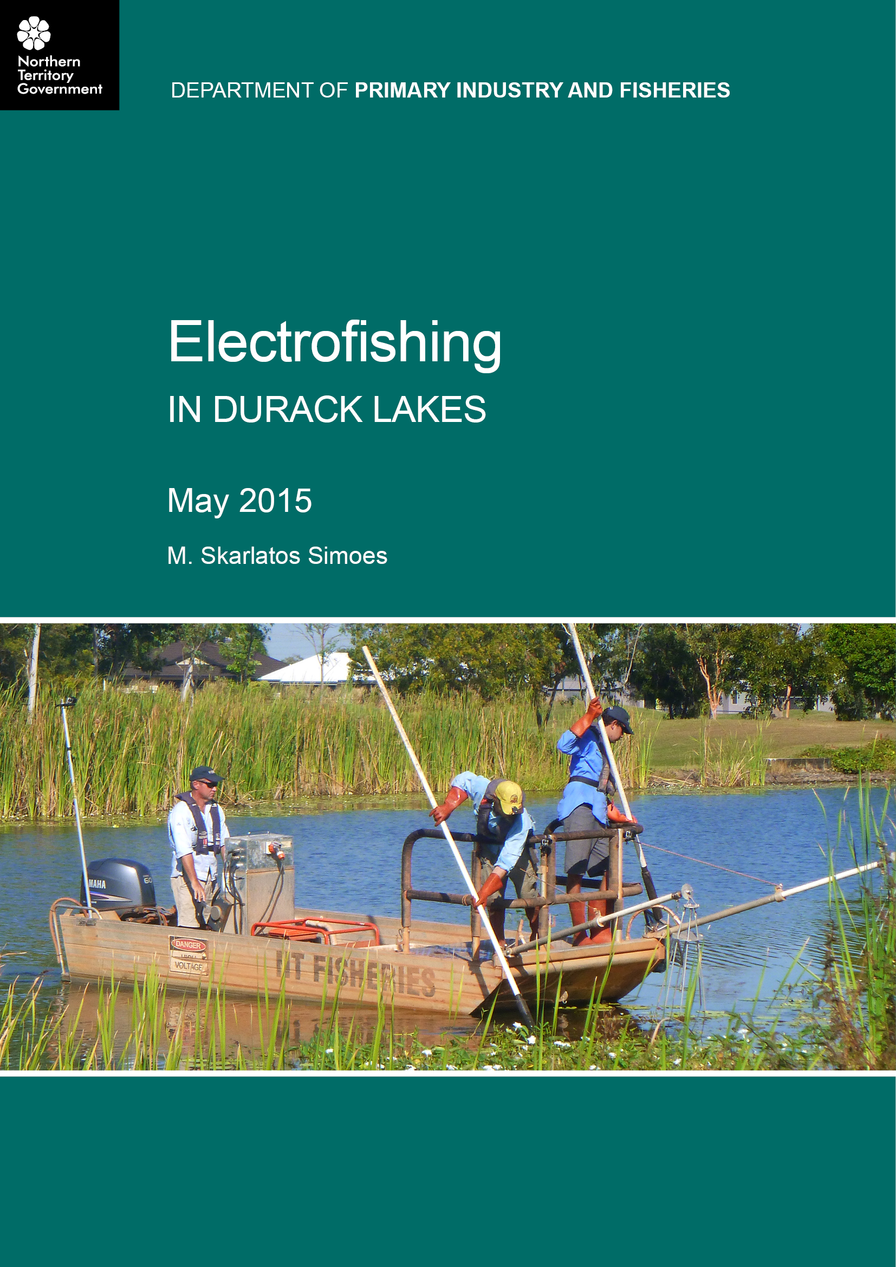

Electrofishing
in Durack Lakes

May 2015

M. Skarlatos Simoes

Produced by:
Northern Territory Government
Department of Primary Industry and Fisheries
May 2015
© Northern Territory Government, 2015

Department of Primary Industry and Fisheries
GPO Box 3000, Darwin NT 0801, AUSTRALIA

Disclaimer
While all care has been taken to ensure that information contained in this Report is true and correct at the time of publication, the Northern Territory of Australia gives no warranty or assurance, and makes no representation as to the accuracy of any information or advice contained in this publication, or that it is suitable for your intended use. No serious business or investment decisions should be made in reliance on this information without obtaining independent and/or professional advice in relation to your particular situation.

TABLE OF CONTENTS

INTRODUCTION 1
METHODS 1
Electrofishing 2
Data collection 2
RESULTS 3
Species diversity 3
Aquatic plants 4
Water quality 5
DISCUSSION 6
ACKNOWLEDGEMENTS 6
APPENDIX A 7

INTRODUCTION
Electrofishing is a technique used by NT Fisheries (Department of Primary Industry and Fisheries) to survey fish populations in freshwater rivers, billabongs, creeks, drains and other water bodies across the Top End. NT Fisheries use this method to collect information about fish populations and to determine the presence or absence of non-native fish in our waterways. It is a technique which allows the collection, identification and measurement of fish with the least harm.
Electrofishing is conducted using a flat bottom boat with a generator and/or a backpack unit powered by batteries. Both setups create an electrical field which stuns fish momentarily giving sufficient time to net and transfer to holding tanks to be identified and measured. Any non-native fish that are detected are removed from the waterway, whilst the native fish are returned when it is safe to do so.
A non-native fish is a species that does not occur naturally in the Northern Territory. Many ornamental fish are non-native species. Whilst not a problem when properly contained in an aquarium, many of these species have the potential to become pests if allowed to escape into our waterways.
If released into natural waterways, non-native fish can:
- compete with native fish for food and space
- dominate waterways by reproducing in large numbers and surviving in adverse and disturbed habitats
- alter and disturb natural habitats
- feed on native fish, insects, and plants
- introduce diseases and parasites.

METHODS
On the morning of Wednesday 20th May 2015, NT Fisheries staff, with assistance from Dr Kitman Dyrting from the Berrimah Veterinary Laboratories (BVL), David Wilson (Aquagreen) and his assistant Cory Young, Michael Hammer from the Museum and Art Gallery of the Northern Territory (MAGNT) and Tristan Sloan from the Amateur Fishermen’s Association of the Northern Territory (AFANT) conducted an electrofishing survey in two of the lakes in Durack.
The electrofishing was conducted using an electrofishing boat in Lakes 9 and 10 (Figure 1) in order to assess current fish stocks and to survey for any non-native fish or aquatic life. Each of these lakes had previously (2012) been stocked with approximately 500 100-150mm barramundi fingerlings by Charles Darwin University.
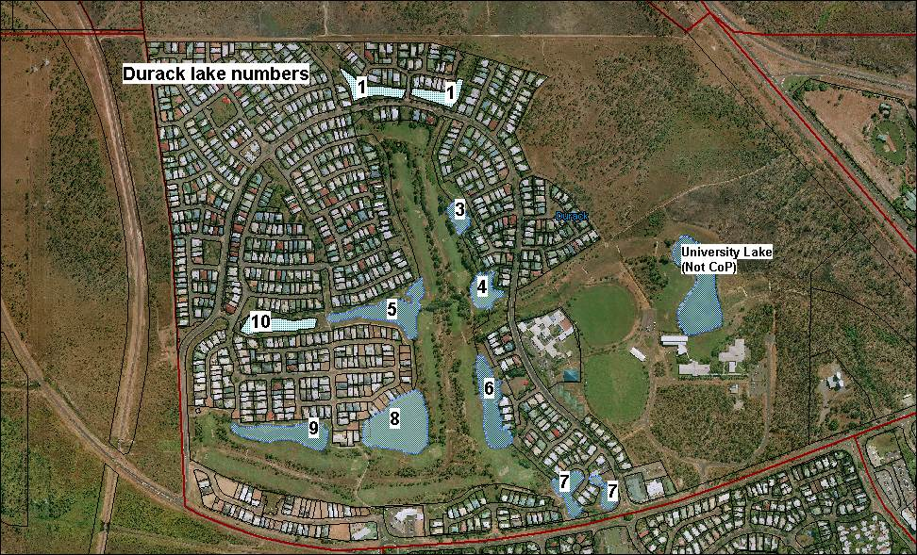
Figure 1: Map of Durack Lakes
Precautionary signage was placed around both lakes, in addition to NT Fisheries staff patrolling the outer edge. This was done to advise the public to keep their distance from the water whilst there was an active electrical current and to also inform them of the purpose of the survey (Figure 2).
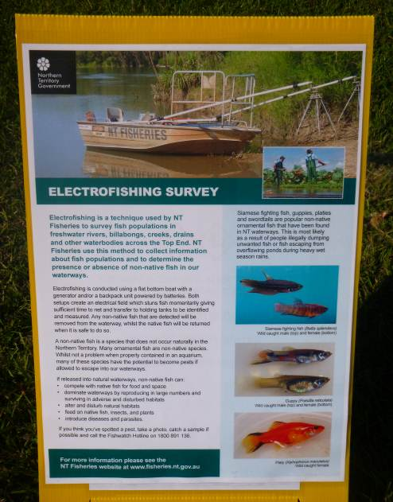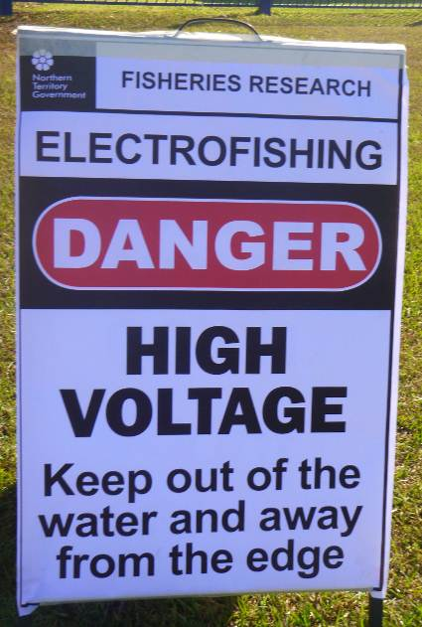
Figure 2: Signage around Durack Lakes 9 and 10

electrofishing
Commencing in Lake 9, trained NT Fisheries staff (Figure 3) used the electrofishing boat to collect fish from the lake and place them in to a large tub filled with water on-board the boat. When this tub was full of fish, they were then transferred to another tub on land to be measured and identified. The electrofishing boat systematically swept each lake several times, focussing on likely fish habitat to ensure that a sufficient and representative sample of fish could be collected for analysis.
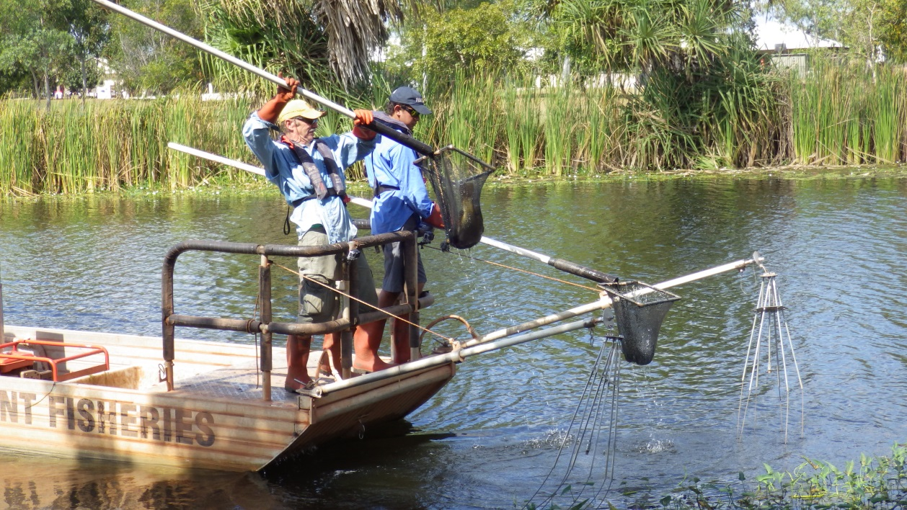
Figure 3: NT Fisheries staff collecting barramundi from Durack Lake 9

DAta collectioN
All collected fish (see Appendix A) were identified and measured as quickly and carefully as possible to reduce stress and harm. Dr Kitman Dyrting (Veterinary Pathologist) inspected all fish prior to placement into an oxygenated holding tank.
Once the electrofishing survey had ceased, all healthy fish were returned to the lake.

RESULTS

species diversity
Many native fish species were found in both lakes (Tables 1 and 2). Two of these species, the chequered rainbowfish and the fly-specked hardhead were more abundant than the others (Figure 5).

Table 1: Native fish (and turtle) assemblage in Durack Lakes 9 and 10
 |  | Lake 9 |  | Lake 10
Common Name | Scientific Name | Total | Mean Length (mm) | Total | Mean Length (mm)
Barramundi | Lates calcarifer | 5 | 630 | 9 | 580
Barred grunter | Amniataba percoides | 7 | 79 | 6 | 156.5
Mouth almighty | Glossamia aprion | 5 | 75 | 6 | 61.5
Fly-specked hardyhead | Craterocephalus stercusmuscarum | 51 | 71 | 35 | 48
Chequered rainbowfish | Melanotaenia splendida inornata | 169 | 63 | 53 | 55
Yellow faced turtle | Emydura tanybaraga | 1 | 61 | - | -
Spangled grunter | Leiopotherapon unicolor | 1 | 207 | - | -
Northwest glassfish | Ambassis sp. | - | - | 4 | 44.5
Northwest river prawn | Macrobrachium bullatum | - | - | 1 | 24
Swamp eel | Ophisternon sp. | - | - | 2 | 197.5
 | Total for each lake | 239 |  | 116

Table 2: Length of barramundi observed and caught in Durack Lakes 9 and 10
Barramundi length (mm)
Caught | Observed
520 | Approx 580
582 | Approx 580
585 | Approx 580
590 | Approx 580
630 | Approx 580
635 | Approx 580
640 | Approx 580

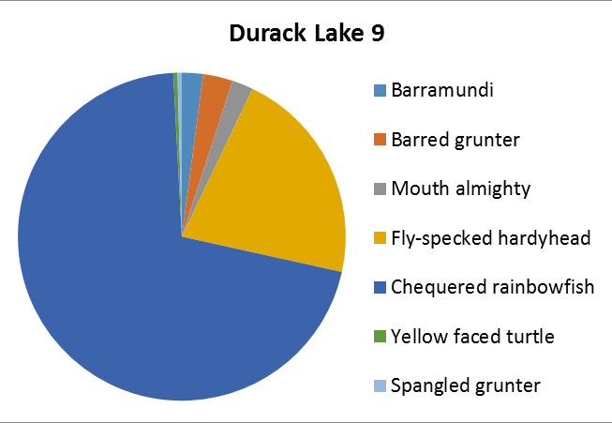

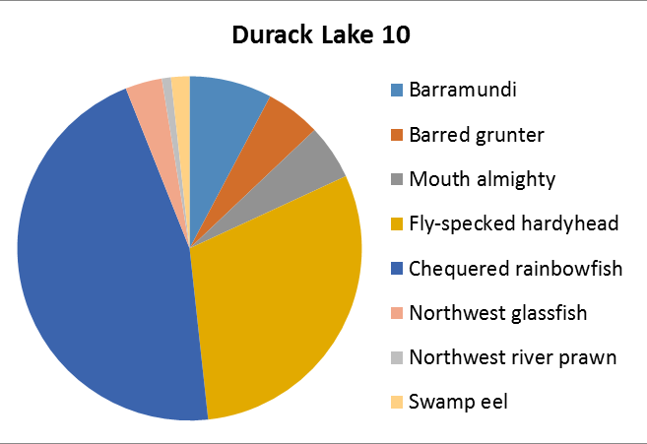
Figure 4: Species diversity in Durack Lakes 9 and 10

Aquatic plants
A list of native and non-native aquatic plants compiled by David Wilson is provided in Table 3. This list has been provided to the Weed Management Branch (Department of Land Resource Management) for their information.

Table 3: Aquatic plants found in Durack Lakes 9 and 10
Common Name | Scientific Name | Lake 9 | Lake 10
Aquatic life
Stonewort (an algae) | Chara sp.
Water Thyme | Hydrilla verticillata
Snowflake Lily | Nymphoides indica
Bladderwort | Utricularia gibba
Ribbon Weed or Val | Vallisneria nana
Floating Pondweed | Potamogeton tricarinatus
Non-aquatic life that live in water
Cumbungi or Bullrushes | Typha domingensis
Willow Primrose | Ludwigia octovalvis
Exotic ornamental plants
Kan Kong | Ipomea aquatica
Mrs Hitchcock | Nymphaea pubescens
Ornamental Taro | Colocasia esculenta
Melon Sword Plant | Echinodorus osiris
Exotic noxious
Salvinia | Salvinia molesta

water quality
Water quality parameters were measured in the deepest area near the middle of both Lakes 9 (Table 4) and 10 (Table 5).
Table 4: Water parameters measured at Durack Lake 9
Depth (m) | Dissolved oxygen (mg/L) | Dissolved oxygen (% sat) | pH | Conductivity (us.cm-1) | Temperature (ºC) | Turbidity (NTU's)
0 | 9.91 | 118.00 | 7.80 | 503.00 | 28.30 | 3.00
1 | 6.52 | 79.30 | 7.37 | 501.00 | 27.60 | 4.50
2 | 1.52 | 18.00 | 7.21 | 501.00 | 26.40 | 23.00
3 | 0.78 | 9.70 | 7.19 | 514.00 | 21.90 | 29.70

Table 5: Water parameters measured at Durack Lake 10
Depth (m) | Dissolved oxygen (mg/L) | Dissolved oxygen (% sat) | pH | Conductivity (us.cm-1) | Temperature (ºC) | Turbidity (NTU's)
0 | 10.1 | 133.70 | 6.76 | 407.00 | 31.50 | 18.10
1 | 4.2 | 43.48 | 7.64 | 422.00 | 27.80 | 20.00

DISCUSSION
The aims of the electrofishing survey were achieved. An adequate sample size of fish were collected, identified and measured to give a representation of the current fish populations in Durack Lakes 9 and 10. Fortunately, no non-native fish were found in either lake which is a positive result. Unfortunately, the declared weed, Salvinia molesta was present within Durack Lake 10. The Weeds Management Branch are aware of this infestation.
The water quality parameters that were recorded were within acceptable limits.
As mentioned in the results, many native fish were collected. The two dominant species observed were chequered rainbowfish (Melanotaenia splendida inornata) and fly-specked hardyheads (Craterocephalus stercusmuscarum). Lake 9 contained seven different species, whereas Lake 10 exhibited eight different species. The single yellow-faced turtle that was found was small (carapace length 61mm) and a native to the Daly River region. Due to its native range and size, it is quite possible that this turtle was a pet that escaped or was released into the lake.
The barramundi (Lates calcarifer) that were observed and caught were all within the same size range (520- 640mm) potentially indicating they were all from the same cohort, consistent with the 2012 stocking in the lakes by Charles Darwin University. Their sizes were within normal limits for their age and all barramundi appeared healthy and in good condition.
The number of barramundi found was low compared to the numbers that were stocked in 2012. This could be due to a range of factors including: a recent fish kill (March 2015) in Lake 9 whereby approximately 30 barramundi ranging from 50-500mm (according to witnesses) died, predation and recreational fishing whereby fish are removed from the lakes and not returned. Also, information obtained from the City of Palmerston is that less than 12 hours after the initial stocking of the lakes, cormorants (aquatic birds) were observed feeding on the fingerlings.
We would consider the survival rate of the barramundi added to the lakes as being fairly good in this situation given the limited food supply and perhaps issues with the oxygen levels in the water (usually the main reason for fish kills which are a natural occurrence).
The two swamp eels (Ophisternon sp.) were collected by Michael Hammer for DNA analysis. Dr Kitman Dyrting collected several fish (chequered rainbowfish, barred grunters, mouth almighty and fly-specked hardyheads) displaying clinical signs of parasites/disease for further parasitological and histological analysis.

ACkNOWLEDGEMENTS
A very special thank you and mention go to all NT Fisheries staff (Quentin Allsop, Wayne Baldwin, Kurtly Harvey, Graham Schultz, Marissa Tabuai, Evan Needham and Michelle Skarlatos Simoes) who assisted that day as well as staff from BVL (Kitman Dyrting), MAGNT (Michael Hammer), AFANT (Tristan Sloan) and Aquagreen (David Wilson and his assistant Cory Young). The electrofishing survey was a great success and could not have been achieved without the assistance of everyone involved.

APPendix A
Fish (and turtle) species found in Durack Lakes 9 and 10.

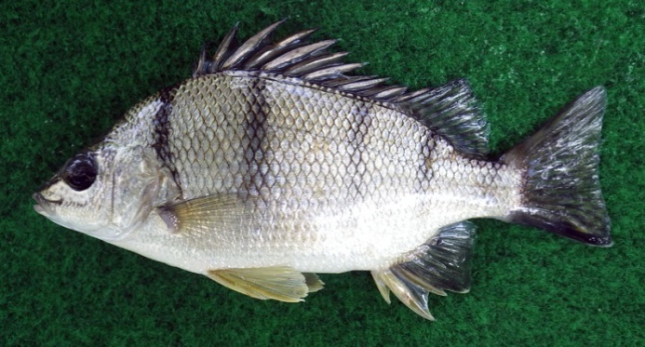 | 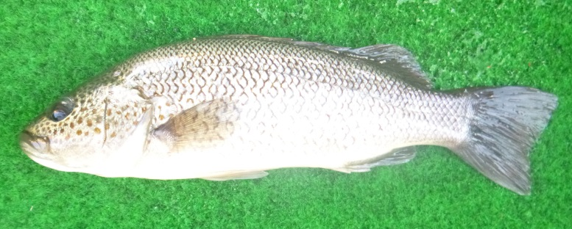
Barred Grunter  Amniataba percoides | Spangled grunter  Leiopotherapon unicolor
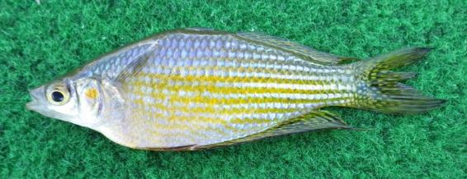 | 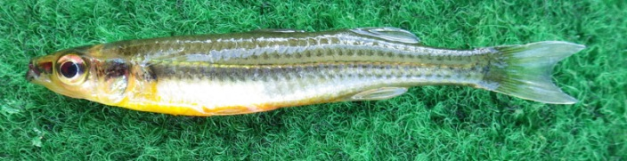
Chequered rainbowfish  Melanotaenia splendida inornata | Fly-specked hardyhead  Craterocephalus stercusmuscarum
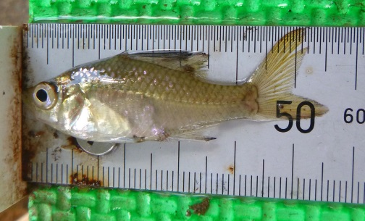 | 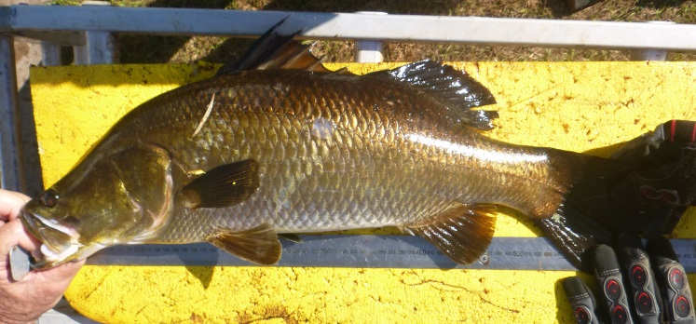
Northwest glassfish  Ambassis sp. | Barramundi  Lates calcarifer
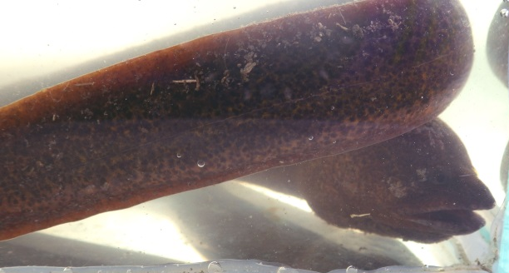 | 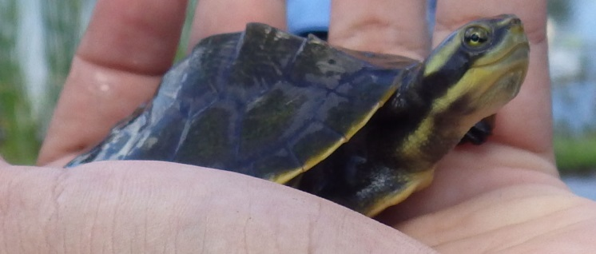
Swamp eel  Ophisternon sp. | Yellow- faced turtle  Emydura tanybaraga

