The purpose of this quarterly outlook is to summarise information relevant to the pastoral industry such as current feed supplies, seasonal conditions, the development of drought conditions and relative fire risk. This edition summarises modelled pasture growth in April 2025.  
You can subscribe to receive the Outlook [here](https://daf.nt.gov.au/publications/agriculture/newsletters/northern-territory-pastoral-feed-outlook).

You can see the entire document and all districts by continuing to scroll through this file. If you are interested in selected sections you can click on the links below.

Summary of current situation & trends - all districts

Northern Territory Seasonal Outlook – as at April 2025

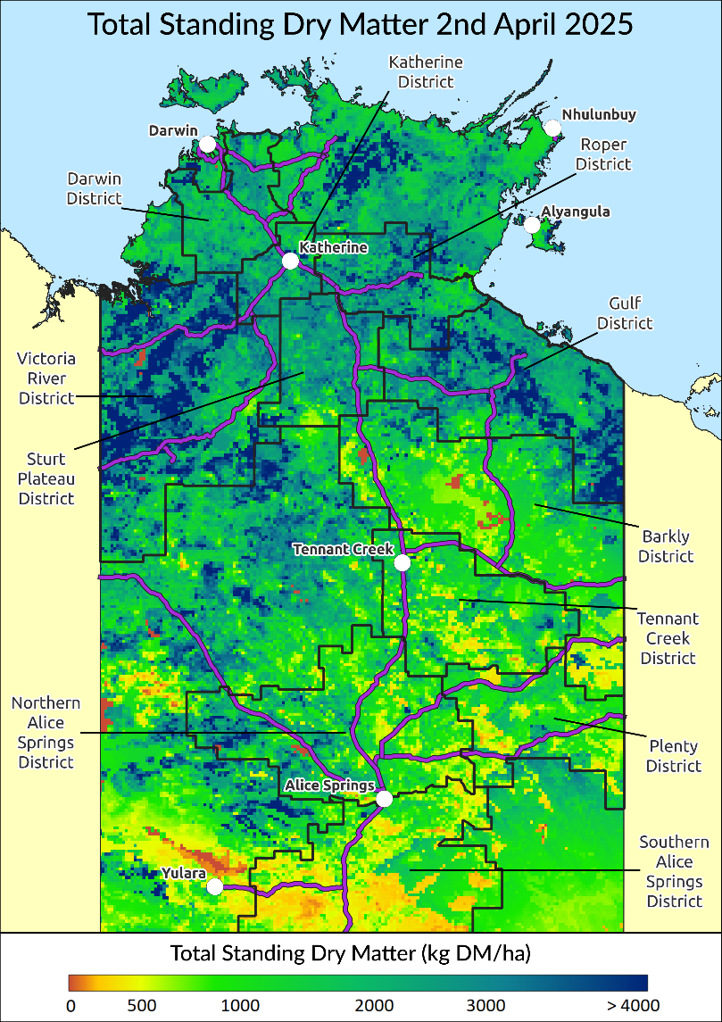Individual District Summaries:

Darwin District

Katherine District

Victoria River District

Sturt Plateau District

Roper District

Gulf District

Barkly District

Tennant Creek District

Northern Alice Springs District

Plenty District

Southern Alice Springs District

For further information about this Outlook, please contact Chris Materne on 08 8951 8135 or Caz Pettit 08 8999 2178.

All pasture data in this report is derived from AussieGRASS <https://www.longpaddock.qld.gov.au/aussiegrass/>

# Summary of current situation and trends – all districts – April 2025

Rainfall in January and February was below average for much of the NT due to the late monsoon onset in the Top End which was finally observed on 7 February, the latest onset at Darwin since records began in the 1957–58 wet season. However March saw much of the NT receive above to well above average monthly rainfall, particularly in central & eastern regions as well as the north west coast. Maximum temperatures between January & April have been above average across most of the NT.

Despite relatively patchy storm driven rather than monsoonal rainfall for most of the wet season, pasture growth has been average to above average for most districts. While relative biomass levels vary with rainfall and grassfires, standing dry matter is still quite high in several districts including Northern Alice Springs & Plenty.

Over the next 3 months, pasture growth is likely to be low to average in some northern districts due to normal seasonal limitations. Areas of very high growth are likely in most of the southern and eastern districts including the Roper, Gulf, Barkly & Plenty districts due to good late wet season rainfall in March.

While the grassfire risk is still low in the northern districts, fire risk remains moderate to high in all southern districts except Southern Alice Springs.

With most major climate drivers including the ENSO currently neutral, rainfall over the next 3 months is likely to be average over much of the southern NT and below average across most of the Top End. Above average temperatures are likely throughout the NT.

|  |  |  |  |  |  |  |  |  |  |  |  |  |  |  |  |  |  |
| --- | --- | --- | --- | --- | --- | --- | --- | --- | --- | --- | --- | --- | --- | --- | --- | --- | --- |
| KEY | Green = low risk | | | | | | Orange = watch | | | | | | Red = high risk | | | | |
| KEY | | **↑** = increasing trend | | | | | | **↓** = decreasing trend | | | | | | **↔** = steady | | | | |
|  | | **Northern Territory Pastoral Districts** | | | | | | | | | | | | | | |  | | |
| **Indicator** | | **Darwin** | **Katherine** | **VRD** | **Sturt Plateau** | **Roper** | | | **Gulf** | **Barkly** | **Tennant Creek** | **Northern Alice Springs** | | | **Plenty** | **Southern Alice Springs** | **Comments** | | |
| 2023/24 total pasture growth | | **↔** | **↑** | **↑** | **↑** | **↔** | | | **↑** | **↔** | **↔** | **↔** | | | **↔** | **↔** | Arrows indicate trend compared to the long-term median (for this time of year) | | |
| Current estimated standing biomass | | **↓** | **↓** | **↓** | **↓** | **↓** | | | **↓** | **↓** | **↓** | **↓** | | | **↓** | **↔** | Arrows indicate trend since previous quarter | | |
| Current fire risk | | **↓** | **↓** | **↓** | **↓** | **↓** | | | **↓** | **↓** | **↓** | **↔** | | | **↔** | **↔** | Arrows indicate the trend since previous quarter | | |
| Current seasonal outlook | | **↔** | **↔** | **↔** | **↔** | **↑** | | | **↑** | **↑** | **↑** | **↓** | | | **↑** | **↑** | Arrows indicate the trend since previous quarter and taking into account the forecasted model predictions | | |

# Northern Territory Seasonal Outlook as at April 2025*

Sourced from the Australian Bureau of Meteorology (BoM)

*This seasonal outlook was correct at the time of publication. For the most up-to-date seasonal outlook, please go to the [Climate Outlook](http://www.bom.gov.au/climate/outlooks/#/rainfall/summary) section of the BoM website.

The BoM outlook for February 2025 to April 2025 indicates that:

* The chance of exceeding the median rainfall between May & July 2025 is low to moderate (25-50%) over most of the NT, with drier than average conditions most likely in the northwest, particularly the VRD. However average rainfall is usually low this time of year. Past outlook accuracy for this time of year is very low to moderate (0-65%).
* Maximum temperatures are likely to be **warmer** than average over most of the NT, with varied (45-100%) past accuracy.
* **Warmer** than average nights are also very likely for most of the NT with good to high past outlook accuracy (55-100%).

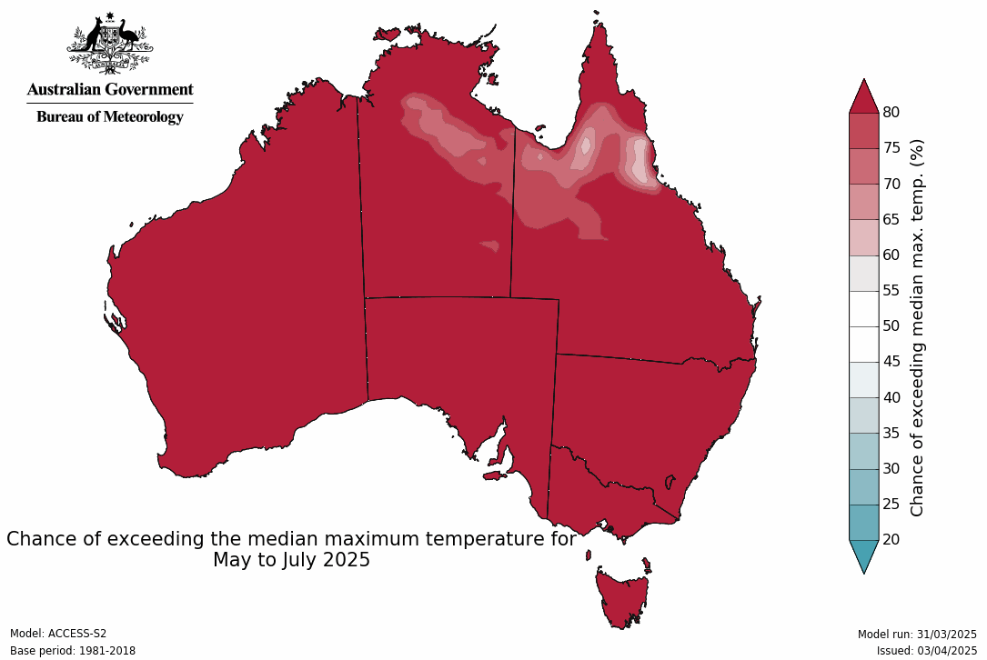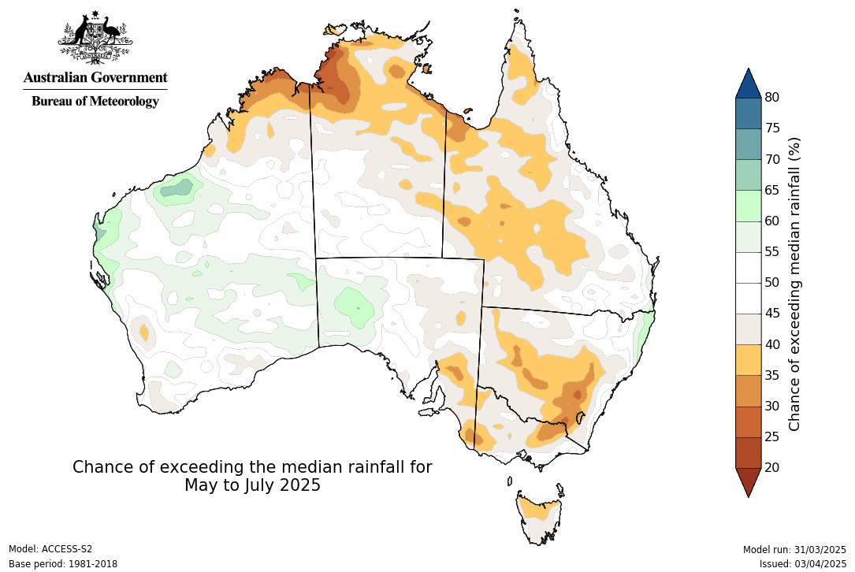

**Influencing Climate drivers**

* This forecast reflects the status and forecasts for several climate drivers, including a neutral ENSO & an active MJO pulse over the Maritime Continent.

|  |  |
| --- | --- |
| **Climate Influences** | **Comments (sourced from the Australian Bureau of Meteorology)** |
| **El Niño Southern Oscillation (ENSO) neutral**  [Pacific Ocean Update](http://www.bom.gov.au/climate/enso/?ninoIndex=nino3.4&index=nino34&period=weekly#tabs=Pacific-Ocean)  (As at 1 April 2025)  *From December 2024 the Bureau of Meteorlogy is no longer issuing (ENSO) Outlook Watch and Alert statements including the ENSO dial. | **The El Niño–Southern Oscillation (ENSO) is currently neutral**.  Monthly sea surface temperature anomalies for Pacific Ocean**30 day moving SOI graph**The latest Niño3.4 value for the week ending 30 March is −0.18 °C. The Bureau's model predicts neutral ENSO (neither El Niño nor La Niña) until at least August which is consistent with all surveyed international models.  To see larger versions of these images, go to Southern Hemisphere Monitoring [Pacific Ocean](http://www.bom.gov.au/climate/enso/?ninoIndex=nino3.4&index=nino34&period=weekly#tabs=Pacific-Ocean) & [Outlook Niño 3.4](http://www.bom.gov.au/climate/ocean/outlooks/?index=nino34). |
| **Indian Ocean Dipole (IOD)**  Current outlook: **Neutral**  [Indian Ocean Update](http://www.bom.gov.au/climate/enso/?ninoIndex=nino3.4&index=nino34&period=weekly#tabs=Indian-Ocean)  (As at 5 April 2025) | Monthly sea surface temperature anomalies for Indian OceanIOD Index time series**The Indian Ocean Dipole (IOD) is currently neutral.**  The IOD is neutral. After reaching +0.74 °C at the end of March, the latest value of the IOD index for the week ending 6 April is +0.35 °C. The IOD index is expected to remain neutral during the rest of April.  To see larger versions of these images, go to Southern Hemisphere Monitoring [Indian Ocean](http://www.bom.gov.au/climate/enso/?ninoIndex=nino3.4&index=nino34&period=weekly#tabs=Indian-Ocean) & [Outlook IOD](http://www.bom.gov.au/climate/ocean/outlooks/?index=iod). |
| **Southern Annular Mode (SAM)**  Current outlook: **Neutral**  [Southern Ocean Update](http://www.bom.gov.au/climate/enso/?ninoIndex=nino3.4&index=nino34&period=weekly#tabs=Southern-Ocean)  (As at 8 April 2025) | Chart showing Southern Annular Mode index**The SAM is currently positive becoming neutral.**  The Southern Annular Mode (SAM) is positive as of 8 April. It is forecast to become neutral with a tendency toward positive values over the rest of the month.  The SAM typically has little impact on Northern Territory rainfall patterns during autumn months (March – May).  To see larger versions of these images, go to Southern Hemisphere Monitoring [Southern Ocean](http://www.bom.gov.au/climate/enso/?ninoIndex=nino3.4&index=nino34&period=weekly#tabs=Southern-Ocean) & [Outlook SAM](http://www.bom.gov.au/climate/ocean/outlooks/?index=sam). |
| **Seasonal Indicator** | **Comments (sourced from the Australian Bureau of Meteorology & the NT Department of Industry, Tourism & Trade)** |
| **Madden–Julian Oscillation (MJO)**  Outlook: **Weak**  [Tropics Update](http://www.bom.gov.au/climate/mjo/#tabs=Tropical-update)  (As at 5 April 2025) | Graph showing Madden - Julian Oscillation Index forecastThe **MJO pulse is currently weak in the Western Pacific.**  During the past week to 5 April, a weak to indiscernible Madden-Jullian Oscillation (MJO) pulse was located over the Western Pacific region. Forecasts for the MJO are mixed. However, some models indicate that over the next fortnight a weak signal of the MJO is likely to strengthen over the Western Pacific region and progress to the Western Hemisphere and Africa region at a moderate strength. The MJO is expected weaken or become indiscernible towards the end of April.  When the MJO is in the African region, it is typically associated with the suppression of cloudiness and rainfall over northern Australia. |
| **Wet Season Onset**  Outlook 2024/25: **Early**  [Northern Rainfall Onset Outlook](http://www.bom.gov.au/climate/rainfall-onset/#tabs=Outlook)  (As at 29 August 2024)  Next Update: 26 June 2025 | **Map showing the chance of early rainfall onset across northern AustraliaAn earlier than normal start to the 2024/25 wet season was forecast for the east of the NT; later in the west.**  Most of the NT was predicted to have an early or average wet season onset date. The actual start date varied across the NT however most northern parts did receive rain earlier or on expected average onset date.  The northern rainfall onset date occurs when the rainfall total reaches 50 mm since the 1st of September. It is considered approximately the amount of rainfall required to stimulate plant growth. |
| Observations 2024/25  (As at 5 April 2025) | Map showing rainfall totals from 1 September 2024Map showing date when total rainfall reached 50 mm from 1st SeptemberMap showing number of days earlier or later than the long-term average onset dateThe onset observations can be found [here](http://www.bom.gov.au/climate/rainfall-onset/#tabs=Observations) |

# Darwin District

* Pasture growth for this time of year is varied, ranging from **low** to **very high** across the district, but is average to slightly above average overall.
* Relative biomass levels are generally **low** to  **average** across the district, with isolated areas of **high** pasture biomass in the south.
* Over the next three months, the chance of exceeding the median growth across much of the district is **low** with pasture growth typically finished by this time of year.
* There have been no fires in the district since January 1st 2025.

**2024/25 Pasture Growth**

**1976 kg/ha**

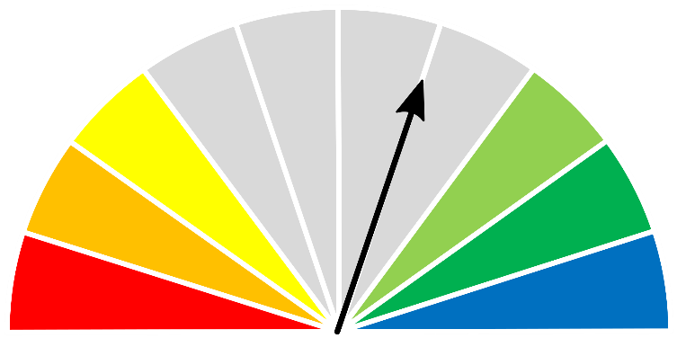



| **As at 1 April 2025** | | | | |
| --- | --- | --- | --- | --- |
| **(% of district)** | **<1,000kg/ha** | **1,000 - 2,000kg/ha** | **2,000 - 3,000kg/ha** | **>3,000kg/ha** |
| 2024/2025  Pasture Growth | 0% | 53% | 44% | 3% |
| Total Standing Dry Matter | 0% | 36% | 55% | 9% |

|  |  |
| --- | --- |
| **Median Pasture Growth (kg/ha)**  **(Running Total)** | **Total Standing Dry Matter at 1 April 2025**  **Relative to Historical Records (1957-now)** |
| **Graph showing running total of pasture growth** | **Map showing total standing dry matter relative to long-term records** |

|  |  |
| --- | --- |
| **6-month Pasture Growth at 1 April 2025**  **Relative to Historical Records (1957-now)** | **Chance of Exceeding Median Pasture Growth**  **April – June 2025** |
| Maps showing current pasture growth relative to long-term records (left) and the chance of exceeding median pasture growth in the next three months (right) | |

# Katherine District

* Pasture growth for this time of year is **above average** over much of the district.
* Biomass levels across the district are mixed, ranging from **low** including burnt areas to **above average**.
* Over the next three months, the chance of exceeding the median growth across most of the district is **low** with pasture growth typically finished by this time of year; however areas of **high** growth are possible, particularly in the south of the district.
* 2% of the district has burnt since January 1st 2025.

**2024/25 Pasture Growth**

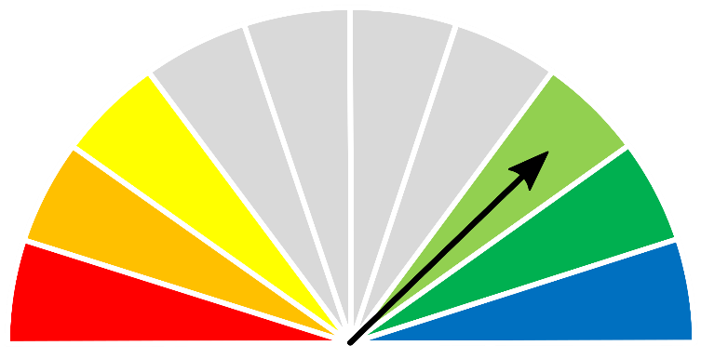

**1990 kg/ha**



| **As at 1 April 2025** | | | | |
| --- | --- | --- | --- | --- |
| **(% of district)** | **<1,000kg/ha** | **1,000 - 2,000kg/ha** | **2,000 - 3,000kg/ha** | **>3,000kg/ha** |
| 2024/2025  Pasture Growth | 0% | 52% | 48% | 0% |
| Total Standing Dry Matter | 1% | 22% | 61% | 16% |

|  |  |
| --- | --- |
| **Median Pasture Growth (kg/ha)**  **(Running Total)** | **Total Standing Dry Matter at 1 April 2025**  **Relative to Historical Records (1957-now)** |
| **Graph showing running total of pasture growth** | **Map showing total standing dry matter relative to long-term records** |

|  |  |
| --- | --- |
| **6-month Pasture Growth at 1 April 2025**  **Relative to Historical Records (1957-now)** | **Chance of Exceeding Median Pasture Growth**  **April – June 2025** |
| Maps showing current pasture growth relative to long-term records (left) and the chance of exceeding median pasture growth in the next three months (right) | |

# Victoria River District

* Pasture growth for this time of year is **average** to **extremely high** across most of the district.
* Relative pasture biomass levels are patchy across the district, varying from **low** where fires have removed standing dry matter, to **very** **high**.
* While pasture growth over the next 3 months is likely to be typically **low**, scattered areas of **very high** growth are possible over much of the district.
* 2% of the district has burnt since January 1st 2025.

**2024/25 Pasture Growth**



**1984 kg/ha**



|  |  |  |  |  |  |
| --- | --- | --- | --- | --- | --- |
| **As at 1 April 2025** | | | | | |
| **(% of district)** | **<1,000kg/ha** | **1,000 - 2,000kg/ha** | | **2,000 - 3,000kg/ha** | **>3,000kg/ha** |
| 2024/2025  Pasture Growth | 10% | 41% | | 45% | 4% |
| Total Standing Dry Matter | 1% | 15% | | 42% | 42% |
|  |  |  | |  |  |
| **Median Pasture Growth (kg/ha)**  **(Running Total)** | | **Total Standing Dry Matter at 1 April 2025**  **Relative to Historical Records (1957-now)** | | | |
| Graph showing running total of pasture growth | | Map showing total standing dry matter relative to long-term records | | | |
|  | |  | | | |
| **6-month Pasture Growth at 1 April 2025**  **Relative to Historical Records (1957-now)** | | | **Chance of Exceeding Median Pasture Growth**  **April – June 2025** | | |
| Maps showing current pasture growth relative to long-term records (left) and the chance of exceeding median pasture growth in the next three months (right) | | | | | |

# Sturt Plateau District

* Pasture growth is **average** to **very high** for this time of year over most of the district apart from some **below average** growth in the south west.
* Pasture biomass levels are generally **average** to **high** across the district, with some **low** levels in the south west, and isolated areas where fires have removed standing dry matter across the rest of the district.
* While pasture growth over the next 3 months is likely to be typically **low**, isolated areas of **higher than normal** growth for this time of year are possible particularly in the north and east of the district.
* 3% of the district has burnt since January 1st 2025.

**2024/25 Pasture Growth**

**1994 kg/ha**

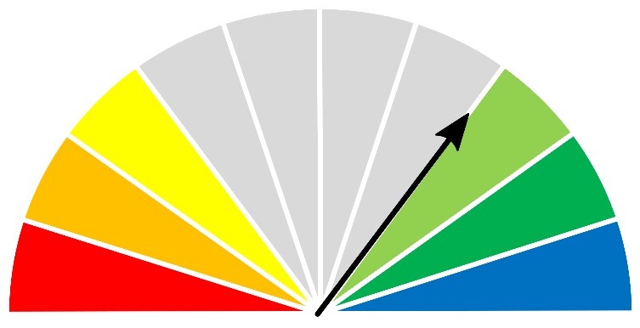



|  |  |  |  |  |
| --- | --- | --- | --- | --- |
| **As at 1 April 2025** | | | | |
| **(% of district)** | **<1,000kg/ha** | **1,000 - 2,000kg/ha** | **2,000 - 3,000kg/ha** | **>3,000kg/ha** |
| 2024/2025  Pasture Growth | 10% | 39% | 50% | <1% |
| Total Standing Dry Matter | 4% | 22% | 61% | 13% |
|  |  |  |  |  |
| **Median Pasture Growth (kg/ha)**  **(Running Total)** | | **Total Standing Dry Matter at 1 April 2025**  **Relative to Historical Records (1957-now)** | | |
| Graph showing running total of pasture growth | | Map showing total standing dry matter relative to long-term records | | |

|  |  |
| --- | --- |
| **6-month Pasture Growth at 1 April 2025**  **Relative to Historical Records (1957-now)** | **Chance of Exceeding Median Pasture Growth**  **April – June 2025** |
| Maps showing current pasture growth relative to long-term records (left) and the chance of exceeding median pasture growth in the next three months (right) | | |

# Roper District

* Apart from some **below average** growth in the eastern parts, overall pasture growth is **average** to **high** over most of the district.
* Relative pasture biomass levels are patchy but generally **low** to **average** across most of the district.
* Although pasture growth over the next 3 months is typically **low**, **higher than usual** growth is likely over much of the district, particularly in the eastern parts due to late March rain.
* 2% of the district has burnt since January 1st 2025.

**2024/25 Pasture Growth**

**1990 kg/ha**





|  |  |  |  |  |
| --- | --- | --- | --- | --- |
| **As at 1 April 2025** | | | | |
| **(% of district)** | **<1,000kg/ha** | **1,000 - 2,000kg/ha** | **2,000 - 3,000kg/ha** | **>3,000kg/ha** |
| 2024/2025  Pasture Growth | 1% | 50% | 49% | <1% |
| Total Standing Dry Matter | 1% | 22% | 50% | 27% |

|  |  |
| --- | --- |
| **Median Pasture Growth (kg/ha)**  **(Running Total)** | **Total Standing Dry Matter at 1 April 2025**  **Relative to Historical Records (1957-now)** |
| Graph showing running total of pasture growth | Map showing total standing dry matter relative to long-term records |

|  |  |
| --- | --- |
| **6-month Pasture Growth at 1 April 2025**  **Relative to Historical Records (1957-now)** | **Chance of Exceeding Median Pasture Growth**  **April – June 2025** |
| Maps showing current pasture growth relative to long-term records (left) and the chance of exceeding median pasture growth in the next three months (right) | |

# Gulf District

* Relative pasture growth for this time of year is generally **average** to **extremely high** over most of the district.
* Relative pasture biomass levels are patchy, varying from **low** including areas where fires have removed standing dry matter, to **extremely high** in isolated areas across the district.
* Although pasture growth over the next 3 months is typically **low**, areas of **higher than usual** growth for this time of year are likely over much of the district due to March rain.
* 2% of the district has burnt since January 1st 2025.

**2024/25 Pasture Growth**

**2080 kg/ha**





|  |  |  |  |  |
| --- | --- | --- | --- | --- |
| **As at 1 April 2025** | | | | |
| **(% of district)** | **<1,000kg/ha** | **1,000 - 2,000kg/ha** | **2,000 - 3,000kg/ha** | **>3,000kg/ha** |
| 2024/2025  Pasture Growth | 3% | 39% | 57% | 1% |
| Total Standing Dry Matter | 1% | 16% | 49% | 34% |

|  |  |
| --- | --- |
| **Median Pasture Growth (kg/ha)**  **(Running Total)** | **Total Standing Dry Matter at 1 April 2025**  **Relative to Historical Records (1957-now)** |
| Graph showing running total of pasture growth | Map showing total standing dry matter relative to long-term records |

|  |  |
| --- | --- |
| **6-month Pasture Growth at 1 April 2025**  **Relative to Historical Records (1957-now)** | **Chance of Exceeding Median Pasture Growth**  **April – June 2025** |
| Maps showing current pasture growth relative to long-term records (left) and the chance of exceeding median pasture growth in the next three months (right) | |

# Barkly District

* Overall relative pasture growth in the Barkly district is **average** for this time of year with isolated areas of **above average** growth. Growth has been much lower than at the same time in the last two previous years.
* While fires have removed standing dry matter in some areas, pasture biomass levels are generally **average** to **above** **average** across most of the district.
* Although pasture growth over the next 3 months is typically **low**, areas of **higher than usual** growth for this time of year are likely over much of the district, particularly in the northern half due to recent rain.
* 4% of the district has burnt since January 1st 2025.

**2024/25 Pasture Growth**

**700 kg/ha**





|  |  |  |  |  |
| --- | --- | --- | --- | --- |
| **As at 1 April 2025** | | | | |
| **(% of district)** | **<500kg/ha** | **500 - 1000kg/ha** | **1000 – 2,000kg/ha** | **>2,000kg/ha** |
| 2024/2025  Pasture Growth | 28% | 49% | 20% | 3% |
| Total Standing Dry Matter | 4% | 25% | 54% | 17% |

|  |  |
| --- | --- |
| **Median Pasture Growth (kg/ha)**  **(Running Total)** | **Total Standing Dry Matter at 1 April 2025**  **Relative to Historical Records (1957-now)** |
| Graph showing running total of pasture growth | Map showing total standing dry matter relative to long-term records |

|  |  |
| --- | --- |
| **6-month Pasture Growth at 1 April 2025**  **Relative to Historical Records (1957-now)** | **Chance of Exceeding Median Pasture Growth**  **April – June 2025** |
| Maps showing current pasture growth relative to long-term records (left) and the chance of exceeding median pasture growth in the next three months (right) | |

# Tennant Creek District

* Relative pasture growth for the Tennant Creek district is generally **average** to **above average**,across most of the district, but less than at the same time for the last two years.
* While fires have removed some large areas of standing dry matter, relative biomass is still generally **average** to **above average** over much of the district.
* Although pasture growth over the next 3 months is typically **low**, areas of **extremely high** growth are likely over much of the district, particularly in the southeast with **average** to **below average** growth more likely in the southwest.
* 6% of the district has burnt since January 1st 2025.

**2024/25 Pasture Growth**

**365 kg/ha**

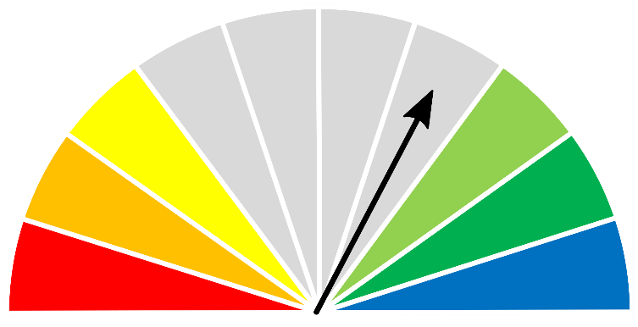



| **As at 1 April 2025** | | | | |
| --- | --- | --- | --- | --- |
| **(% of district)** | **<250kg/ha** | **250 - 500kg/ha** | **500 – 1,000kg/ha** | **>1,000kg/ha** |
| 2024/2025  Pasture Growth | 30% | 38% | 26% | 6% |
| Total Standing Dry Matter | 1% | 5% | 24% | 70% |

| **Median Pasture Growth (kg/ha)**  **(Running Total)** | **Total Standing Dry Matter at 1 April 2025**  **Relative to Historical Records (1957-now)** |
| --- | --- |
| Graph showing running total of pasture growth | Map showing total standing dry matter relative to long-term records |

| **6-month Pasture Growth at 1 April 2025**  **Relative to Historical Records (1957-now)** | **Chance of Exceeding Median Pasture Growth**  **April – June 2025** |
| --- | --- |
| Maps showing current pasture growth relative to long-term records (left) and the chance of exceeding median pasture growth in the next three months (right) | |

# Northern Alice Springs District

* Relative pasture growth across the Northern Alice Springs district is generally **average** with areas of **above average** growth in southern and western parts of the district.
* While fires have removed areas of standing dry matter, relative biomass is still generally **average** to **above average** over much of the district.
* The chance of exceeding median pasture growth over the next three months is generally **low** to **average**, however areas of extremely high growth are possible in the eastern part of the district.
* 3% of the district has burnt since January 1st 2025.

**2024/25 Pasture Growth**

**417 kg/ha**

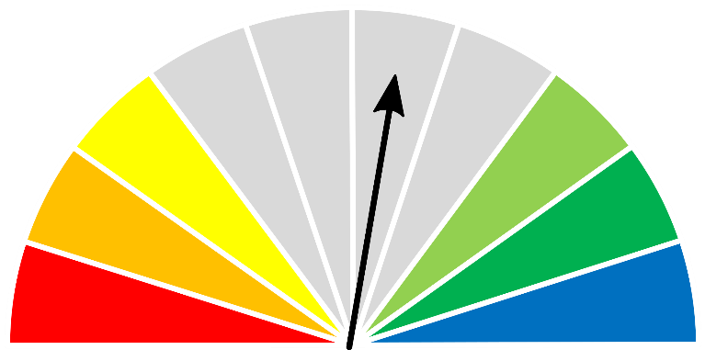



|  |  |  |  |  |
| --- | --- | --- | --- | --- |
| **As at 1 April 2025** | | | | |
| **(% of district)** | **<250kg/ha** | **250 - 500kg/ha** | **500 – 1,000kg/ha** | **>1,000kg/ha** |
| 2024/2025  Pasture Growth | 27% | 32% | 27% | 14% |
| Total Standing Dry Matter | 1% | 3% | 21% | 75% |

| **Median Pasture Growth (kg/ha)**  **(Running Total)** | **Total Standing Dry Matter at 1 April 2025**  **Relative to Historical Records (1957-now)** |
| --- | --- |
| Graph showing running total of pasture growth | Map showing total standing dry matter relative to long-term records |

| **6-month Pasture Growth at 1 April 2025**  **Relative to Historical Records (1957-now)** | **Chance of Exceeding Median Pasture Growth**  **April – June 2025** |
| --- | --- |
| Maps showing current pasture growth relative to long-term records (left) and the chance of exceeding median pasture growth in the next three months (right) | |

# Plenty District

* Overall, relative pasture growth in the Plenty district is **average** to slightly **below average** for this time of year, but much lower than for the previous two years.
* Pasture biomass levels are still **average** to **above** **average** over most of the district.
* Over the next three months, pasture growth is likely to be **extremely high**, except for spinifex pastures that have already had high growth and likely reached nitrogen and/or temperature limitations.
* Around 1% of the district has burnt since January 1st 2025.

**2024/25 Pasture Growth**

**203 kg/ha**

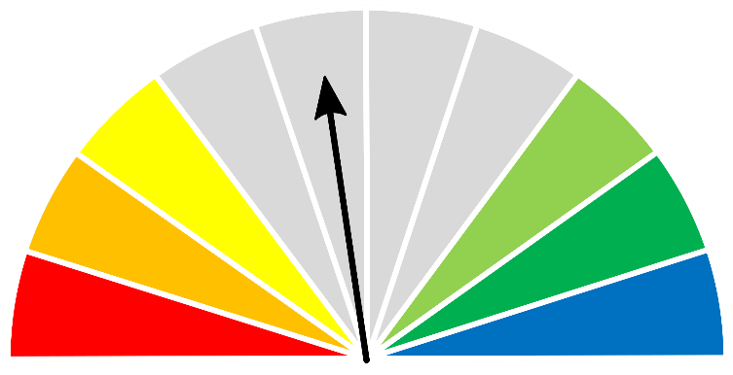



|  |  |  |  |  |
| --- | --- | --- | --- | --- |
| **As at 1 April 2025** | | | | |
| **(% of district)** | **<250kg/ha** | **250 - 500kg/ha** | **500 – 1,000kg/ha** | **>1,000kg/ha** |
| 2024/2025  Pasture Growth | 67% | 30% | 3% | <1% |
| Total Standing Dry Matter | 1% | 9% | 29% | 61% |

| **Median Pasture Growth (kg/ha)**  **(Running Total)** | **Total Standing Dry Matter at 1 April 2025**  **Relative to Historical Records (1957-now)** |
| --- | --- |
| Graph showing running total of pasture growth | Map showing total standing dry matter relative to long-term records |

| **6-month Pasture Growth at 1 April 2025**  **Relative to Historical Records (1957-now)** | **Chance of Exceeding Median Pasture Growth**  **April – June 2025** |
| --- | --- |
| Maps showing current pasture growth relative to long-term records (left) and the chance of exceeding median pasture growth in the next three months (right) | |

# Southern Alice Springs District

* Overall, pasture growth for the Southern Alice Springs district is **average** for this time of year with growth levels ranging from **below average** in the north to **above average** in the south.
* Relative pasture biomass varied across the district but was mostly **average** with areas of **below average** growth in the south half and scattered areas of **above average** growth in the north.
* Over the next three months, pasture growth is likely to be **low** to **average** over most of the district with areas of **very high** growth likely in the southern & eastern parts.
* 0.06% (58 km²) of the district has burnt since January 1st 2025.

**2024/25 Pasture Growth**

**158 kg/ha**

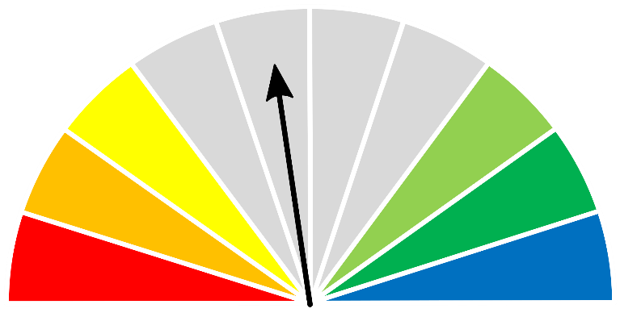



|  |  |  |  |  |
| --- | --- | --- | --- | --- |
| **As at 1 April 2025** | | | | |
| **(% of district)** | **<250kg/ha** | **250 - 500kg/ha** | **500 – 1,000kg/ha** | **>1,000kg/ha** |
| 2024/2025  Pasture Growth | 74% | 20% | 5% | 1% |
| Total Standing Dry Matter | 9% | 28% | 32% | 31% |

| **Median Pasture Growth (kg/ha)**  **(Running Total)** | **Total Standing Dry Matter at 1 April 2025**  **Relative to Historical Records (1957-now)** |
| --- | --- |
| Graph showing running total of pasture growth | Map showing total standing dry matter relative to long-term records |

| **6-month Pasture Growth at 1 April 2025**  **Relative to Historical Records (1957-now)** | **Chance of Exceeding Median Pasture Growth**  **April – June 2025** |
| --- | --- |
| Maps showing current pasture growth relative to long-term records (left) and the chance of exceeding median pasture growth in the next three months (right) | |

# Pasture information

The pasture and grass fire risk information in this document is derived from AussieGRASS.

<https://www.longpaddock.qld.gov.au/aussiegrass/>

AussieGRASS is a model that simulates pasture growth and standing biomass using climate data, vegetation mapping, fire history and regional estimates of grazing pressure. The model can be used to track simulated pasture growth and total standing pasture biomass at the landscape scale.

Note that the model does not use stocking rate data for individual properties. Where stock numbers are significantly higher or lower than typical for a district, model estimates of total standing dry matter may be not reflect local conditions.

Fire scar data used to calculate percentage of districts burnt is derived from North Australia & Rangelands Fire Information (NAFI)

<https://firenorth.org.au/nafi3/>

**Disclaimer**

While all care has been taken to ensure that information contained in this document is true and correct at the time of production, changes in circumstances after the time of distribution may affect the accuracy of its information. The Northern Territory of Australia gives no warranty or assurance, and makes no representation as to the accuracy of any information or advice contained herein, or that it is suitable for your intended use.

You should not rely solely upon information in this document for the purpose of making business or investment decisions in relation to your particular situation.

The Northern Territory of Australia disclaims any liability or responsibility or duty of care towards any person for loss of damage caused by any use of or reliance on this information.