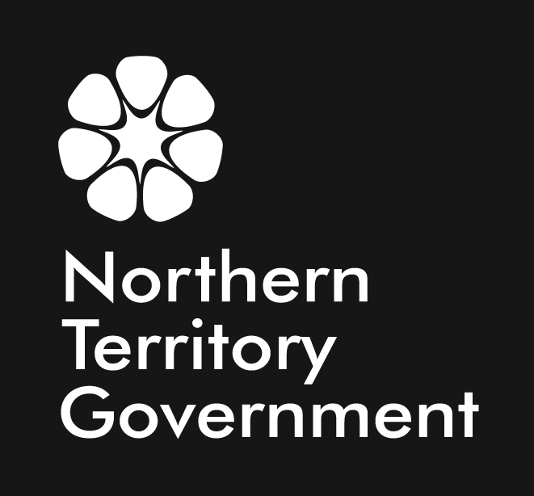 | DEPARTMENT OF RESOURCES  FISHERIES GROUP  AQUACULTURE BRANCH  Aquaculture Strategic Plan 2011 - 2015
Our vision  A growing, viable and economically sustainable aquaculture industry |  |  | Our mission  To stimulate and sustain economic development and employment through aquaculture
Our Values  - Professional delivery of services and research  - Excellence in our field  - Dedicated and professionally nurtured team |  |  | Our Core Business  - Delivery of services and priority research to industry  - Developing aquaculture enterprises in partnership with Indigenous communities  - Facilitating business investment
STRATEGIC PRIORITIES |  | KEY ACTIONS | MAJOR OUTCOMES
Facilitate economic growth and viability of existing and emerging aquaculture industries |  | - Develop strong partnerships with existing and emerging aquaculture sectors.  - Ensure all programs and services of the Aquaculture Branch are aligned with industry priorities.  - Maintain a responsive and effective aquatic animal health diagnostic service. | A profitable and expanding aquaculture industry.
Attract high-quality investment in aquaculture |  | - Develop a planned approach to aquaculture development by identifying regions with economic, social and environmental potential for aquaculture.  - Identify and address major barriers to venture implementation and expansion.  - Develop enabling policies and a positive regulatory framework. | A favourable business environment that provides greater certainty for investment in aquaculture in the Territory.
Facilitate Indigenous economic development and employment opportunities |  | - Identify and address constraints to involvement of Aboriginal people in aquaculture.  - Partner with Indigenous communities to conduct pilot programs for farming a range of target species to assess their suitability for culture in remote locations.  - Integrate aquaculture planning into development plans for the coastal Territory Growth Towns (A Working Future).  - Produce an aquaculture development plan for at least one key Territory region. | Successful aquaculture enterprises that provide employment and business opportunities for Indigenous people.
Optimal use of the Darwin Aquaculture Centre |  | - Deliver high quality R&D that delivers against industry and Indigenous economic development priorities.  - Continue to develop and strengthen linkages with other tropical R&D institutions and programs to maximise the benefits to the Territory’s aquaculture industry.  - Grow the Darwin Aquaculture Centre’s research capacity through strategic staff and student development programs. | The Darwin Aquaculture Centre is highly valued by government and industry for its capacity to deliver against identified priorities.
Ensure a high standard of environmental sustainability |  | - Develop and implement risk-based environmental assessment frameworks in collaboration with other agencies.  - Ensure the Territory’s aquaculture industry operates within current and relevant environmental management plans.  - Prepare an annual report on environmental management of aquaculture in the Territory. | The Territory’s aquaculture industry operates according to environmental best practice.

