The purpose of this quarterly outlook is to summarise information relevant to the pastoral industry such as current feed supplies, seasonal conditions, the development of drought conditions and relative fire risk. This edition summarises modelled pasture growth in October 2026.
You can subscribe to receive the Outlook here.
You can see the entire document and all districts by continuing to scroll through this file. If you are interested in selected sections, you can click on the links below.
Summary of current situation & trends - all districts
Northern Territory Seasonal Outlook – as at October 2026

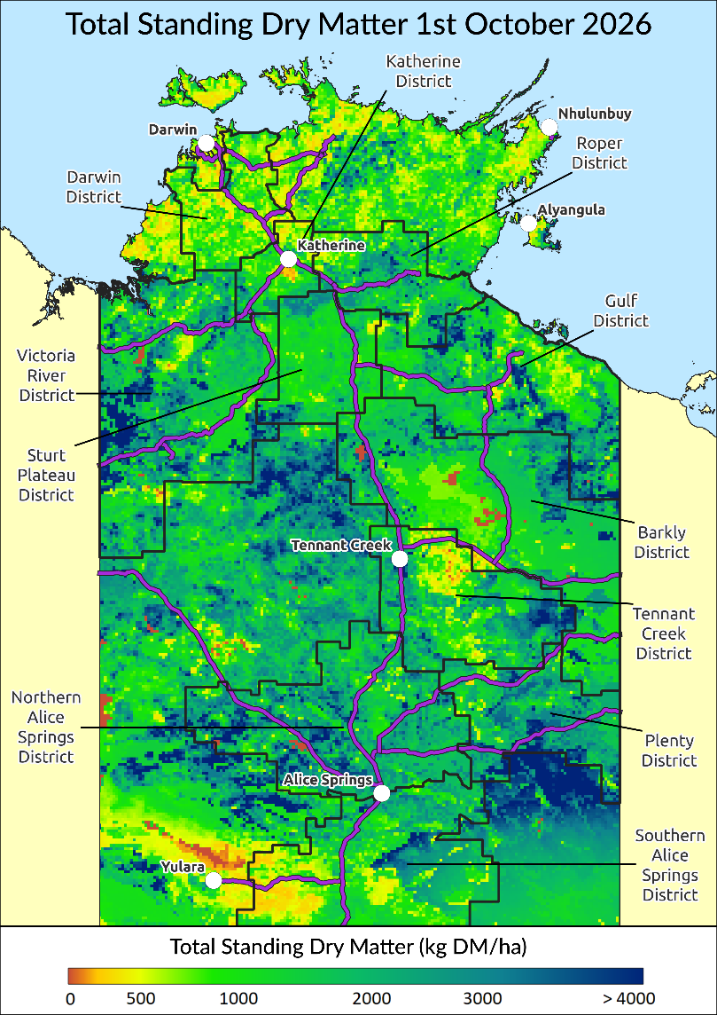
Individual District Summaries:
Darwin District
Katherine District
Victoria River District
Sturt Plateau District
Roper District
Gulf District
Barkly District
Tennant Creek District
Northern Alice Springs District
Plenty District
Southern Alice Springs District
For further information about this Outlook, please contact Chris Materne on 08 8951 8135.
All pasture data in this report is derived from AussieGRASS https://www.longpaddock.qld.gov.au/aussiegrass/

Summary of current situation and trends – all districts – October 2026
Rainfall totals during the northern dry season (May to September) were above average for most of the southern and eastern Northern Territory and parts of the Top End. Area-averaged mean temperatures were also warmer than average for most of the NT.
Pasture growth remains seasonally low across most of the Northern Territory reflecting the normal dry season limitations on plant growth. However, some areas of the Northern and Southern Alice Springs districts have shown above average growth relative to the long-term median due to recent rainfall events. Despite this, cumulative total growth remains low. Pasture biomass levels are patchy and varied in most of the northern districts, while the southern districts are showing large areas of above average to very high relative biomass. Dry season fires have removed large areas of standing dry matter in a few districts including Roper, Gulf & Tennant Creek.
Modelled pasture growth predictions for the next 3 months suggest that growth is likely to be generally average to above average for most of the southern districts; however, large areas of below average growth are likely in some of the northern districts, particularly Darwin & Katherine due to later than usual northern rainfall onset.
Dry conditions in the north and high carry-over pasture biomass in the south continue to drive very high grassfire risk across most pastoral districts.
There is a strong El Niño event underway with relative-Niño3.4 values forecast to reach record levels during late spring or summer and persist into autumn 2027.
KEY | Green = low risk |  |  |  |  |  | Orange = watch |  |  |  |  |  | Red = high risk
KEY |  | ↑ = increasing trend |  |  |  |  |  | ↓ = decreasing trend |  |  |  |  |  | ↔ = steady
 |  | Northern Territory Pastoral Districts
Indicator |  | Darwin | Katherine | VRD | Sturt Plateau | Roper |  |  | Gulf | Barkly | Tennant Creek | Northern Alice Springs |  |  | Plenty | Southern Alice Springs | Comments
2026/27 total pasture growth |  | ↔ | ↔ | ↔ | ↔ | ↔ |  |  | ↔ | ↔ | ↔ | ↑ |  |  | ↔ | ↑ | Arrows indicate trend compared to the long-term median (for this time of year)
Current estimated standing biomass |  | ↓ | ↓ | ↓ | ↓ | ↓ |  |  | ↓ | ↔ | ↔ | ↔ |  |  | ↔ | ↔ | Arrows indicate trend since previous quarter
Current fire risk |  | ↑ | ↑ | ↑ | ↑ | ↑ |  |  | ↑ | ↑ | ↑ | ↔ |  |  | ↑ | ↑ | Arrows indicate the trend since previous quarter
Current seasonal outlook |  | ↔ | ↔ | ↑ | ↔ | ↔ |  |  | ↔ | ↑ | ↑ | ↑ |  |  | ↑ | ↑ | Arrows indicate the trend since previous quarter, taking into account the forecasted model predictions

Northern Territory Seasonal Outlook as at October 2026*
Sourced from the Australian Bureau of Meteorology (BoM)
*This seasonal outlook was correct at the time of publication. For the most up-to-date seasonal outlook, please go to the Climate Outlook section of the BoM website.
The BoM outlook for November 2026 to January 2027 indicates that:
- The chance of exceeding the median rainfall between November 2026 & January 2027 is average to high (50-80%) in the southern and north-west NT, while for the northern NT, the chance of exceeding the median rainfall is low to average (25-45%). The forecasted December to February chance of higher than median rainfall is low to very low across the northern half of the NT, and average to moderate in the southern half of the NT. This suggests that the second half of the wet season (Jan–Feb) is particularly unlikely to exceed median rainfall. However, past outlook accuracy for this time of year is very low to moderate (0-55%), and seasonal forecasts should be checked again throughout the wet season to get the most accurate prediction closer to the time of forecast.
- Maximum temperatures are likely to be warmer than average right across the NT. Past outlook accuracy for this time of year is low to good (45-75%).
- Warmer than average nights are also likely for the entire NT. Past outlook accuracy for this time of year is moderate to high (50-100%) for most of the NT but low (0-50%) in the central NT.
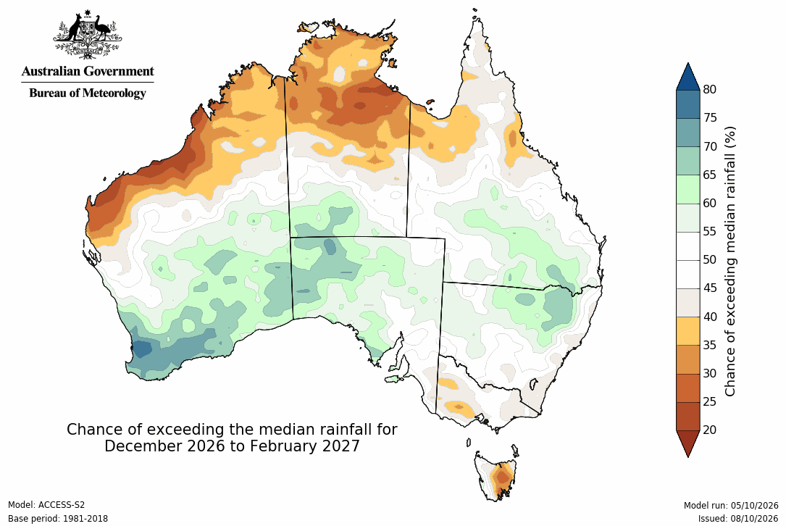
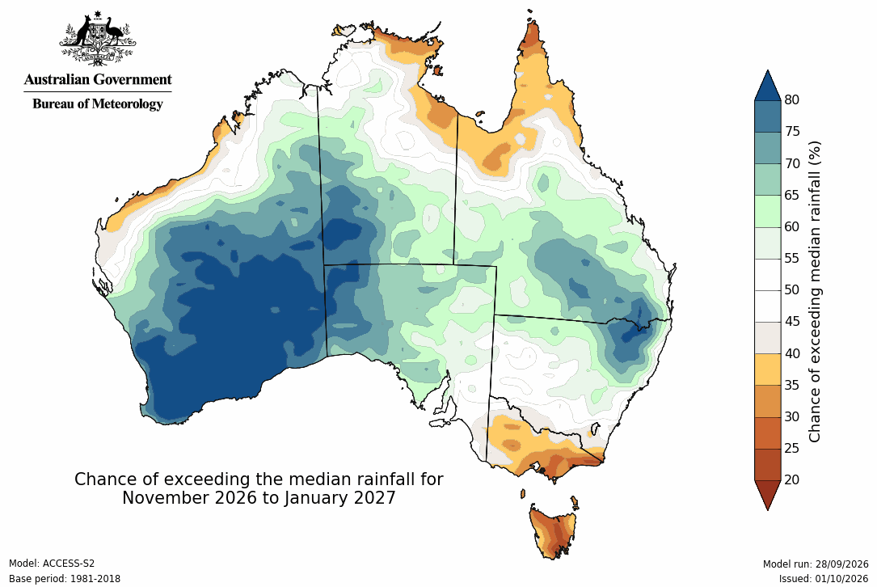

Influencing Climate Drivers

This forecast reflects the status and forecasts for several climate drivers, including positive ENSO, neutral SAM and a potential positive IOD event.
Climate Influences | Comments (sourced from the Australian Bureau of Meteorology)
El Niño Southern Oscillation (ENSO) positive  Pacific Ocean Update  (As at 6 October 2026)  *From December 2024 the Bureau of Meteorology is no longer issuing (ENSO) Outlook Watch and Alert statements including the ENSO dial. | The El Niño–Southern Oscillation (ENSO) is strongly positive.  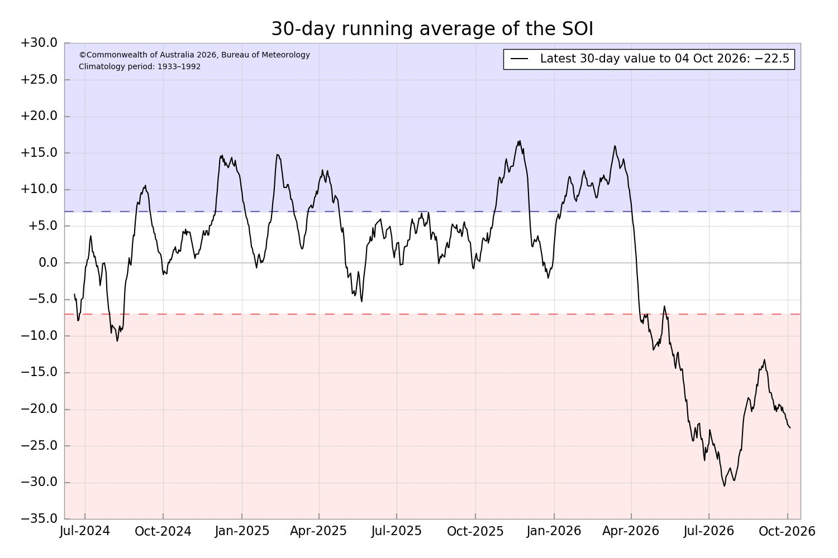  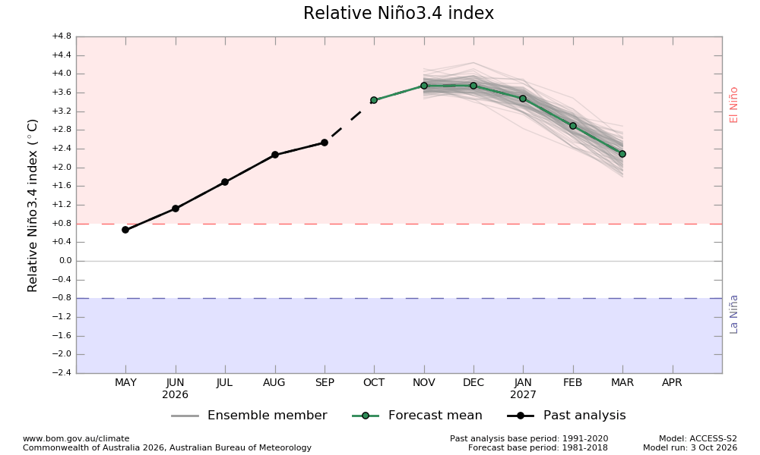  El Niño is at near-record levels. Both oceanic and atmospheric indices reflect values consistent with a strong El Niño. The latest relative Niño3.4 index value for the week ending 27 September 2026 is +2.72 °C, which is the second-highest value on record, behind +2.76 °C for the week ending 22 November 2015. All models forecast the tropical Pacific to continue warming through the southern hemisphere spring, likely peaking in late spring or summer, and persisting into autumn 2027.  To see larger versions of these images, go to Southern Hemisphere Monitoring Pacific Ocean & Outlook Niño 3.4.
Indian Ocean Dipole (IOD)  Current outlook: Neutral  Indian Ocean Update  (As at 1 October 2026) | 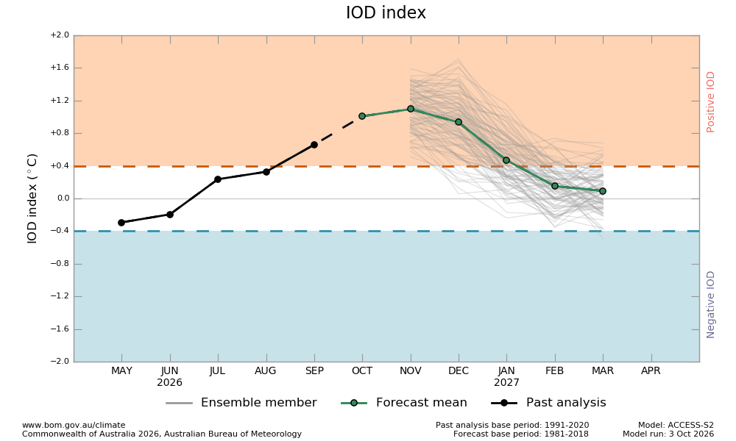  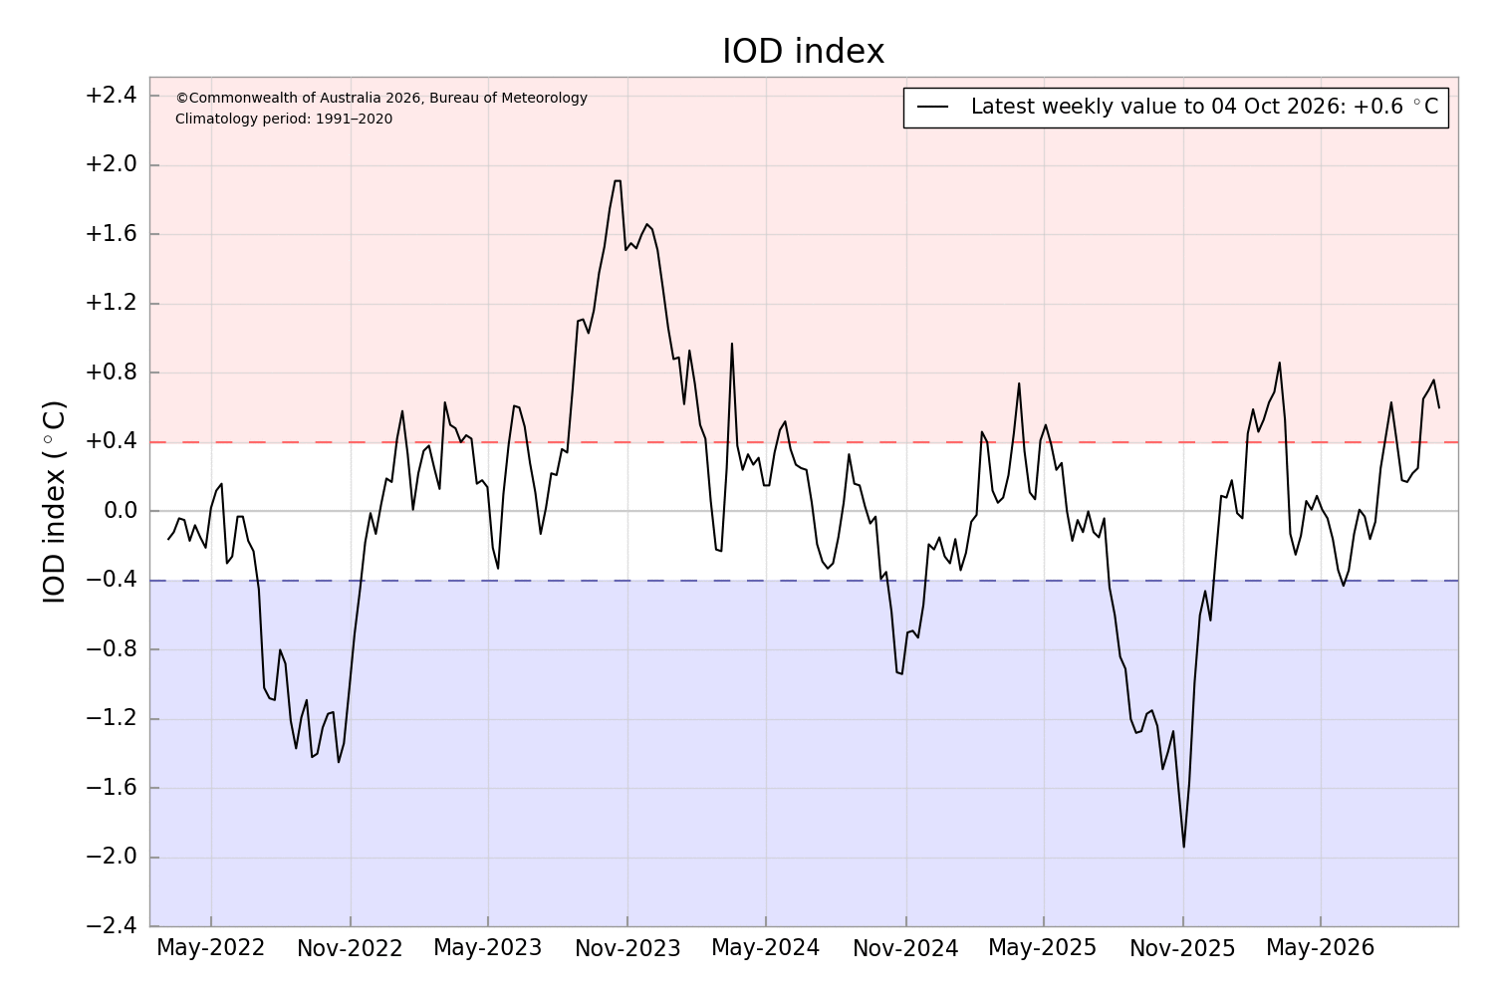  The Indian Ocean Dipole (IOD) is currently neutral.  While values have been positive for the last 3 weeks, they have not been sustained above the positive threshold (+0.4 °C). A positive IOD is likely to develop during the southern hemisphere spring and persist into early summer, although model guidance indicates some uncertainty in the strength and duration of the event.  To see larger versions of these images, go to Southern Hemisphere Monitoring Indian Ocean & Outlook IOD.
Southern Annular Mode (SAM)  Current outlook: Neutral  Southern Ocean Update  (As at 1 October 2026) | 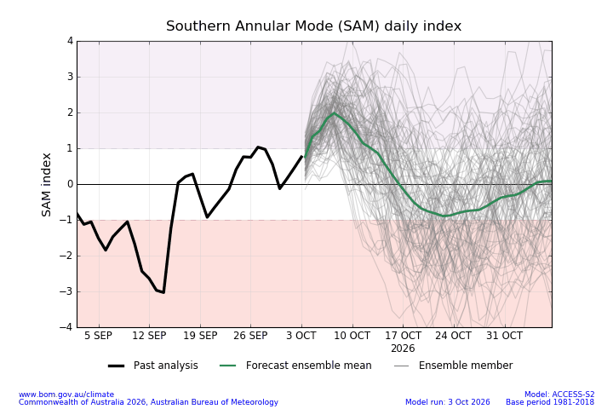  The SAM is currently neutral.  The Southern Annular Mode (SAM) index has been mostly negative during September. SAM is neutral as of 26 September. It is forecast to remain neutral during the next week.  To see larger versions of these images, go to Southern Hemisphere Monitoring Southern Ocean & Outlook SAM.
Seasonal Indicator | Comments (sourced from the Australian Bureau of Meteorology & the NT Department of Industry, Tourism & Trade)
Madden–Julian Oscillation (MJO)  Outlook: Moderate-weakening  Tropics Update  (As at 4 October 2026) | 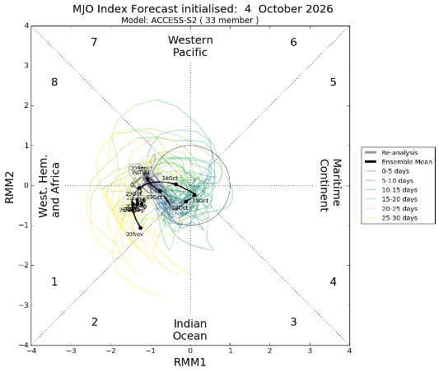  The MJO pulse is moderately strong.  The moderate Madden–Julian Oscillation (MJO) is currently in the Western Hemisphere. As of 4 October, forecasts indicate it is most likely to remain in this region and weaken over the coming week, largely influenced by the strong El Niño signal.
Wet Season Onset  Outlook 2026/27: Early  Northern Rainfall Onset Outlook  (As at 27 August 2026)  This is the final issue of the northern rainfall onset forecast for the 2026–27 season. | 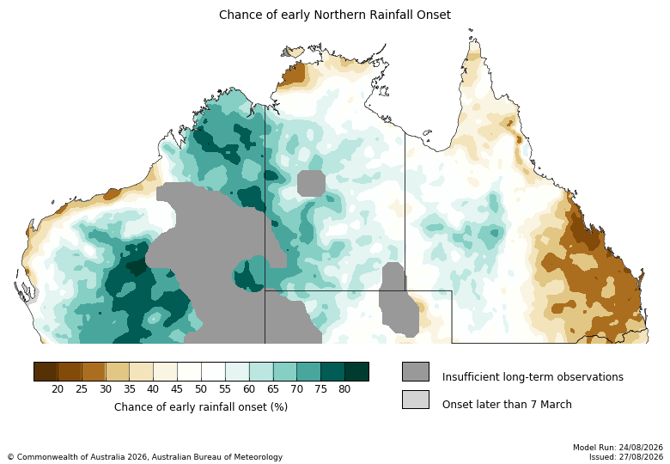  Average to early for much of NT, late in the Top End.  For most of the southern and central NT there is a 60–80% chance of an earlier than normal northern rainfall onset, particularly in the western half. However for northern coastal regions, particularly the north-west Top End including the Darwin region, rainfall onset is likely to be delayed, with a 60–75% chance of a later than normal northern rainfall onset predicted.  The northern rainfall onset date occurs when the rainfall total reaches 50 mm since the 1st of September. It is considered approximately the amount of rainfall required to stimulate plant growth.
Observations 2026/27  As at 6 October 2026 | 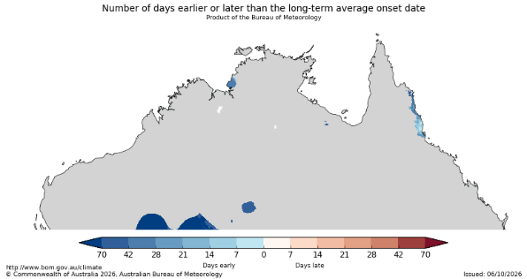  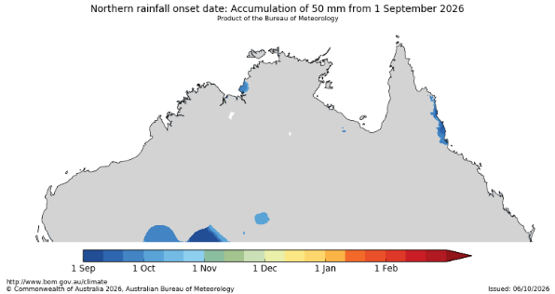  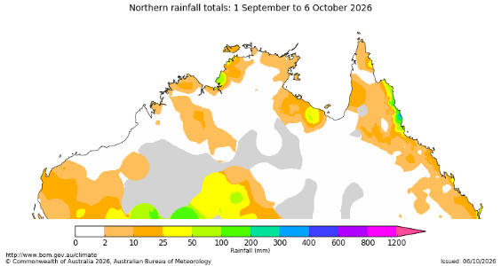  The onset observations can be found here

Darwin District

- The Darwin district is still experiencing typical, seasonally low pasture growth which is considered average for this time of year.
- Relative pasture biomass levels are varied and patchy but generally average to low over much of the district, particularly where fires have removed standing dry matter.
- Over the next 3 months, pasture growth is likely to be low to average over much of the district, with minor scattered areas of above average growth possible, particularly in the south-west of the district.
- 41% of the district has burnt since January 1st. 11% has burnt since July 1st 2026.
2026/27 Pasture Growth
0 kg/ha

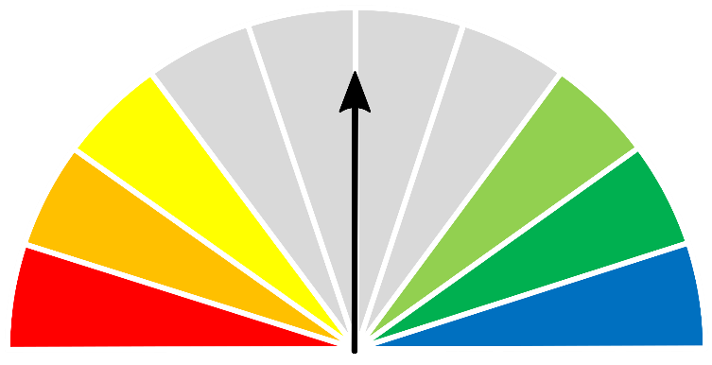


As at 1 October 2026
(% of district) | <1,000kg/ha | 1,000 - 2,000kg/ha | 2,000 - 3,000kg/ha | >3,000kg/ha
2026/2027  Pasture Growth | 100% | 0% | 0% | 0%
Total Standing Dry Matter | 67% | 30% | 3% | <1%

Median Pasture Growth (kg/ha)  (Running Total) | Total Standing Dry Matter at 1 October 2026  Relative to Historical Records (1957-now)
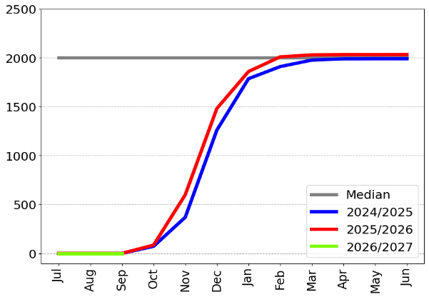 | 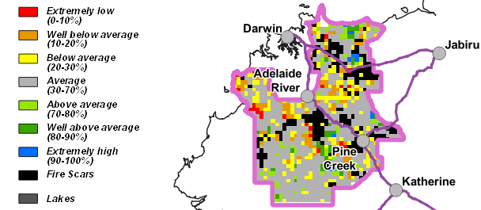

3-month Pasture Growth at 1 October 2026  Relative to Historical Records (1957-now) | Chance of Exceeding Median Pasture Growth  October - December 2026
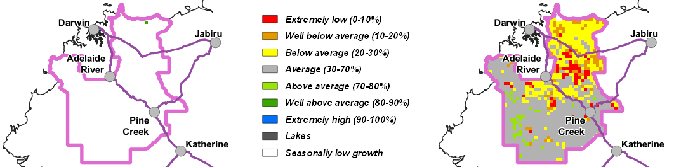

Katherine District

- The Katherine district is still experiencing typical, seasonally low pasture growth which is considered average for this time of year.
- While pasture biomass levels are still high in the south, the rest of the district is mostly low to average, particularly in the central regions where fires have removed standing dry matter.
- Over the next 3 months, pasture growth is predicted to be low to average across the entire district.
- 20% of the district has burnt since January 1st. 7% has burnt since July 1st 2026.
2026/27 Pasture Growth
0 kg/ha



As at 1 October 2026
(% of district) | <1,000kg/ha | 1,000 - 2,000kg/ha | 2,000 - 3,000kg/ha | >3,000kg/ha
2026/2027  Pasture Growth | 100% | 0% | 0% | 0%
Total Standing Dry Matter | 37% | 45% | 17% | 1%

Median Pasture Growth (kg/ha)  (Running Total) | Total Standing Dry Matter at 1 October 2026  Relative to Historical Records (1957-now)
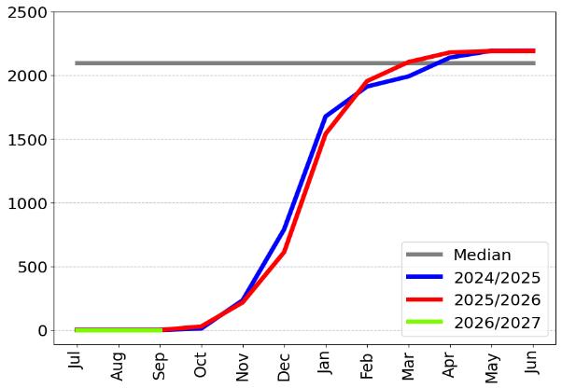 | 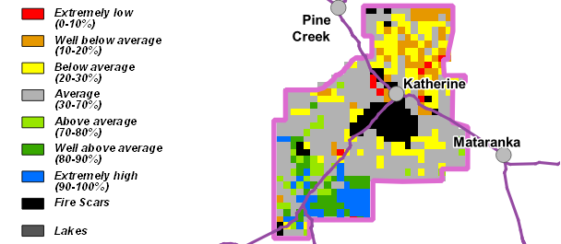

3-month Pasture Growth at 1 October 2026  Relative to Historical Records (1957-now) | Chance of Exceeding Median Pasture Growth  October - December 2026
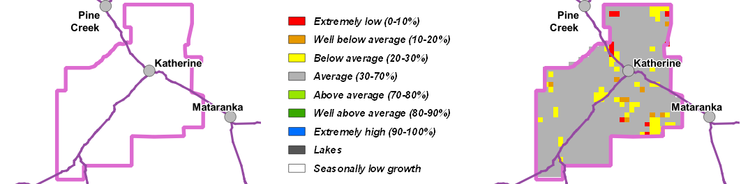

Victoria River District
- The Victoria River district is experiencing typical, seasonally low pasture growth which is considered average for this time of year.
- Pasture biomass levels are patchy across the district, varying from low where fires have removed standing dry matter, to very high.
- Over the next 3 months, pasture growth is likely to be low to average over much of the district, with possible scattered areas of above average growth.
- 13% of the district has burnt since January 1st. 6% has burnt since July 1st 2026.
2026/27 Pasture Growth
0 kg/ha



As at 1 October 2026
(% of district) | <1,000kg/ha | 1,000 - 2,000kg/ha |  | 2,000 - 3,000kg/ha | >3,000kg/ha
2026/2027  Pasture Growth | 100% | 0% |  | 0% | 0%
Total Standing Dry Matter | 8% | 48% |  | 27% | 17%
Median Pasture Growth (kg/ha)  (Running Total) |  | Total Standing Dry Matter at 1 October 2026  Relative to Historical Records (1957-now)
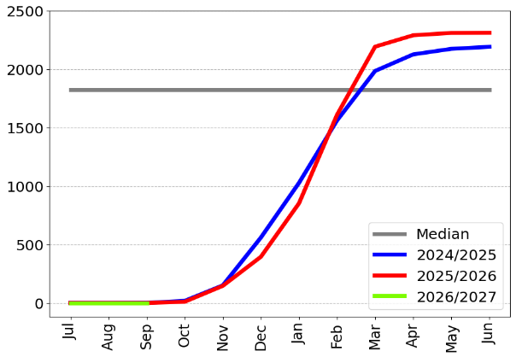 |  | 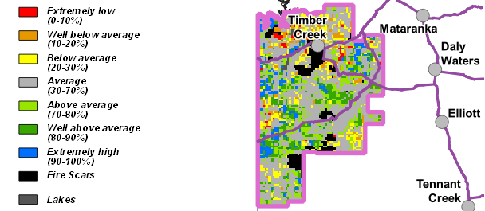
3-month Pasture Growth at 1 October 2026  Relative to Historical Records (1957-now) |  |  | Chance of Exceeding Median Pasture Growth  October - December 2026
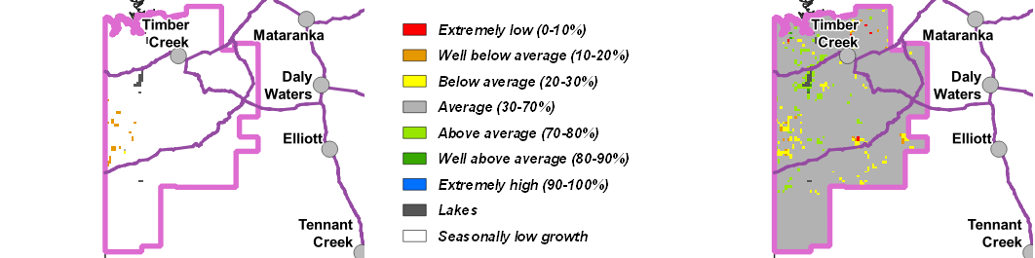

Sturt Plateau District
- The Sturt Plateau district is experiencing typical, seasonally low pasture growth over the entire district which is considered average for this time of year.
- Relative pasture biomass levels are generally still average to very high across most of the district.
- Over the next 3 months, pasture growth is likely to be average to slightly below average over most of the district.
- 5% of the district has burnt since January 1st. 3% has burnt since July 1st 2026.
2026/27 Pasture Growth
0 kg/ha

As at 1 October 2026
(% of district) | <1,000kg/ha | 1,000 - 2,000kg/ha | 2,000 - 3,000kg/ha | >3,000kg/ha
2026/2027  Pasture Growth | 100% | 0% | 0% | 0%
Total Standing Dry Matter | 6% | 78% | 11% | 5%
Median Pasture Growth (kg/ha)  (Running Total) |  | Total Standing Dry Matter at 1 October 2026  Relative to Historical Records (1957-now)
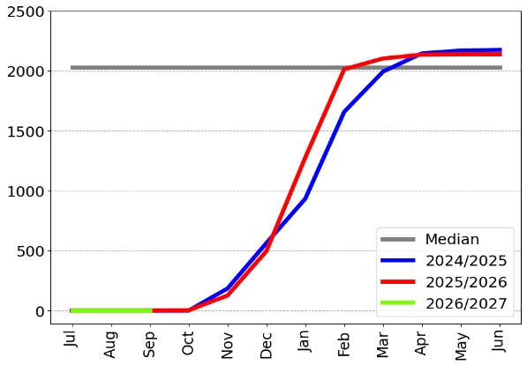 |  | 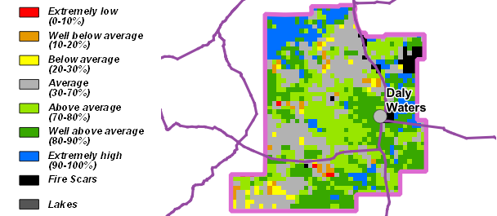

3-month Pasture Growth at 1 October 2026  Relative to Historical Records (1957-now) | Chance of Exceeding Median Pasture Growth  October - December 2026
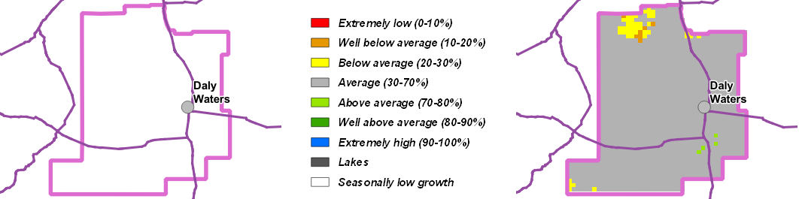

Roper District
- The Roper district is experiencing typical, seasonally low pasture growth over the entire district which is considered average for this time of year.
- Relative pasture biomass levels are varied & patchy ranging from low to very high. Dry season fires have also removed some large areas of standing dry matter across the district.
- Over the next 3 months, pasture growth is predicted to be generally low to average over most of the district.
- 25% of the district has burnt since January 1st. 12% has burnt since July 1st 2026.
2026/27 Pasture Growth
0 kg/ha



As at 1 October 2026
(% of district) | <1,000kg/ha | 1,000 - 2,000kg/ha | 2,000 - 3,000kg/ha | >3,000kg/ha
2026/2027  Pasture Growth | 100% | 0% | 0% | 0%
Total Standing Dry Matter | 17% | 48% | 28% | 7%

Median Pasture Growth (kg/ha)  (Running Total) | Total Standing Dry Matter at 1 October 2026  Relative to Historical Records (1957-now)
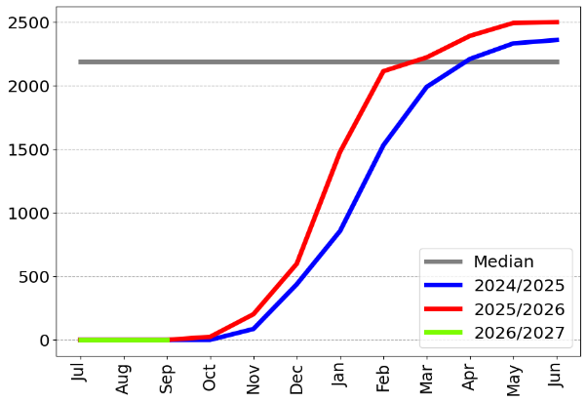 | 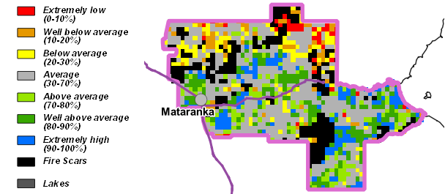

3-month Pasture Growth at 1 October 2026  Relative to Historical Records (1957-now) | Chance of Exceeding Median Pasture Growth  October - December 2026
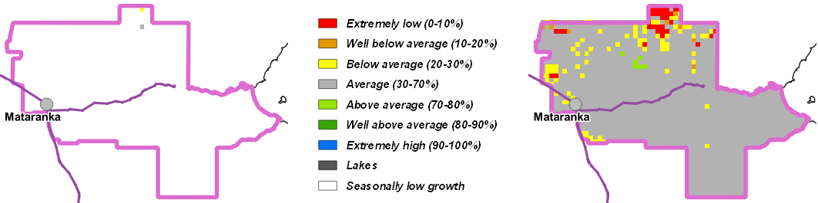

Gulf District
- The Gulf district is experiencing typical, seasonally low pasture growth over the entire district which is considered average for this time of year.
- Relative pasture biomass levels are varied & patchy ranging from low where fires have removed large areas of standing dry matter to very high, particularly in the western part of the district.
- Over the next 3 months, pasture growth is predicted to be generally average over most of the district.
- 25% of the district has burnt since January 1st. 17% has burnt since July 1st 2026.
2026/27 Pasture Growth
0 kg/ha

As at 1 October 2026
(% of district) | <1,000kg/ha | 1,000 - 2,000kg/ha | 2,000 - 3,000kg/ha | >3,000kg/ha
2026/2027  Pasture Growth | 100% | 0% | 0% | 0%
Total Standing Dry Matter | 15% | 49% | 21% | 15%

Median Pasture Growth (kg/ha)  (Running Total) | Total Standing Dry Matter at 1 October 2026  Relative to Historical Records (1957-now)
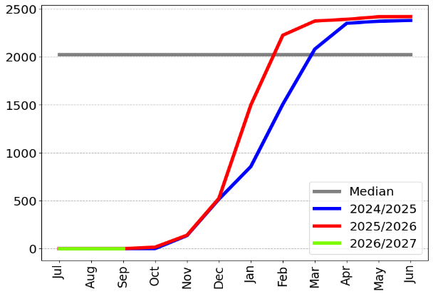 | 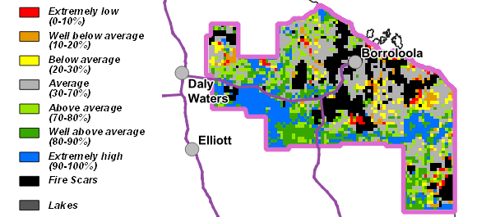

3-month Pasture Growth at 1 October 2026  Relative to Historical Records (1957-now) | Chance of Exceeding Median Pasture Growth  October - December 2026
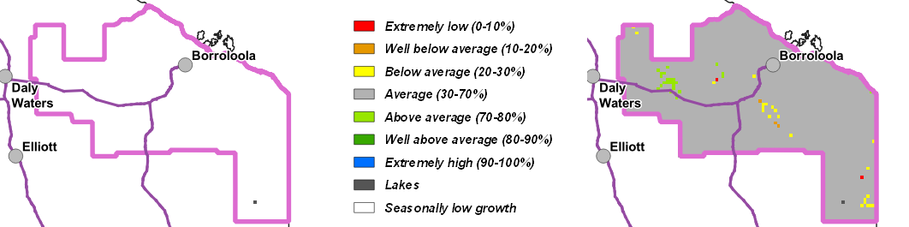

Barkly District
- The Barkly district is experiencing typical, seasonally low pasture growth over the entire district which is considered average for this time of year.
- Relative pasture biomass levels are still above average to extremely high over most of the district.
- Over the next 3 months, pasture growth is predicted to be generally average over most of the district, with some areas of above average growth possible along the south-west border.
- 3% of the district has burnt since January 1st. 1% has burnt since July 1st 2026.
2026/27 Pasture Growth
0 kg/ha



As at 1 October 2026
(% of district) | <250kg/ha | 250 – 500kg/ha | 500 – 1,000kg/ha | >1,000kg/ha
2026/2027  Pasture Growth | 100% | 0% | 0% | 0%
Total Standing Dry Matter | <1% | 1% | 12% | 87%

Median Pasture Growth (kg/ha)  (Running Total) | Total Standing Dry Matter at 1 October 2026  Relative to Historical Records (1957-now)
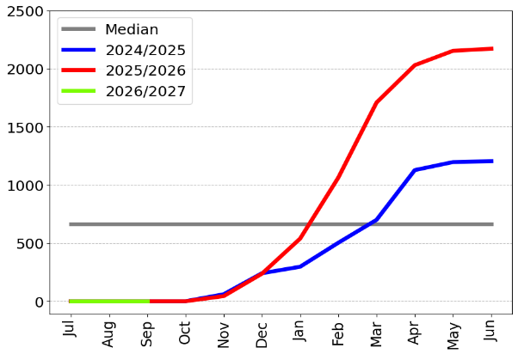 | 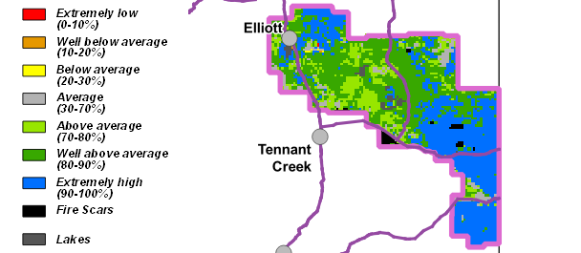

3-month Pasture Growth at 1 October 2026  Relative to Historical Records (1957-now) | Chance of Exceeding Median Pasture Growth  October - December 2026
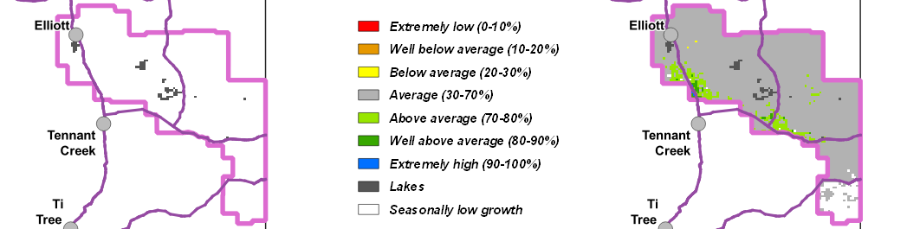

Tennant Creek District
- The Tennant Creek district is still experiencing typical, seasonally low pasture growth over most of the district, with isolated areas of above average to very high growth.
- While fires have removed large areas of standing dry matter in the north-east, relative pasture biomass levels are generally average to very high across most of the district.
- Pasture growth over the next 3 months is predicted to be generally average to above average over most of the district.
- 9% of the district has burnt since January 1st. 7% has burnt since July 1st 2026.
2026/27 Pasture Growth
20 kg/ha



As at 1 October 2026
(% of district) | <250kg/ha | 250 – 500kg/ha | 500 – 1,000kg/ha | >1,000kg/ha
2026/2027  Pasture Growth | 99% | <1% | <1% | 0%
Total Standing Dry Matter | 1% | 4% | 17% | 78%

Median Pasture Growth (kg/ha)  (Running Total) | Total Standing Dry Matter at 1 October 2026  Relative to Historical Records (1957-now)
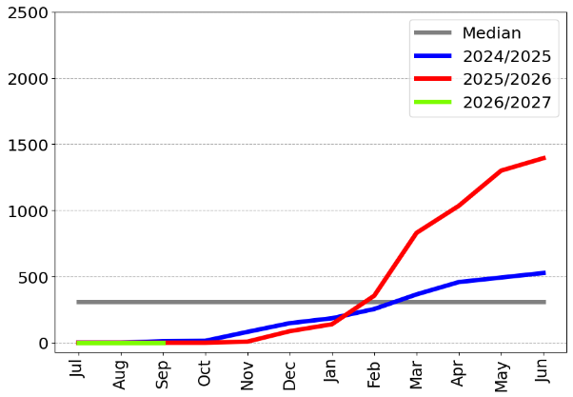 | 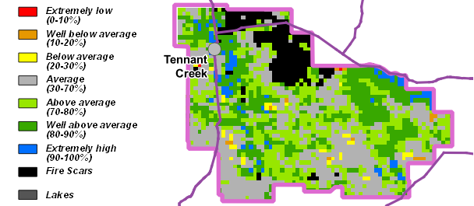

3-month Pasture Growth at 1 October 2026  Relative to Historical Records (1957-now) | Chance of Exceeding Median Pasture Growth  October - December 2026
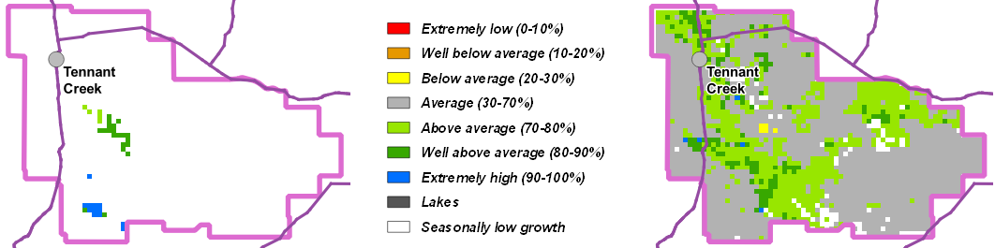

Northern Alice Springs District
- While much of the district is still experiencing seasonally low growth, the last 3 months have seen scattered areas of very high growth across the district.
- Relative pasture biomass levels are still above average to extremely high over much of the district, particularly across the south-east parts.
- Over the next 3 months, pasture growth is predicted to be average to above average over most of the district with scattered areas of extremely high growth.
- 3% of the district has burnt since January 1st. 2% has burnt since July 1st 2026.
2026/27 Pasture Growth
133 kg/ha
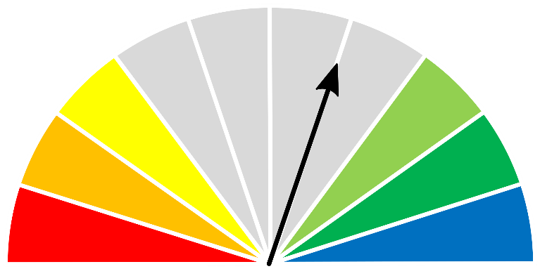


As at 1 October 2026
(% of district) | <1000kg/ha | 1000 – 1500kg/ha | 1500 – 2,000kg/ha | >2,000kg/ha
2026/2027  Pasture Growth | 97% | 3% | 0% | 0%
Total Standing Dry Matter | 4% | 10% | 25% | 61%

Median Pasture Growth (kg/ha)  (Running Total) | Total Standing Dry Matter at 1 October 2026  Relative to Historical Records (1957-now)
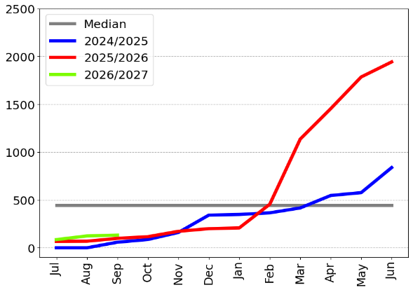 | 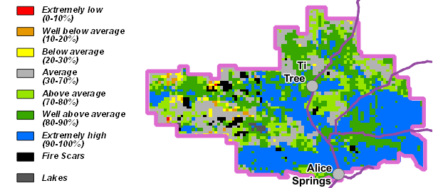

3-month Pasture Growth at 1 October 2026  Relative to Historical Records (1957-now) | Chance of Exceeding Median Pasture Growth  October - December 2026
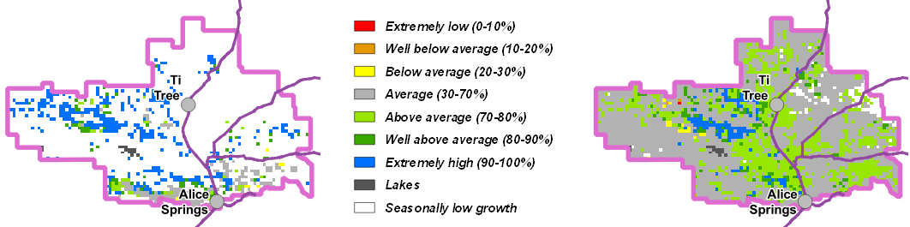

Plenty District
- While much of the district has experienced seasonally low growth over the last 3 months, there are some isolated areas of average to very high growth especially in the south of the district.
- Relative pasture biomass levels are generally above average to extremely high over most of the district.
- Over the next 3 months, pasture growth is likely to be generally average to above average over much of the district.
- Less than 1% of the district has burnt since January 1st. Less than 1% (28 km²) has burnt since July 1st 2026.
2026/27 Pasture Growth
74 kg/ha

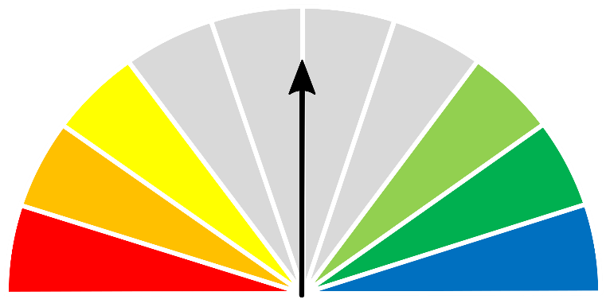


As at 1 October 2026
(% of district) | <1000kg/ha | 1000 – 1500kg/ha | 1500 – 2,000kg/ha | >2,000kg/ha
2026/2027  Pasture Growth | 100% | 0% | 0% | 0%
Total Standing Dry Matter | 5% | 6% | 22% | 67%

Median Pasture Growth (kg/ha)  (Running Total) | Total Standing Dry Matter at 1 October 2026  Relative to Historical Records (1957-now)
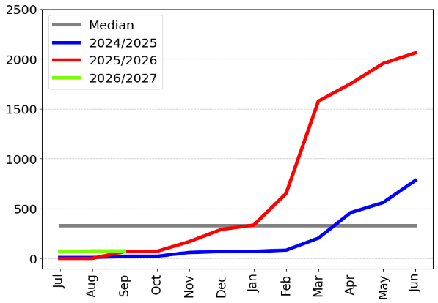 | 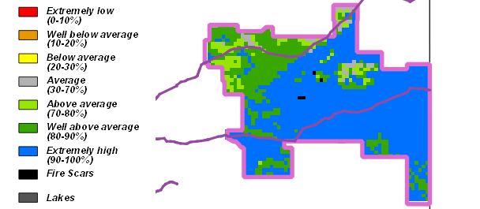

3-month Pasture Growth at 1 October 2026  Relative to Historical Records (1957-now) | Chance of Exceeding Median Pasture Growth  October - December 2026
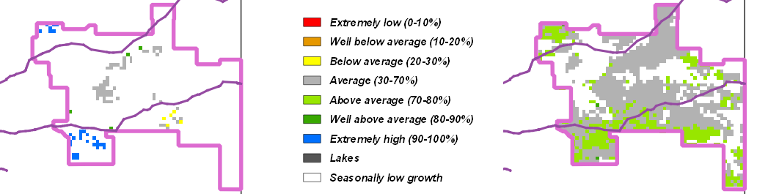

Southern Alice Springs District
- While much of the district has experienced seasonally low growth over the last 3 months, there are some isolated areas of average to very high growth across the district.
- Relative pasture biomass levels are average to extremely high over most of the district with some areas of below average standing dry matter in the western part of the district.
- Over the next 3 months, pasture growth is likely to be generally average to above average across much of the district.
- Less than 1% of the district has burnt since January 1st. (31 km²) has burnt since July 1st 2026.
2026/27 Pasture Growth
178 kg/ha

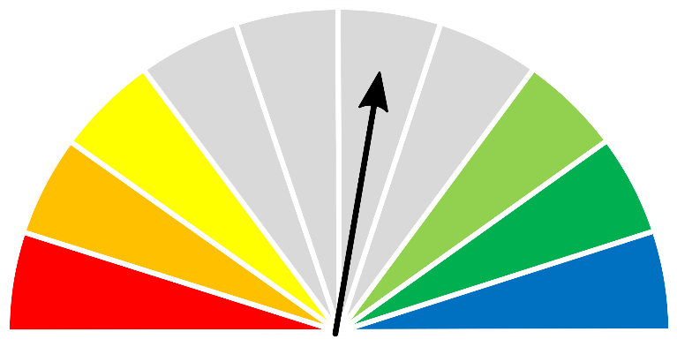

As at 1 October 2026
(% of district) | <250kg/ha | 250 – 500kg/ha | 500 – 1,000kg/ha | >1,000kg/ha
2026/2027  Pasture Growth | 59% | 30% | 10% | <1%
Total Standing Dry Matter | 1% | 9% | 20% | 70%

Median Pasture Growth (kg/ha)  (Running Total) | Total Standing Dry Matter at 1 October 2026  Relative to Historical Records (1957-now)
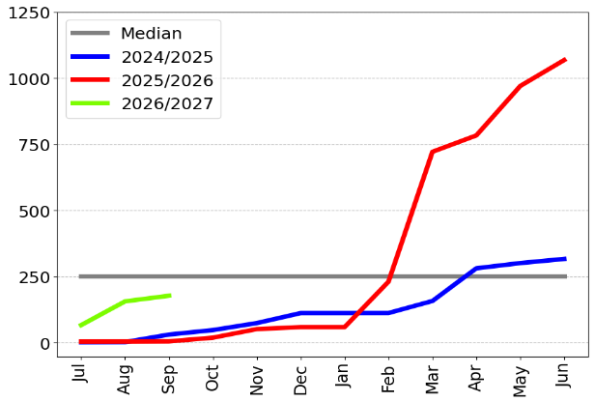 | 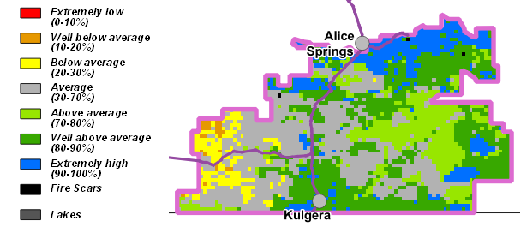

3-month Pasture Growth at 1 October 2026  Relative to Historical Records (1957-now) | Chance of Exceeding Median Pasture Growth  October - December 2026
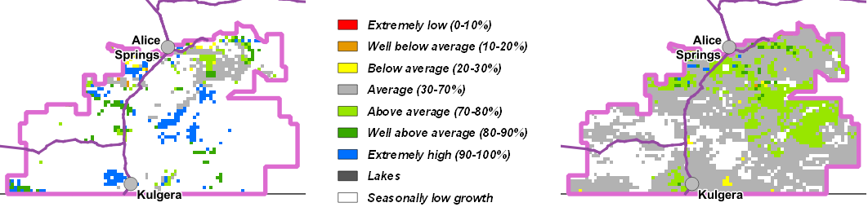

Pasture information
The pasture and grass fire risk information in this document is derived from AussieGRASS.
https://www.longpaddock.qld.gov.au/aussiegrass/
AussieGRASS is a model that simulates pasture growth and standing biomass using climate data, vegetation mapping, fire history and regional estimates of grazing pressure. The model can be used to track simulated pasture growth and total standing pasture biomass at the landscape scale.
Note that the model does not use stocking rate data for individual properties. Where stock numbers are significantly higher or lower than typical for a district, model estimates of total standing dry matter may be not reflect local conditions.
Fire scar data used to calculate percentage of districts burnt is derived from North Australia & Rangelands Fire Information (NAFI)
https://firenorth.org.au/nafi3/
Disclaimer
While all care has been taken to ensure that information contained in this document is true and correct at the time of production, changes in circumstances after the time of distribution may affect the accuracy of its information. The Northern Territory of Australia gives no warranty or assurance, and makes no representation as to the accuracy of any information or advice contained herein, or that it is suitable for your intended use.
You should not rely solely upon information in this document for the purpose of making business or investment decisions in relation to your particular situation.
The Northern Territory of Australia disclaims any liability or responsibility or duty of care towards any person for loss of damage caused by any use of or reliance on this information.

