The purpose of this quarterly outlook is to summarise information relevant to the pastoral industry such as current feed supplies, seasonal conditions, the development of drought conditions and relative fire risk. This edition summarises modelled pasture growth in July 2026.
You can subscribe to receive the Outlook here.
You can see the entire document and all districts by continuing to scroll through this file. If you are interested in selected sections you can click on the links below.
Summary of current situation & trends - all districts
Northern Territory Seasonal Outlook – as at July 2026

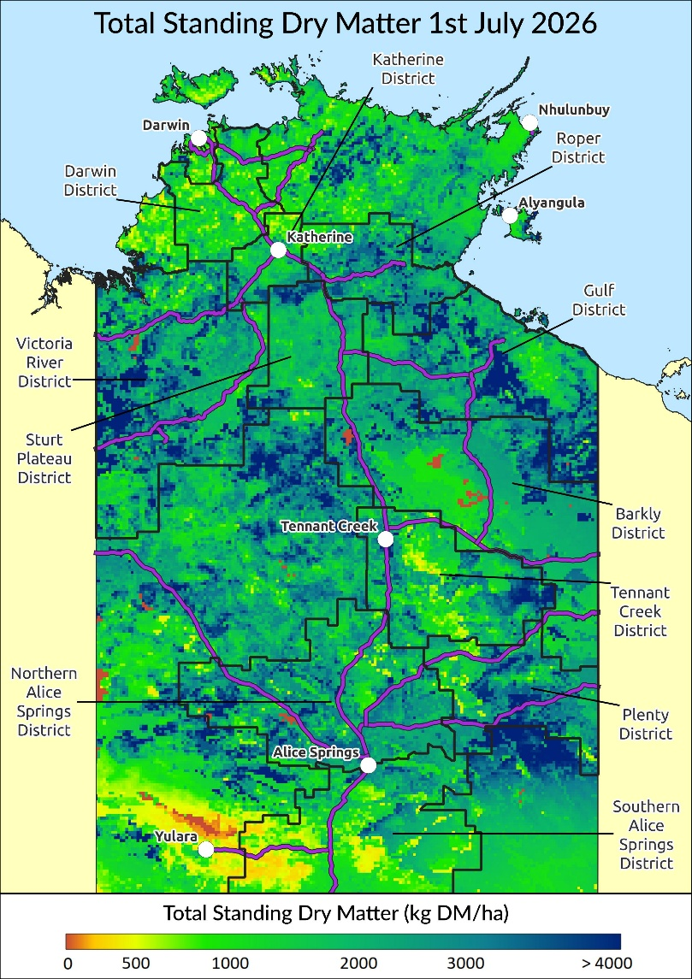
Individual District Summaries:
Darwin District
Katherine District
Victoria River District
Sturt Plateau District
Roper District
Gulf District
Barkly District
Tennant Creek District
Northern Alice Springs District
Plenty District
Southern Alice Springs District
For further information about this Outlook, please contact Chris Materne on 08 8951 8135.
All pasture data in this report is derived from AussieGRASS https://www.longpaddock.qld.gov.au/aussiegrass/

Summary of current situation and trends – all districts – July 2026
The 2025–2026 wet season concluded with area-averaged rainfall 56% above the long-term average, making it the seventh-wettest wet season on record across the Territory. May was cooler and wetter than average with mean maximum temperatures 0.96 °C below average and rainfall 48% above average. During mid-May, a north-west cloud band brought several days of unseasonable rainfall to the south of the NT. June was warmer and wetter than average, with mean maximum temperatures 1.65 °C above average and rainfall 7% above average. In mid-June, a significant cloud-band event brought unseasonal rainfall and thunderstorms across parts of the NT, with several locations recording their wettest June day on record.
Pasture growth for the 2025-2026 season finished above average for all pastoral districts with the Barkly and southern districts recording exceptionally high growth. Relative biomass is patchy but overall above average to high, particularly in the Barkly & Plenty districts.
Over the next 3 months, little to no pasture growth is predicted for the northern districts due to normal cool, dry seasonal conditions. Despite normal seasonal limitations, scattered, isolated areas of above average to high relative growth are possible for most of the southern pastoral districts.
With potentially high fuel loads associated with above average pasture growth and biomass, fire risk is moderate to high across all pastoral districts.
There is an active El Niño event underway with models forecasting further warming in the tropical Pacific over coming months.
KEY | Green = low risk |  |  |  |  |  | Orange = watch |  |  |  |  |  | Red = high risk
KEY |  | ↑ = increasing trend |  |  |  |  |  | ↓ = decreasing trend |  |  |  |  |  | ↔ = steady
 |  | Northern Territory Pastoral Districts
Indicator |  | Darwin | Katherine | VRD | Sturt Plateau | Roper |  |  | Gulf | Barkly | Tennant Creek | Northern Alice Springs |  |  | Plenty | Southern Alice Springs | Comments
2025/26 total pasture growth |  | ↑ | ↑ | ↑ | ↑ | ↑ |  |  | ↑ | ↑ | ↑ | ↑ |  |  | ↑ | ↑ | Arrows indicate trend compared to the long-term median (for this time of year)
Current estimated standing biomass |  | ↓ | ↓ | ↓ | ↓ | ↓ |  |  | ↓ | ↔ | ↑ | ↑ |  |  | ↑ | ↑ | Arrows indicate trend since previous quarter
Current fire risk |  | ↑ | ↑ | ↑ | ↑ | ↑ |  |  | ↑ | ↑ | ↑ | ↑ |  |  | ↑ | ↑ | Arrows indicate the trend since previous quarter
Current seasonal outlook |  | ↔ | ↔ | ↓ | ↓ | ↔ |  |  | ↔ | ↓ | ↓ | ↓ |  |  | ↓ | ↓ | Arrows indicate the trend since previous quarter and taking into account the forecasted model predictions

Northern Territory Seasonal Outlook as at July 2026*
Sourced from the Australian Bureau of Meteorology (BoM)
*This seasonal outlook was correct at the time of publication. For the most up-to-date seasonal outlook, please go to the Climate Outlook section of the BoM website.
The BoM outlook for August 2026 to October 2026 indicates that:
- The chance of exceeding the median rainfall between August & October 2026 is above average to high (55-80%) in the south-west NT. For the rest of the NT, particularly the north-west Top End, there is a low likelihood of wetter than average conditions (decreases to 25-40%). Past outlook accuracy for this time of year is moderate to high (50-100%), but rainfall is usually very low across the NT this time of year (0-25mm).
- Maximum temperatures are likely to be warmer than average in the southern NT and western Top End. Past outlook accuracy for this time of year is good to high (65-100%).
- Warmer than average nights are also likely for the entire NT with moderate to high past outlook accuracy (55-100%).
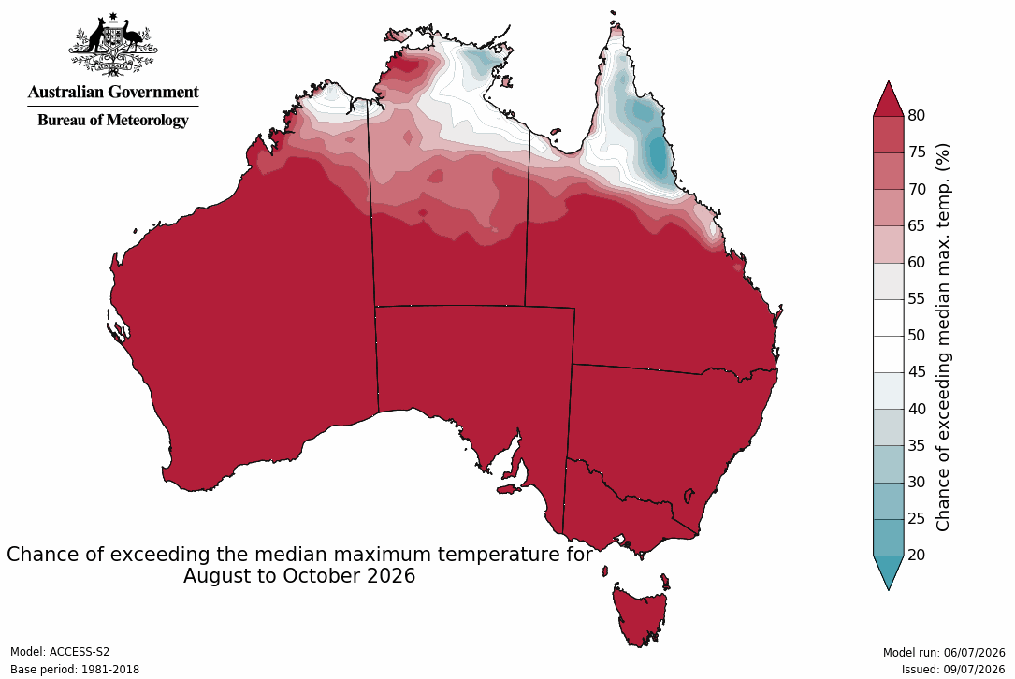
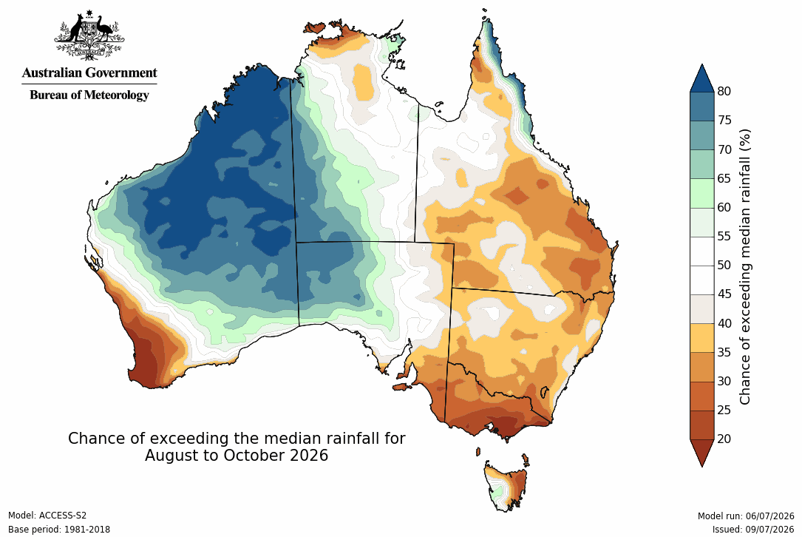

Influencing Climate drivers

- This forecast reflects the status and forecasts for several climate drivers, including positive ENSO, neutral SAM and a potential positive IOD event.
Climate Influences | Comments (sourced from the Australian Bureau of Meteorology)
El Niño Southern Oscillation (ENSO) positive  Pacific Ocean Update  (As at 14 July 2026)  *From December 2024 the Bureau of Meteorology is no longer issuing (ENSO) Outlook Watch and Alert statements including the ENSO dial. | The El Niño–Southern Oscillation (ENSO) is currently positive.  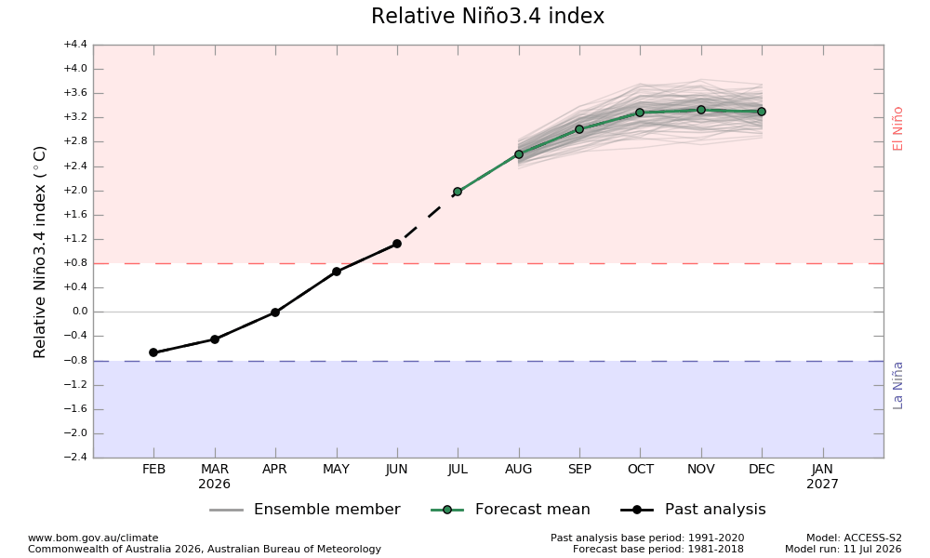  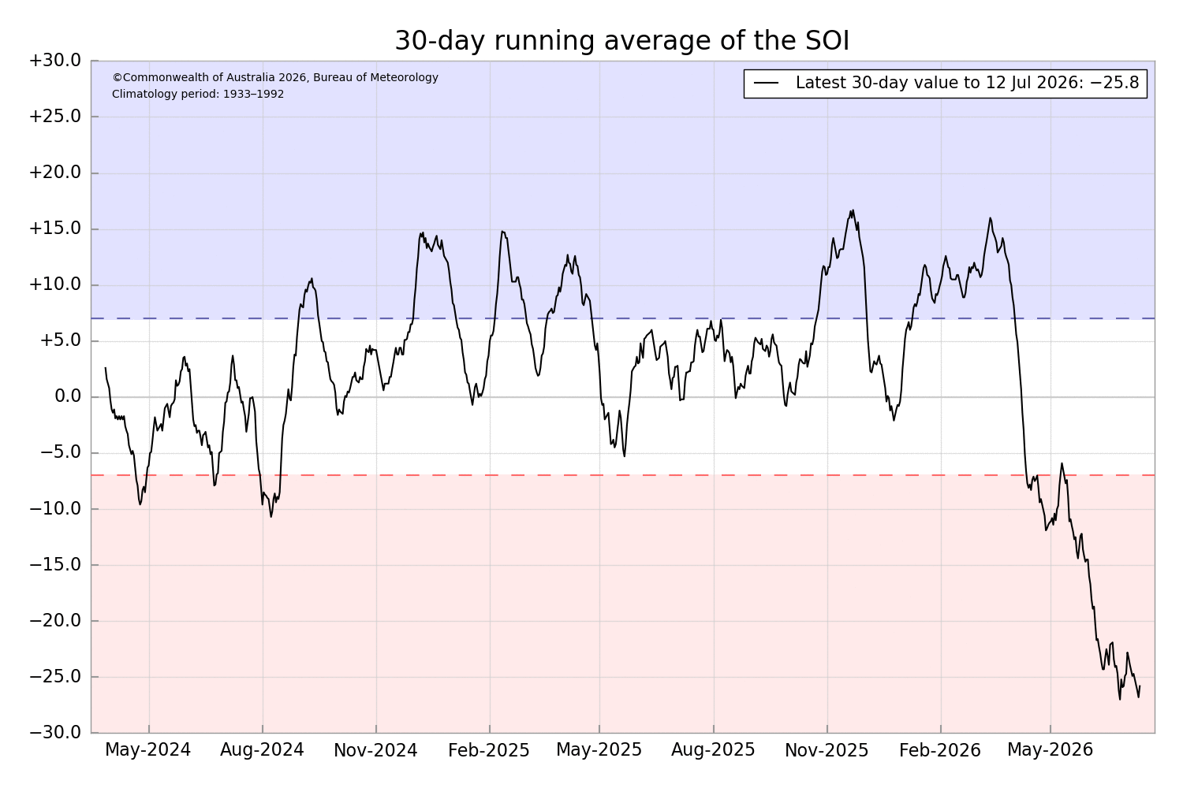  El Niño is underway. Sea surface temperatures (SSTs) in the central tropical Pacific are above El Niño thresholds, and atmospheric indicators are also consistent with an El Niño state. The latest relative Niño3.4 index value for the week ending 12 July 2026 is +1.47 °C, well above the El Niño threshold (+0.80 °C) and warming by around 0.2 °C over the past fortnight. All models forecast the tropical Pacific to continue warming in the coming months.  To see larger versions of these images, go to Southern Hemisphere Monitoring Pacific Ocean & Outlook Niño 3.4.
Indian Ocean Dipole (IOD)  Current outlook: Neutral  Indian Ocean Update  (As at 14 July 2026) | 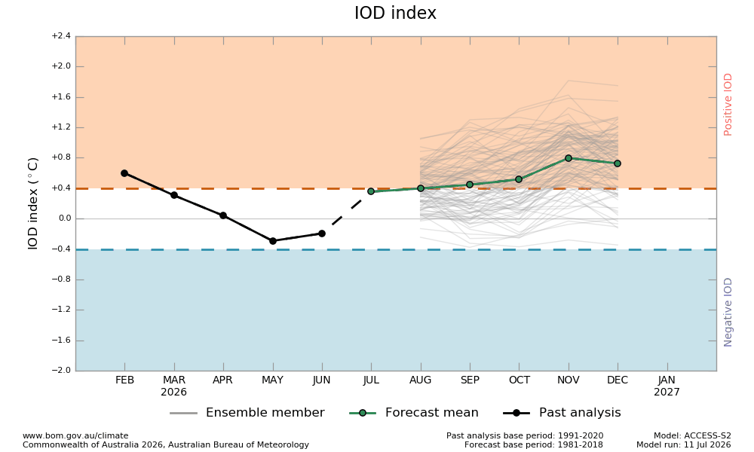  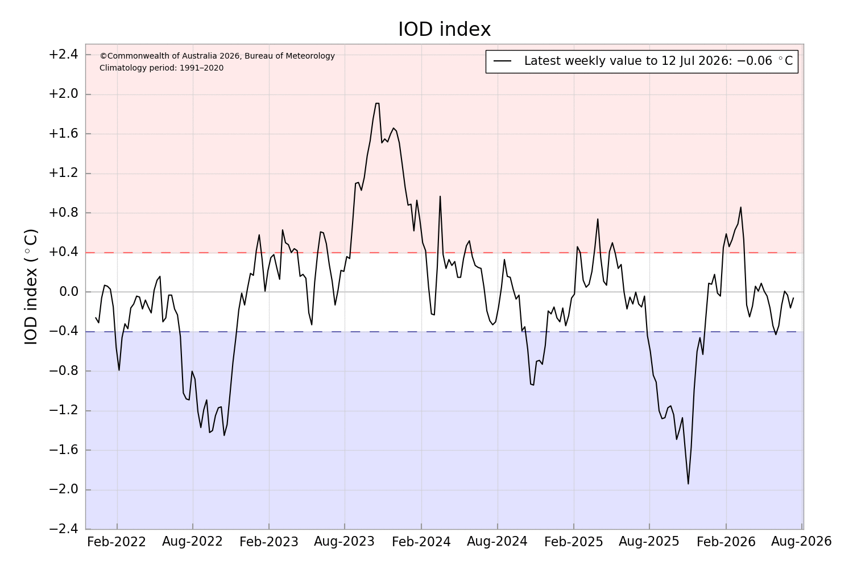  The Indian Ocean Dipole (IOD) is currently neutral.  The Indian Ocean Dipole (IOD) is currently neutral. As of 12 July 2026, the weekly IOD index is −0.06 °C. Models suggest a positive IOD event is likely in the southern hemisphere winter-spring. However, model forecasts show a large variation in both the timing and strength of this potential event.  To see larger versions of these images, go to Southern Hemisphere Monitoring Indian Ocean & Outlook IOD.
Southern Annular Mode (SAM)  Current outlook: Neutral  Southern Ocean Update  (As at 14 July 2026) | 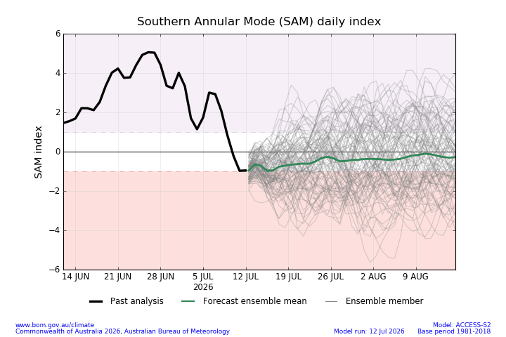  The SAM is currently neutral.  The Southern Annular Mode (SAM) index is trending back to neutral after a prolonged strongly positive phase since late May, with near-record high monthly average values in June. A positive SAM in winter pushes westerly rain-bearing westerly winds in the Southern Ocean further south than usual causing drier conditions in parts of southern Australia but increasing the chance of wet onshore flow for the east coast. The impact on the NT climate is typically minimal.  To see larger versions of these images, go to Southern Hemisphere Monitoring Southern Ocean & Outlook SAM.
Seasonal Indicator | Comments (sourced from the Australian Bureau of Meteorology & the NT Department of Industry, Tourism & Trade)
Madden–Julian Oscillation (MJO)  Outlook: Moderately Strong  Tropics Update  (As at 14 July 2026) | 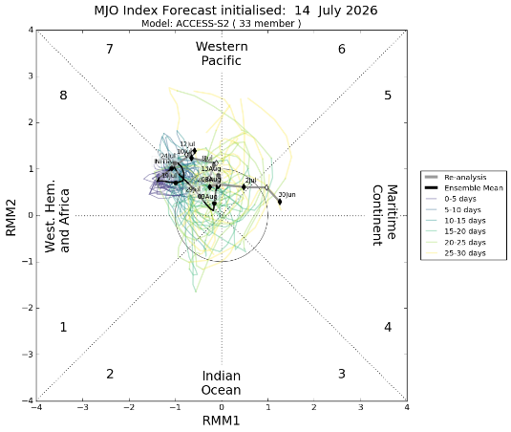  The MJO pulse is moderately strong.  The moderately strong pulse of Madden–Julian Oscillation (MJO) has been relatively stationary in the western Pacific over the past week. This pattern is likely a dominance of westerly winds in the western Pacific from the current El Niño pattern, rather than an active MJO pulse. Most models forecast this pattern to continue into late July.
Wet Season Onset  Outlook 2026/27: Early  Northern Rainfall Onset Outlook  (As at 16 July 2026)  Next Update: 30 July 2026 | 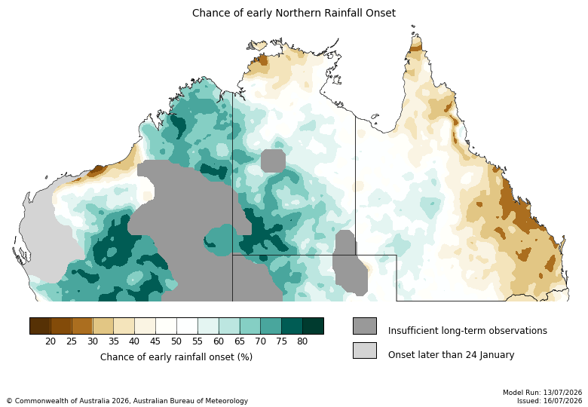  Average to early for much of NT, late in the Top End.  For most of the southern and central NT there is a 60–80% chance of an earlier than normal northern rainfall onset. However the Top End onset timing is predicted to be average to later than usual, particularly northern NT coastal regions, where there is a 60–75% chance of a later than normal northern rainfall onset.  The northern rainfall onset date occurs when the rainfall total reaches 50 mm since the 1st of September. It is considered approximately the amount of rainfall required to stimulate plant growth.
Observations 2025/26  (As at 31 May 2026 for the previous wet season) | 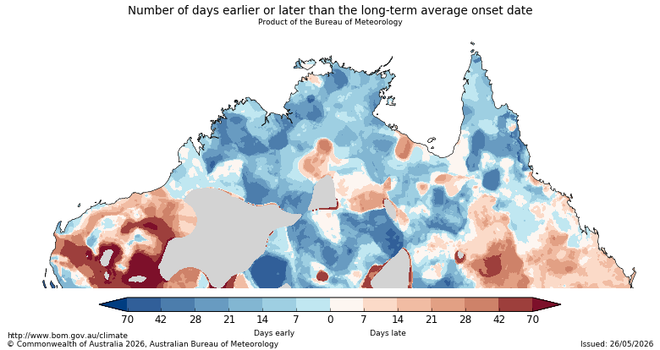  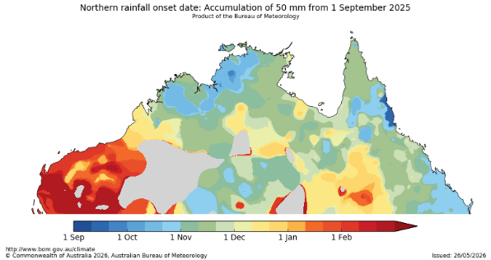  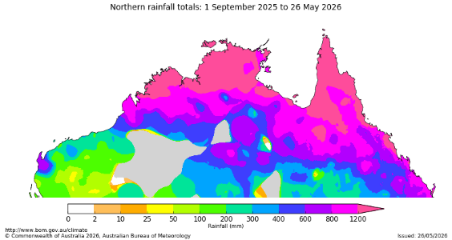  The onset observations can be found here

Darwin District

- Pasture growth in 2025/2026 was above average. While 12-month relative growth varied across the district, annual variability is typically low because growth tends to be constrained by nitrogen availability rather than rainfall. This is reflected in the cumulative growth total, which finished close to the long-term median.
- Relative biomass levels are low over large parts of the district where fires have removed standing dry matter and varied and patchy over the rest of the district.
- As expected for this time of year, no further growth is predicted until wet season rainfall onset.
- 31% of the district has burnt since January 1st. Less than 1% has burnt since July 1st 2026.
2025/26 Pasture Growth

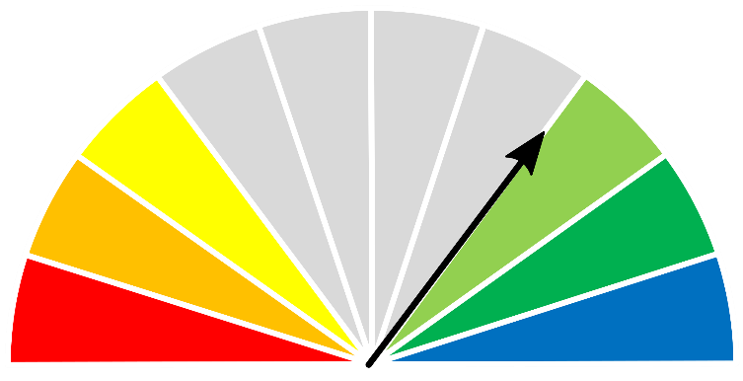
2032 kg/ha


As at 1 July 2026
(% of district) | <1,000kg/ha | 1,000 - 2,000kg/ha | 2,000 - 3,000kg/ha | >3,000kg/ha
2025/2026  Pasture Growth | 0% | 47% | 48% | 5%
Total Standing Dry Matter | 19% | 67% | 12% | 2%

Median Pasture Growth (kg/ha)  (Running Total) | Total Standing Dry Matter at 1 July 2026  Relative to Historical Records (1957-now)
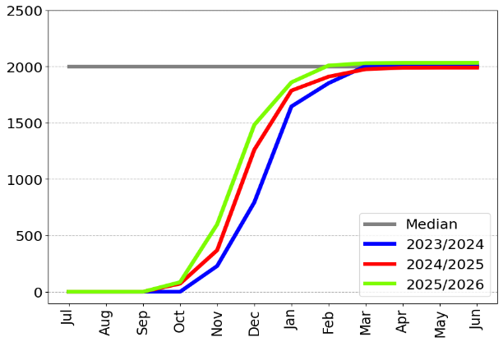 | 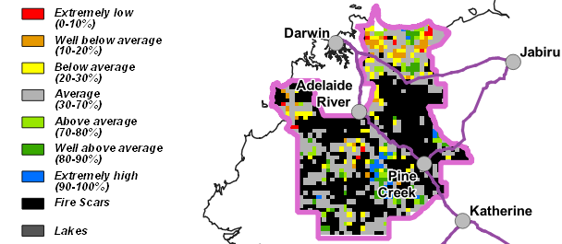

12-month Pasture Growth at 1 July 2026  Relative to Historical Records (1957-now) | Chance of Exceeding Median Pasture Growth  July - September 2026
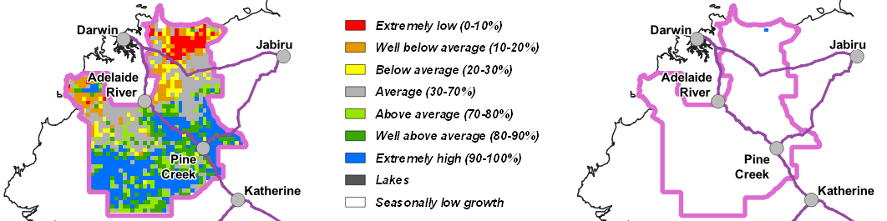

Katherine District

- Pasture growth in 2025/2026 was above average. While 12-month relative growth varied across the district, annual variability is typically low because growth tends to be constrained by nitrogen availability rather than rainfall. This is reflected in the cumulative growth total, which finished slightly above the long-term median.
- While biomass levels are still high in the south of the district, the rest of the district is low to average, particularly in the north where fires have removed standing dry matter.
- As expected for this time of year, no further growth is predicted until wet season rainfall onset.
- 13% of the district has burnt since January 1st. Less than 1% has burnt since July 1st 2026.
2025/26 Pasture Growth

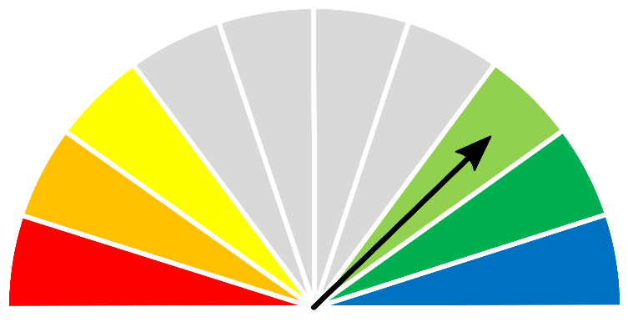
2190 kg/ha


As at 1 July 2026
(% of district) | <1,000kg/ha | 1,000 - 2,000kg/ha | 2,000 - 3,000kg/ha | >3,000kg/ha
2025/2026  Pasture Growth | 0% | 28% | 68% | 4%
Total Standing Dry Matter | 11% | 47% | 33% | 9%

Median Pasture Growth (kg/ha)  (Running Total) | Total Standing Dry Matter at 1 July 2026  Relative to Historical Records (1957-now)
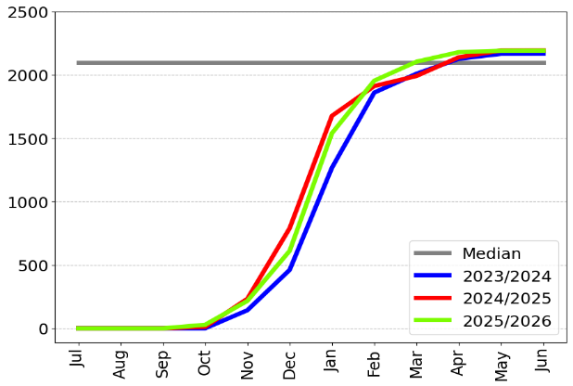 | 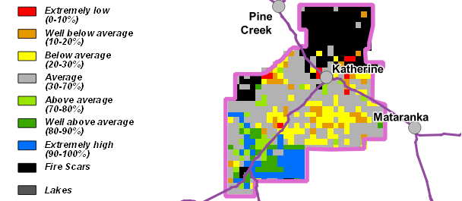

12-month Pasture Growth at 1 July 2026  Relative to Historical Records (1957-now) | Chance of Exceeding Median Pasture Growth  July - September 2026
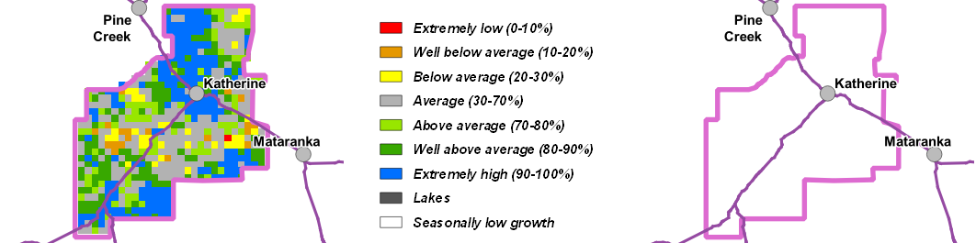

Victoria River District
- Pasture growth for the 2025/2026 season finished well above average. Relative growth varied from average to extremely high across most of the district.
- Pasture biomass levels are patchy across the district, varying from low where fires have removed standing dry matter, to very high.
- As expected for this time of year, no further growth is predicted until wet season rainfall onset.
- 7% of the district has burnt since January 1st. Less than 1% has burnt since July 1st 2026.
2025/26 Pasture Growth

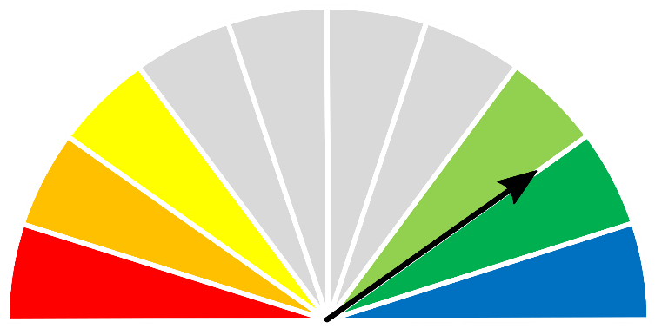
2310 kg/ha



As at 1 July 2026
(% of district) | <1,000kg/ha | 1,000 - 2,000kg/ha |  | 2,000 - 3,000kg/ha | >3,000kg/ha
2025/2026  Pasture Growth | <1% | 27% |  | 64% | 9%
Total Standing Dry Matter | 1% | 28% |  | 42% | 29%
Median Pasture Growth (kg/ha)  (Running Total) |  | Total Standing Dry Matter at 1 July 2026  Relative to Historical Records (1957-now)
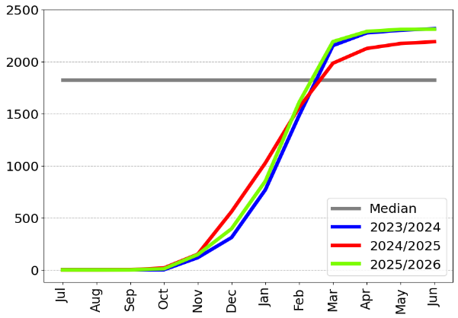 |  | 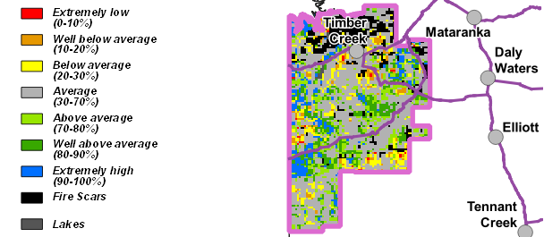
12-month Pasture Growth at 1 July 2026  Relative to Historical Records (1957-now) |  |  | Chance of Exceeding Median Pasture Growth  July - September 2026
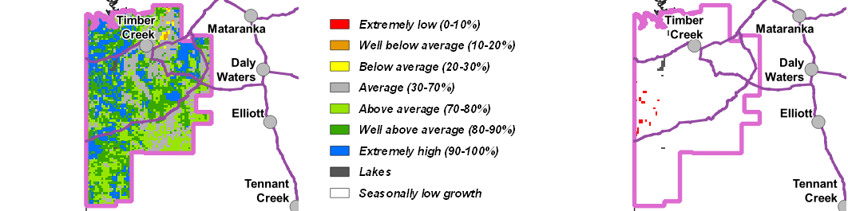

Sturt Plateau District
- Pasture growth for the 2025/2026 season finished above average. Relative growth varied from average to extremely high across most of the district.
- Relative biomass levels are generally low to very high across most of the district with some scattered areas where fires have removed standing dry matter.
- As expected for this time of year, no further growth is predicted until wet season rainfall onset.
- 2% of the district has burnt since January 1st. Less than 1% has burnt since July 1st 2026.
2025/26 Pasture Growth

2138 kg/ha

As at 1 July 2026
(% of district) | <1,000kg/ha | 1,000 - 2,000kg/ha | 2,000 - 3,000kg/ha | >3,000kg/ha
2025/2026  Pasture Growth | 0% | 28% | 67% | 5%
Total Standing Dry Matter | 1% | 42% | 46% | 11%
Median Pasture Growth (kg/ha)  (Running Total) |  | Total Standing Dry Matter at 1 July 2026  Relative to Historical Records (1957-now)
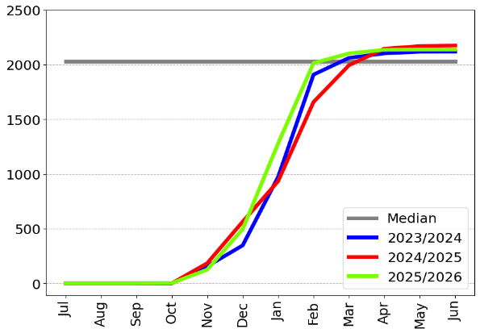 |  | 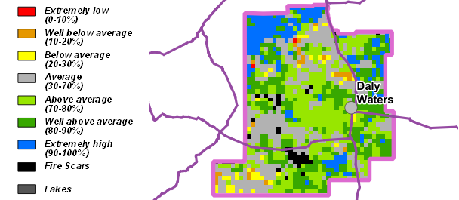

12-month Pasture Growth at 1 July 2026  Relative to Historical Records (1957-now) | Chance of Exceeding Median Pasture Growth  July - September 2026
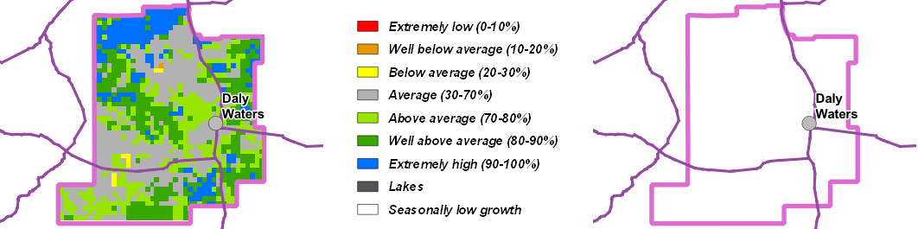

Roper District
- Pasture growth for the 2025/2026 season finished well above average with large areas of extremely high growth across much of the district.
- Relative pasture biomass levels are varied & patchy ranging from low to very high. Fires have removed large areas of standing dry matter, particularly in the northern half of the district.
- As expected for this time of year, little to no further growth is predicted until wet season rainfall onset.
- 15% of the district has burnt since January 1st. 2% has burnt since July 1st 2026.
2025/26 Pasture Growth

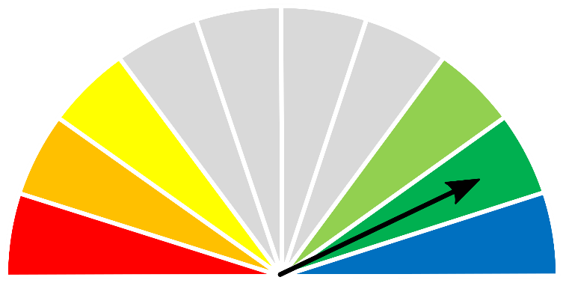
2499 kg/ha


As at 1 July 2026
(% of district) | <1,000kg/ha | 1,000 - 2,000kg/ha | 2,000 - 3,000kg/ha | >3,000kg/ha
2025/2026  Pasture Growth | 0% | 12% | 74% | 14%
Total Standing Dry Matter | 3% | 23% | 49% | 25%

Median Pasture Growth (kg/ha)  (Running Total) | Total Standing Dry Matter at 1 July 2026  Relative to Historical Records (1957-now)
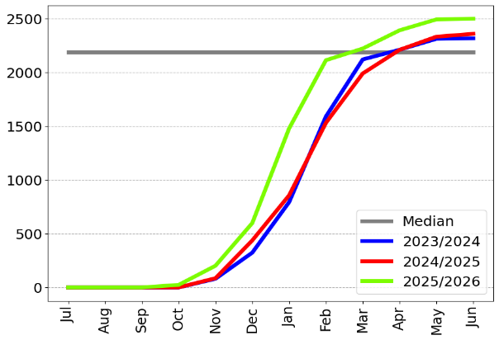 | 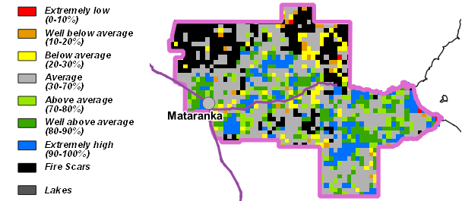

12-month Pasture Growth at 1 July 2026  Relative to Historical Records (1957-now) | Chance of Exceeding Median Pasture Growth  July - September 2026
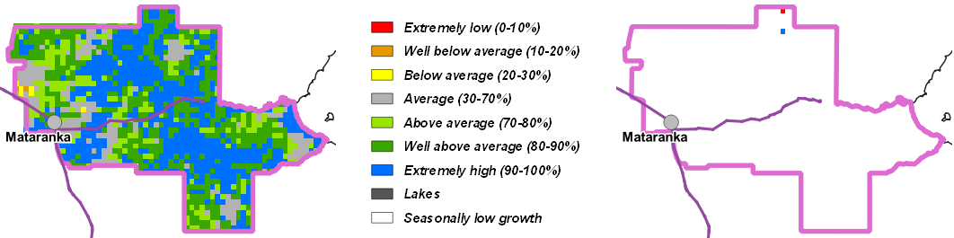

Gulf District
- Pasture growth was well above average for the 2025/2026 season, with widespread areas of extremely high growth, particularly in the southern half of the district.
- Relative pasture biomass levels are varied & patchy ranging from low where fires have removed large areas of standing dry matter to very high, particularly in the western part of the district.
- As expected for this time of year, little to no further growth is predicted until wet season rainfall onset.
- 8% of the district has burnt since January 1st. 1% has burnt since July 1st 2026.
2025/26 Pasture Growth

2419 kg/ha


As at 1 July 2026
(% of district) | <1,000kg/ha | 1,000 - 2,000kg/ha | 2,000 - 3,000kg/ha | >3,000kg/ha
2025/2026  Pasture Growth | 0% | 16% | 67% | 17%
Total Standing Dry Matter | 1% | 24% | 43% | 32%

Median Pasture Growth (kg/ha)  (Running Total) | Total Standing Dry Matter at 1 July 2026  Relative to Historical Records (1957-now)
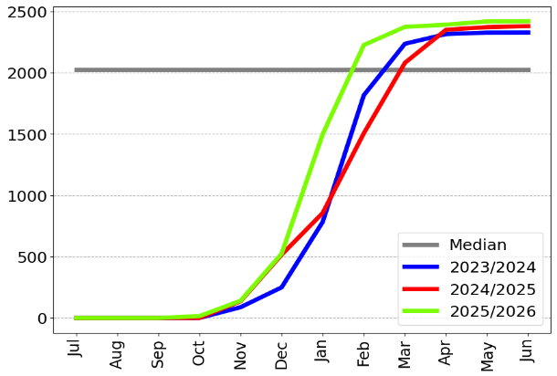 | 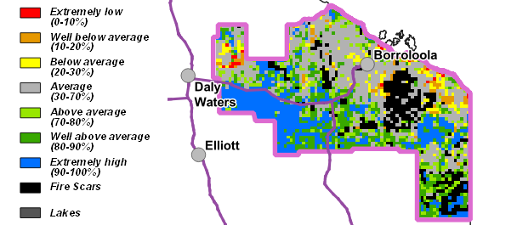

12-month Pasture Growth at 1 July 2026  Relative to Historical Records (1957-now) | Chance of Exceeding Median Pasture Growth  July - September 2026
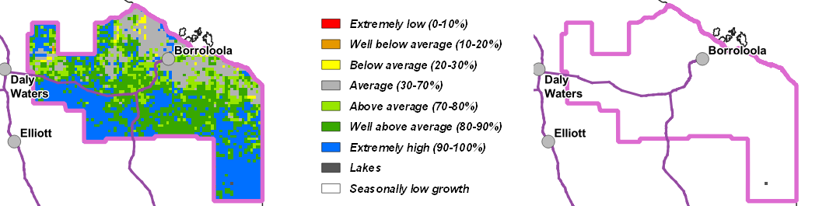

Barkly District
- Relative pasture growth for the 2025/2026 season finished extremely high over much of the district. Cumulative median total growth also finished extremely high in comparison to the long-term median.
- Relative pasture biomass levels are also above average to extremely high over most of the district.
- As expected for this time of year, no further growth is predicted until wet season rainfall onset.
- 1% of the district has burnt since January 1st. There have been no fires in the district since July 1st 2026.
2025/26 Pasture Growth

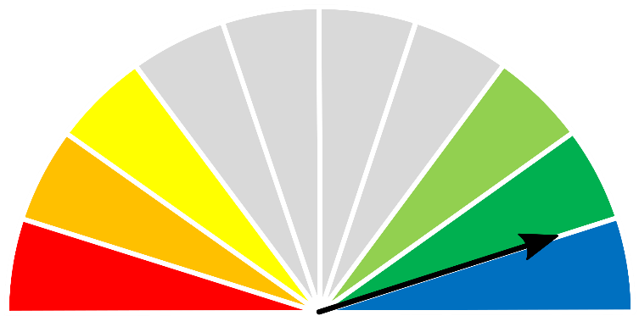
2171 kg/ha


As at 1 July 2026
(% of district) | <1,000kg/ha | 1,000 – 2,000kg/ha | 2,000 – 3,000kg/ha | >3,000kg/ha
2025/2026  Pasture Growth | 1% | 36% | 60% | 3%
Total Standing Dry Matter | 1% | 34% | 50% | 15%

Median Pasture Growth (kg/ha)  (Running Total) | Total Standing Dry Matter at 1 July 2026  Relative to Historical Records (1957-now)
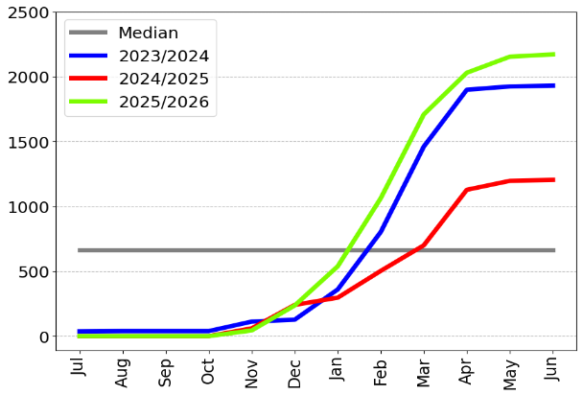 | 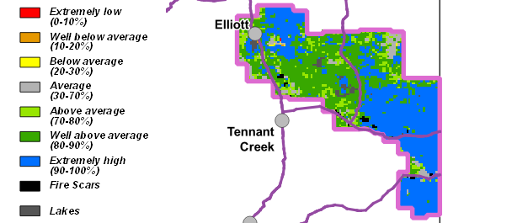

12-month Pasture Growth at 1 July 2026  Relative to Historical Records (1957-now) | Chance of Exceeding Median Pasture Growth  July - September 2026
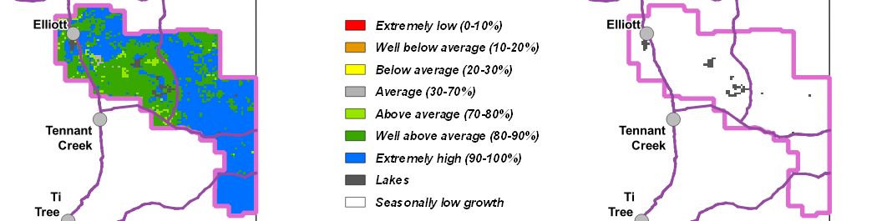

Tennant Creek District
- Relative pasture growth in the Tennant Creek district finished well above average for the 2025/2026 season. Cumulative median total growth also finished well above the long-term median.
- Relative pasture biomass levels are patchy across the district, varying from low to very high.
- Although pasture growth over the next 3 months is typically low, small, isolated areas of extremely high growth are possible, particularly in the western half of the district.
- 2% of the district has burnt since January 1st. There have been no fires in the district since July 1st 2026.
2025/26 Pasture Growth

1394 kg/ha


As at 1 July 2026
(% of district) | <1,000kg/ha | 1,000 – 1,500kg/ha | 1,500 – 2,000kg/ha | >2,000kg/ha
2025/2026  Pasture Growth | 18% | 41% | 21% | 20%
Total Standing Dry Matter | 11% | 15% | 21% | 53%

Median Pasture Growth (kg/ha)  (Running Total) | Total Standing Dry Matter at 1 July 2026  Relative to Historical Records (1957-now)
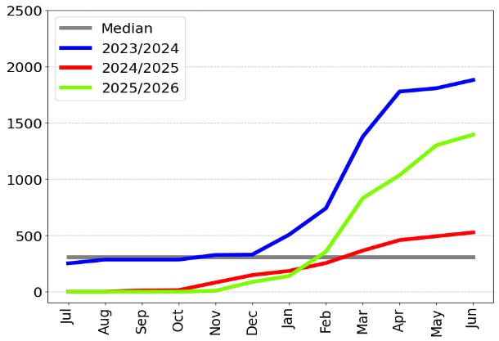 | 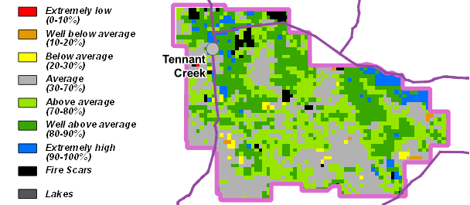

12-month Pasture Growth at 1 July 2026  Relative to Historical Records (1957-now) | Chance of Exceeding Median Pasture Growth  July - September 2026
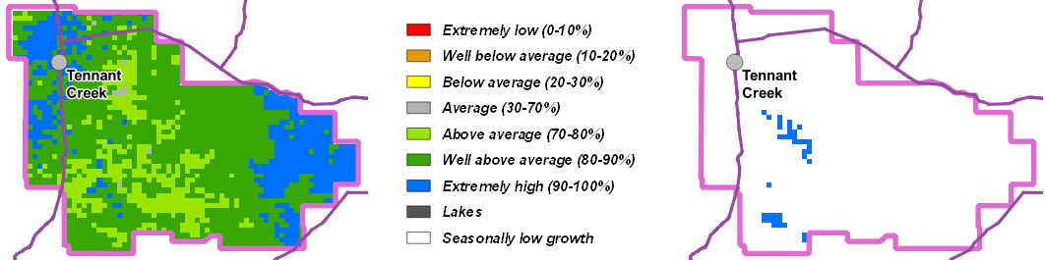

Northern Alice Springs District
- Relative pasture growth for the 2025/2026 season finished above average to extremely high over most of the district. Cumulative median total growth also finished extremely high in comparison to the long-term median.
- Relative biomass levels are generally average to extremely high over most of the district.
- Over the next three months, pasture growth is likely to be low across most of the district due to seasonal limitations. However, scattered areas of very high growth are possible.
- 1% of the district has burnt since January 1st. There have been no fires in the district since July 1st 2026.
2025/26 Pasture Growth

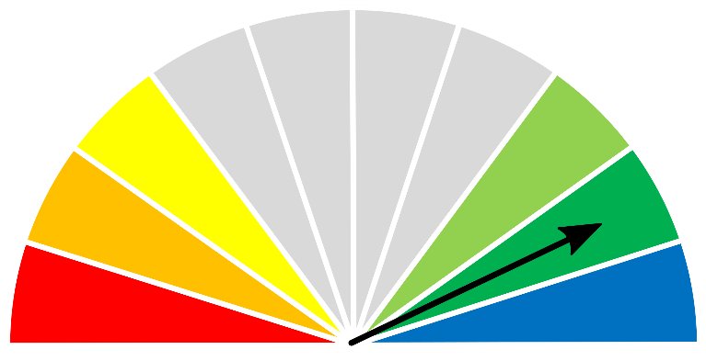
1943 kg/ha


As at 1 July 2026
(% of district) | <1,000kg/ha | 1,000 – 1,500kg/ha | 1,500 – 2,000kg/ha | >2,000kg/ha
2025/2026  Pasture Growth | 17% | 24% | 12% | 47%
Total Standing Dry Matter | 4% | 8% | 13% | 75%

Median Pasture Growth (kg/ha)  (Running Total) | Total Standing Dry Matter at 1 July 2026  Relative to Historical Records (1957-now)
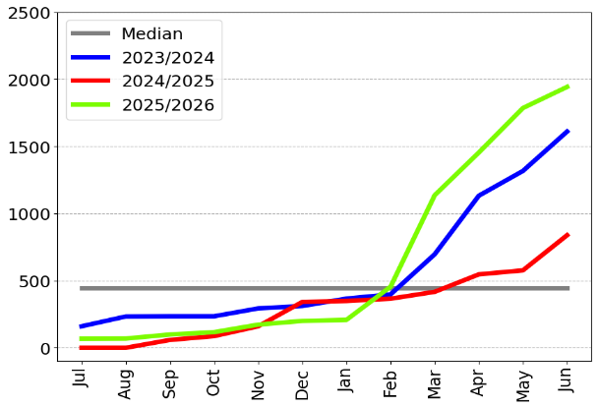 | 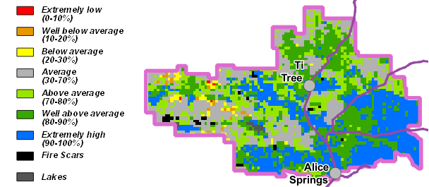

12-month Pasture Growth at 1 July 2026  Relative to Historical Records (1957-now) | Chance of Exceeding Median Pasture Growth  July - September 2026
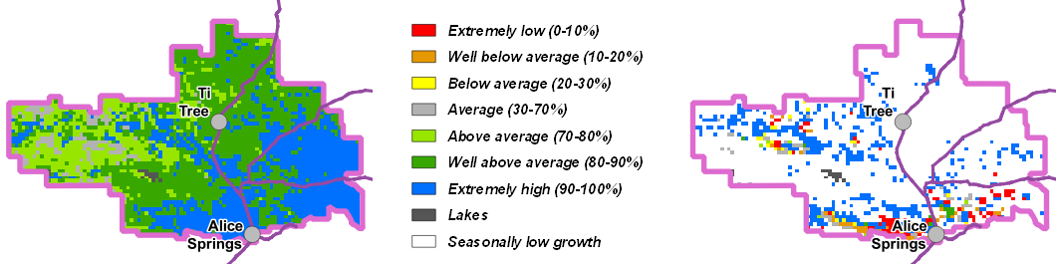

Plenty District
- Relative pasture growth for the 2025/2026 season finished extremely high over much of the district. Cumulative median total growth also finished extremely high in comparison to the long-term median.
- Relative pasture biomass levels are generally above average to extremely high over most of the district.
- Over the next three months, pasture growth is likely to be low across much of the district due to seasonal limitations. However, small areas of very high growth are possible, mainly in the western half of the district.
- Less than 1% of the district has burnt since January 1st. There have been no fires in the district since July 1st 2026.
2025/26 Pasture Growth

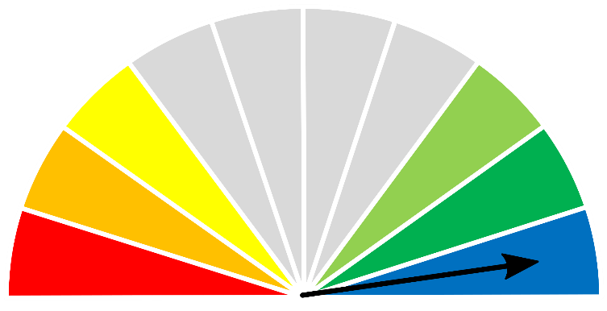
2060 kg/ha


As at 1 July 2026
(% of district) | <1,000kg/ha | 1,000 – 1,500kg/ha | 1,500 – 2,000kg/ha | >2,000kg/ha
2025/2026  Pasture Growth | 16% | 12% | 19% | 53%
Total Standing Dry Matter | 5% | 6% | 13% | 76%

Median Pasture Growth (kg/ha)  (Running Total) | Total Standing Dry Matter at 1 July 2026  Relative to Historical Records (1957-now)
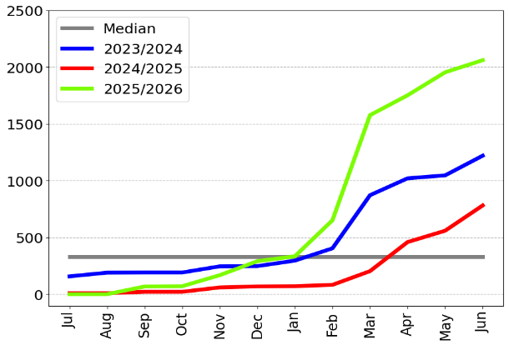 | 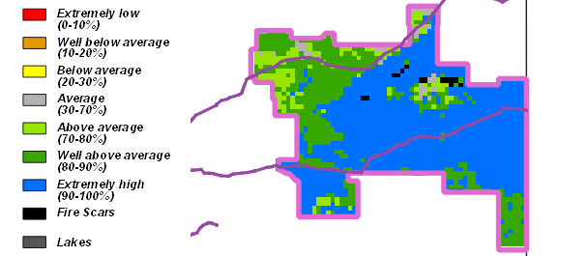

12-month Pasture Growth at 1 July 2026  Relative to Historical Records (1957-now) | Chance of Exceeding Median Pasture Growth  July - September 2026
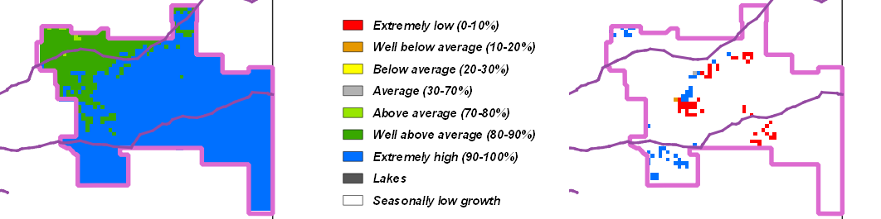

Southern Alice Springs District
- Relative pasture growth for the 2025/2026 season finished well above average to extremely high over much of the district. Cumulative median total growth also finished extremely high in comparison to the long-term median.
- Relative pasture biomass levels are average to extremely high over most of the district with scattered areas of below average standing dry matter in the western part of the district.
- Although pasture growth over the next 3 months is typically low, scattered areas of high growth is possible across the district.
- Less than 1% of the district has burnt since January 1st. There have been no fires in the district since July 1st 2026.
2025/26 Pasture Growth

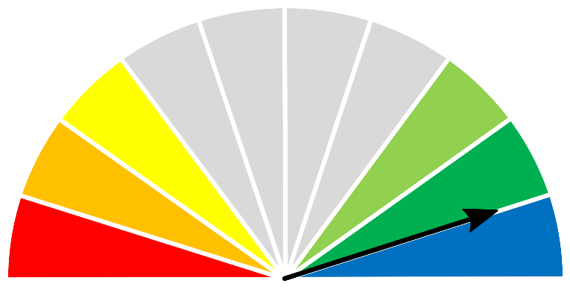
1068 kg/ha


As at 1 July 2026
(% of district) | <500kg/ha | 500 - 1,000kg/ha | 1,000 – 1,500kg/ha | >1,500kg/ha
2025/2026  Pasture Growth | 29% | 14% | 37% | 20%
Total Standing Dry Matter | 11% | 20% | 24% | 45%

Median Pasture Growth (kg/ha)  (Running Total) | Total Standing Dry Matter at 1 July 2026  Relative to Historical Records (1957-now)
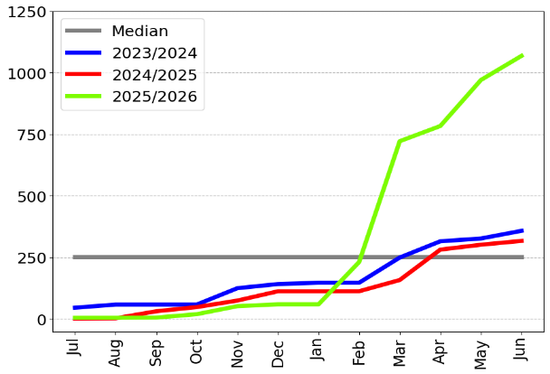 | 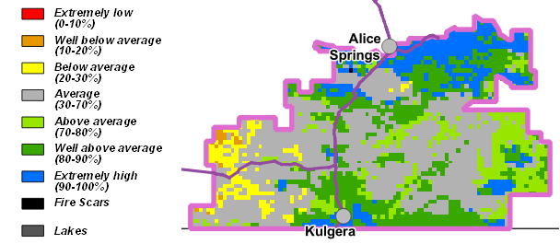

12-month Pasture Growth at 1 July 2026  Relative to Historical Records (1957-now) | Chance of Exceeding Median Pasture Growth  July - September 2026
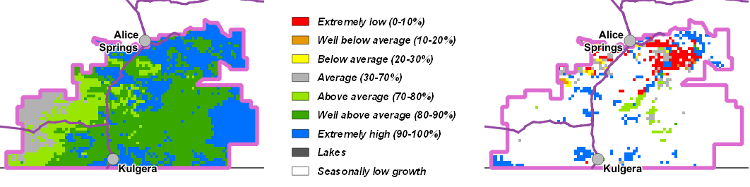

Pasture information
The pasture and grass fire risk information in this document is derived from AussieGRASS.
https://www.longpaddock.qld.gov.au/aussiegrass/
AussieGRASS is a model that simulates pasture growth and standing biomass using climate data, vegetation mapping, fire history and regional estimates of grazing pressure. The model can be used to track simulated pasture growth and total standing pasture biomass at the landscape scale.
Note that the model does not use stocking rate data for individual properties. Where stock numbers are significantly higher or lower than typical for a district, model estimates of total standing dry matter may be not reflect local conditions.
Fire scar data used to calculate percentage of districts burnt is derived from North Australia & Rangelands Fire Information (NAFI)
https://firenorth.org.au/nafi3/
Disclaimer
While all care has been taken to ensure that information contained in this document is true and correct at the time of production, changes in circumstances after the time of distribution may affect the accuracy of its information. The Northern Territory of Australia gives no warranty or assurance, and makes no representation as to the accuracy of any information or advice contained herein, or that it is suitable for your intended use.
You should not rely solely upon information in this document for the purpose of making business or investment decisions in relation to your particular situation.
The Northern Territory of Australia disclaims any liability or responsibility or duty of care towards any person for loss of damage caused by any use of or reliance on this information.

