The purpose of this quarterly outlook is to summarise information relevant to the pastoral industry such as current feed supplies, seasonal conditions, the development of drought conditions and relative fire risk. This edition summarises modelled pasture growth in January 2025.  
You can subscribe to receive the Outlook [here](https://daf.nt.gov.au/publications/agriculture/newsletters/northern-territory-pastoral-feed-outlook).

You can see the entire document and all districts by continuing to scroll through this file. If you are interested in selected sections you can click on the links below.

Summary of current situation & trends - all districts

Northern Territory Seasonal Outlook – as at January 2025

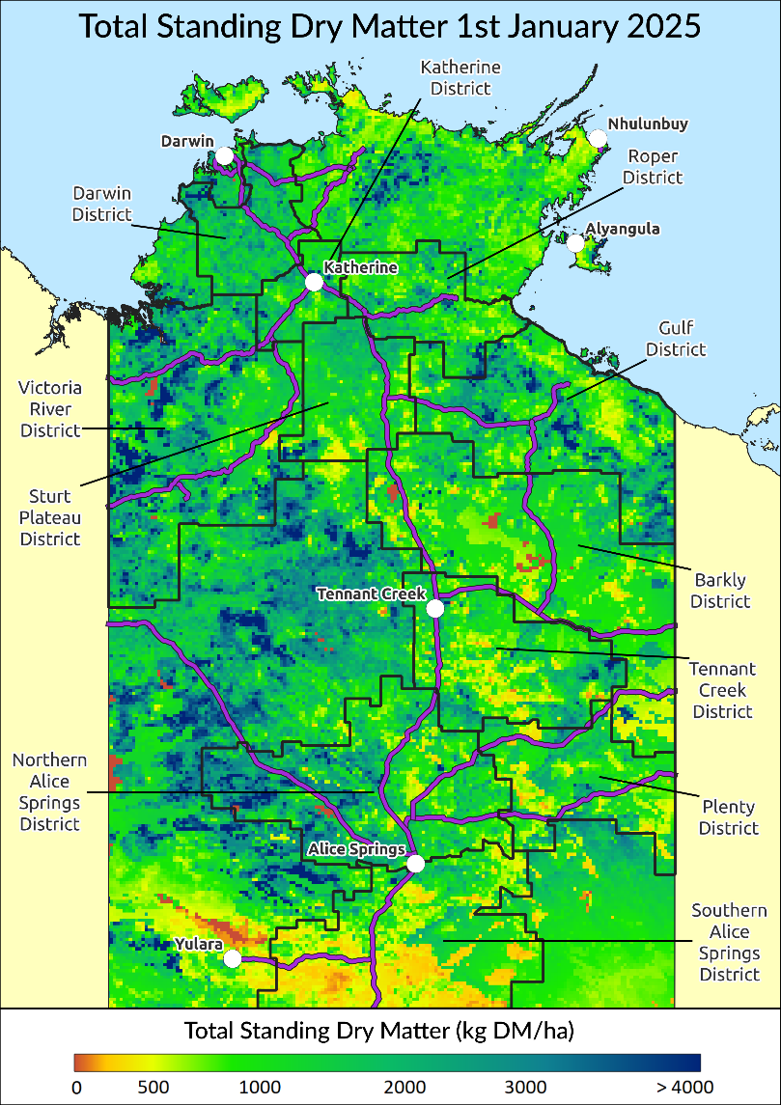

Individual District Summaries:

Darwin District

Katherine District

Victoria River District

Sturt Plateau District

Roper District

Gulf District

Barkly District

Tennant Creek District

Northern Alice Springs District

Plenty District

Southern Alice Springs District

For further information about this Outlook, please contact Chris Materne on 08 8951 8135.

All pasture data in this report is derived from AussieGRASS <https://www.longpaddock.qld.gov.au/aussiegrass/>

# Summary of current situation and trends – all districts – January 2025

Most of the Top End had and early start to the 2024/2025 wet season with some good rainfall recorded in the VRD, Sturt Plateau & Gulf Districts. In the VRD Humbert River & Kidman Springs have both received over received 300mm since September 1. On the Sturt Plateau, Lakefield has recorded over 500mm since the beginning of September while Centre Island in the Gulf received 290mm during November & December.

While relative pasture growth is tracking above average for most districts, overall cumulative total growth is still quite low. Average to above average biomass levels are still present in most districts although fires during 2024 reduced standing dry matter in some areas including parts of the Sturt Plateau, Roper, Gulf & Tennant Creek.

Over the next 3 months many districts are likely to see average to above average pasture growth, boosted by early rainfall. However, for large parts of the northern districts, growth is unlikely to exceed the median due to seasonal limitations in soil nitrogen availability at this time of year.

While the fire risk is easing in the Darwin & Katherine Districts, the grassfire risk remains moderate to high in all other districts except Southern Alice Springs.

The Bureau of Meteorology’s Southern Hemisphere Monitoring & Outlook reports that, while the ENSO is still considered neutral, many indicators have been hovering around La Niña thresholds. International climate models predict an active MJO pulse moving across the equatorial Africa and Indian Ocean during mid-January, bringing an increased likelihood of monsoon onset for the Top End towards the end of January.

|  |  |  |  |  |  |  |  |  |  |  |  |  |  |  |  |  |  |
| --- | --- | --- | --- | --- | --- | --- | --- | --- | --- | --- | --- | --- | --- | --- | --- | --- | --- |
| KEY | Green = low risk | | | | | | Orange = watch | | | | | | Red = high risk | | | | |
| KEY | | **↑** = increasing trend | | | | | | **↓** = decreasing trend | | | | | | **↔** = steady | | | | |
|  | | **Northern Territory Pastoral Districts** | | | | | | | | | | | | | | |  | | |
| **Indicator** | | **Darwin** | **Katherine** | **VRD** | **Sturt Plateau** | **Roper** | | | **Gulf** | **Barkly** | **Tennant Creek** | **Northern Alice Springs** | | | **Plenty** | **Southern Alice Springs** | **Comments** | | |
| 2023/24 total pasture growth | | **↑** | **↑** | **↑** | **↑** | **↑** | | | **↑** | **↑** | **↑** | **↑** | | | **↑** | **↑** | Arrows indicate trend compared to the long-term median (for this time of year) | | |
| Current estimated standing biomass | | **↑** | **↑** | **↔** | **↑** | **↔** | | | **↔** | **↔** | **↔** | **↔** | | | **↔** | **↔** | Arrows indicate trend since previous quarter | | |
| Current fire risk | | **↓** | **↓** | **↓** | **↓** | **↓** | | | **↓** | **↔** | **↑** | **↔** | | | **↑** | **↔** | Arrows indicate the trend since previous quarter | | |
| Current seasonal outlook | | **↓** | **↔** | **↑** | **↑** | **↑** | | | **↑** | **↑** | **↑** | **↑** | | | **↑** | **↔** | Arrows indicate the trend since previous quarter and taking into account the forecasted model predictions | | |

# Northern Territory Seasonal Outlook as at January 2025*

Sourced from the Australian Bureau of Meteorology (BoM)

*This seasonal outlook was correct at the time of publication. For the most up-to-date seasonal outlook, please go to the [Climate Outlook](http://www.bom.gov.au/climate/outlooks/#/rainfall/summary) section of the BoM website.

The BoM outlook for February 2025 to April 2025 indicates that:

* The chance of exceeding the median rainfall between February & April 2025 is moderate (55-65%) over most of the NT, but slightly higher in parts of the Barkly, VRD and the eastern southern NT. Past outlook accuracy for this time of year is good (55-75%).
* Maximum temperatures are likely to be warmer than average for the coastal & far southern parts, with good to high (55-100%) past accuracy.
* **Warmer** than average nights are also very likely for the whole of the NT with good past outlook accuracy (55-100%).

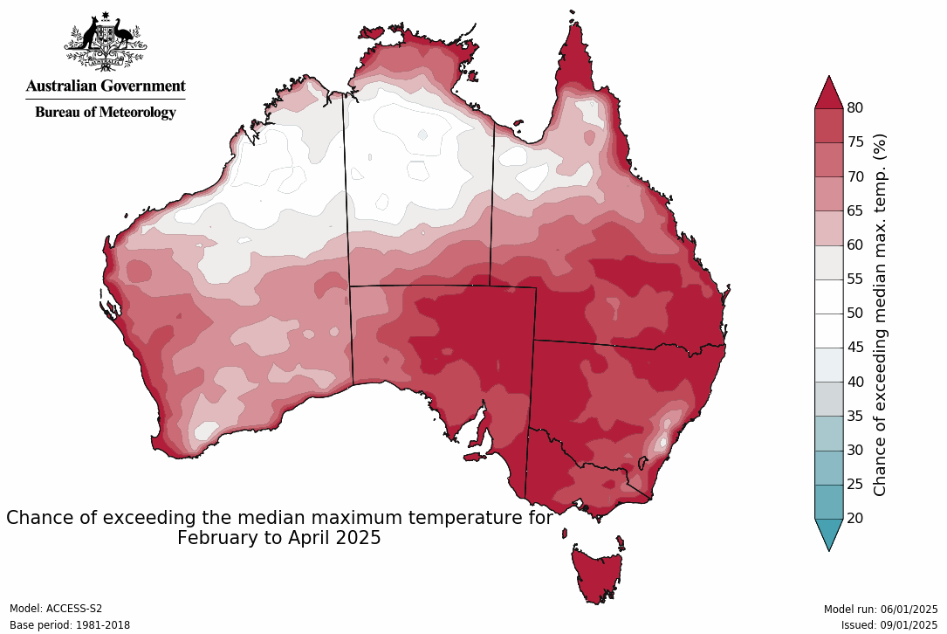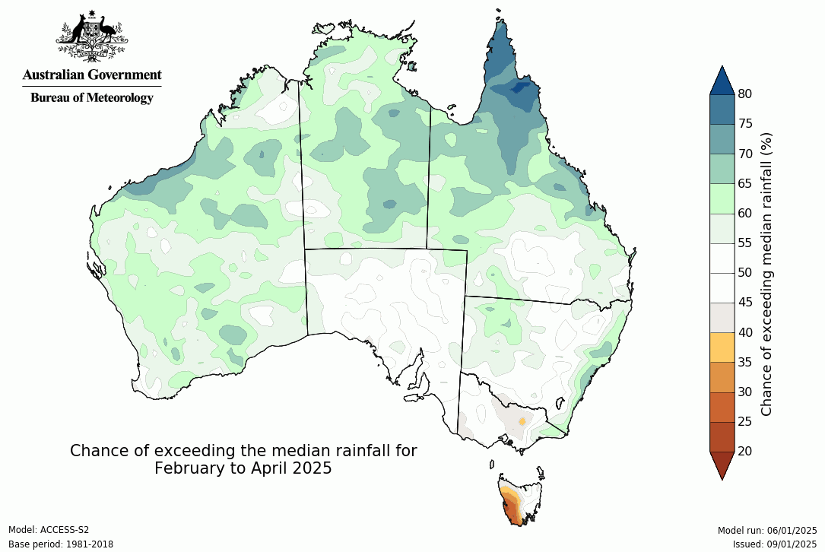

**Influencing Climate drivers**

* This forecast reflects the status and forecasts for several climate drivers, including a neutral ENSO & an active MJO pulse over the Maritime Continent.

|  |  |
| --- | --- |
| **Climate Influences** | **Comments (sourced from the Australian Bureau of Meteorology)** |
| **El Niño Southern Oscillation (ENSO) neutral with signs of La Niña**  [Pacific Ocean Update](http://www.bom.gov.au/climate/enso/?ninoIndex=nino3.4&index=nino34&period=weekly#tabs=Pacific-Ocean)  (As at 8 January 2025)  *From December 2024 the Bureau of Meteorlogy is no longer issuing (ENSO) Outlook Watch and Alert statements including the ENSO dial. | **The El Niño–Southern Oscillation (ENSO) is currently neutral**.  **30 day moving SOI graph**Monthly sea surface temperature anomalies for Pacific OceanThe Bureau considers that the ENSO in the tropical Pacific remains neutral. While many of the indicators have recently met the threshold for La Niña they have not been sustained for levels or duration sufficient to warrant La Niña status.  While the establishment of a La Niña event looks likely for at least part of the 2024-25 summer, most models have ENSO returning to neutral by March .  To see larger versions of these images, go to Southern Hemisphere [Monitoring Pacific Ocean](http://www.bom.gov.au/climate/enso/?ninoIndex=nino3.4&index=nino34&period=weekly#tabs=Pacific-Ocean) & [Outlook Niño 3.4](http://www.bom.gov.au/climate/ocean/outlooks/?index=nino34). |
| **Indian Ocean Dipole (IOD)**  Current outlook: **Neutral**  [Indian Ocean Update](http://www.bom.gov.au/climate/enso/?ninoIndex=nino3.4&index=nino34&period=weekly#tabs=Indian-Ocean)  (As at 8 January 2025) | Monthly sea surface temperature anomalies for Indian OceanIOD Index time series**The Indian Ocean Dipole (IOD) is currently neutral.**  The IOD had been tending negative from mid-October but returned to neutral values at the start of December 2024. The latest weekly IOD index value (as of 5 January) is -0.16°C. Most climate models indicate that the IOD will remain neutral until at least May 2025.  To see larger versions of these images, go to Southern Hemisphere [Monitoring Indian Ocean](http://www.bom.gov.au/climate/enso/?ninoIndex=nino3.4&index=nino34&period=weekly#tabs=Indian-Ocean) & [Outlook IOD](http://www.bom.gov.au/climate/ocean/outlooks/?index=iod). |
| **Southern Annular Mode (SAM)**  Current outlook: **Neutral**  [Southern Ocean Update](http://www.bom.gov.au/climate/enso/?ninoIndex=nino3.4&index=nino34&period=weekly#tabs=Southern-Ocean)  (As at 8 January 2025) | Chart showing Southern Annular Mode index**The SAM is currently neutral.**  The Southern Annular Mode (SAM) is neutral as of 8 January. It is forecast to remain neutral for the rest of the forecast period to the end of January 2025.  A negative SAM during summer typically decreases rainfall over eastern Australia due to westerly winds extending further north, reducing moist onshore flow from the east.  To see larger versions of these images, go to Southern Hemisphere [Monitoring Southern Ocean](http://www.bom.gov.au/climate/enso/?ninoIndex=nino3.4&index=nino34&period=weekly#tabs=Southern-Ocean) & [Outlook SAM](http://www.bom.gov.au/climate/ocean/outlooks/?index=sam). |
| **Seasonal Indicator** | **Comments (sourced from the Australian Bureau of Meteorology & the NT Department of Industry, Tourism & Trade)** |
| **Madden–Julian Oscillation (MJO)**  Outlook: **Weak**  [Tropics Update](http://www.bom.gov.au/climate/mjo/#tabs=Tropical-update)  (As at 7 January 2025) | Graph showing Madden - Julian Oscillation Index forecastThe **MJO pulse is currently weak in the Western Pacific.**  The Madden–Julian Oscillation (MJO) has moved slowly across the Western Pacific and weakened in the past fortnight. It is currently indiscernible and near-stationary (as at 4 January 2025).  International climate models suggest that the MJO pulse will re-strengthen and move across the equatorial Africa and Indian Ocean during mid-January.  At this time of the year, an active MJO in the African and Indian Ocean region is typically associated with increasing convection and cloudiness extending across the Indian Ocean. The tropical cyclone risk is also typically elevated in the southern Indian Ocean. |
| **Wet Season Onset**  Outlook 2024/25: **Early**  [Northern Rainfall Onset Outlook](http://www.bom.gov.au/climate/rainfall-onset/#tabs=Outlook)  (As at 29 August 2024)  Next Update: 26 June 2025 | **Map showing the chance of early rainfall onset across northern AustraliaAn earlier than normal start to the 2024/25 wet season was forecast for the east of the NT; later in the west.**  A 50-65% chance of an earlier than usual northern rainfall onset was predicted for most of the eastern NT, particularly for the Gulf and Top End. The western NT including the VRD was predicted to experience slightly later than usual wet season onset.  The northern rainfall onset date occurs when the rainfall total reaches 50 mm since the 1st of September. It is considered approximately the amount of rainfall required to stimulate plant growth. |
| Observations 2024/25  (As at 7 January 2025) | Map showing number of days earlier or later than the long-term average onset dateMap showing date when total rainfall reached 50 mm from 1st SeptemberMap showing rainfall totals from 1 September 2022The onset observations can be found [here](http://www.bom.gov.au/climate/rainfall-onset/#tabs=Observations) |

# Darwin District

* Pasture growth for this time of year is **well** **above average** across much of the district.
* Relative biomass levels are generally **average** to **above average** across the district, with isolated areas of **very high** pasture biomass.
* Over the next three months, the chance of exceeding the median growth is likely to be limited by nitrogen availability over most of the district.
* 42% of the district burnt in 2024. 12% burnt between July 1 – December 31 2024.
* In a typical wet season, pasture growth in the Darwin region tends to be limited by available soil nitrogen rather than soil moisture. This means that the annual variation in growth and pasture biomass on upland country is quite low.

**2024/25 Pasture Growth**

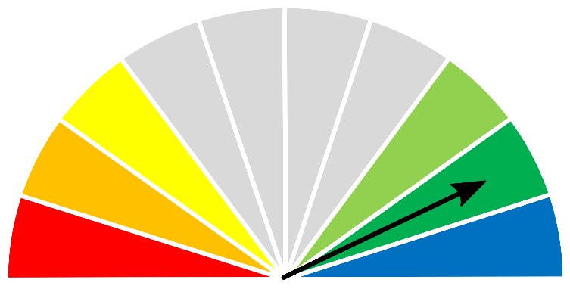

**1260 kg/ha**



| **As at 1 January 2025** | | | | |
| --- | --- | --- | --- | --- |
| **(% of district)** | **<1,000kg/ha** | **1,000 - 2,000kg/ha** | **2,000 - 3,000kg/ha** | **>3,000kg/ha** |
| 2024/2025  Pasture Growth | 30% | 61% | 8% | 1% |
| Total Standing Dry Matter | 2% | 60% | 34% | 4% |

|  |  |
| --- | --- |
| **Median Pasture Growth (kg/ha)**  **(Running Total)** | **Total Standing Dry Matter at 1 January 2025**  **Relative to Historical Records (1957-now)** |
| **Graph showing running total of pasture growth** | **Map showing total standing dry matter relative to long-term records** |

|  |  |
| --- | --- |
| **3-month Pasture Growth at 1 January 2025**  **Relative to Historical Records (1957-now)** | **Chance of Exceeding Median Pasture Growth**  **January 2025 – March 2025** |
| Maps showing current pasture growth relative to long-term records (left) and the chance of exceeding median pasture growth in the next three months (right) | |

# Katherine District

* Pasture growth for this time of year is **above average** to **extremely high** over most of the district.
* Biomass levels are **low** where fires have removed standing dry matter and **average** to **very high** over the rest of the district.
* Over the next three months, the chance of exceeding the median growth is **very low** due to limited nitrogen availability however, areas of high growth are possible, particularly in the south of the district.
* 26% of the district burnt in 2024. 14% burnt between July 1 – December 31 2024.
* Wet season pasture growth in the Katherine region tends to be limited by available soil nitrogen rather than soil moisture, resulting in relatively low variation in annual pasture growth & biomass levels.

**2024/25 Pasture Growth**

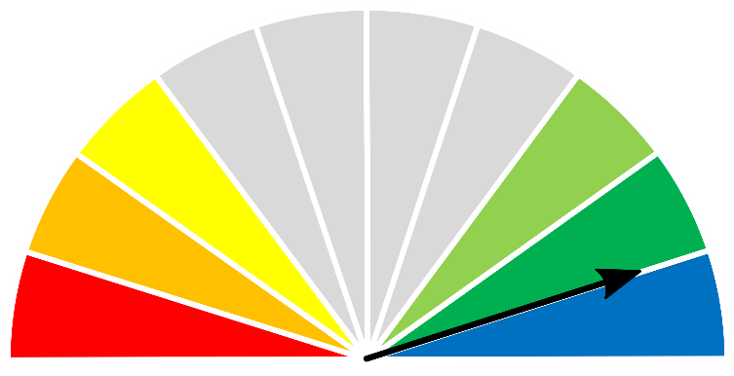

**790 kg/ha**



| **As at 1 January 2025** | | | | |
| --- | --- | --- | --- | --- |
| **(% of district)** | **<1,000kg/ha** | **1,000 - 2,000kg/ha** | **2,000 - 3,000kg/ha** | **>3,000kg/ha** |
| 2024/2025  Pasture Growth | 73% | 27% | 0% | 0% |
| Total Standing Dry Matter | 10% | 64% | 23% | 3% |

|  |  |
| --- | --- |
| **Median Pasture Growth (kg/ha)**  **(Running Total)** | **Total Standing Dry Matter at 1 January 2025**  **Relative to Historical Records (1957-now)** |
| **Graph showing running total of pasture growth** | **Map showing total standing dry matter relative to long-term records** |

|  |  |
| --- | --- |
| **3-month Pasture Growth at 1 January 2025**  **Relative to Historical Records (1957-now)** | **Chance of Exceeding Median Pasture Growth**  **January 2025 – March 2025** |
| Maps showing current pasture growth relative to long-term records (left) and the chance of exceeding median pasture growth in the next three months (right) | |

# Victoria River District

* Pasture growth for this time of year is **above average** to **extremely high** across much of the district.
* Relative pasture biomass levels are patchy across the district, varying from **low** where fires have removed standing dry matter, to **very** **high**.
* Growth over the next three months is predicted to be **average** to **very high** across much of the VRD with areas of nitrogen-limited **low** growth, particularly in the northern half of the district.
* 24% of the district burnt in 2024. 16% burnt between July 1 – December 31 2024.

**2024/25 Pasture Growth**



**559 kg/ha**



|  |  |  |  |  |  |
| --- | --- | --- | --- | --- | --- |
| **As at 1 January 2025** | | | | | |
| **(% of district)** | **<1,000kg/ha** | **1,000 - 2,000kg/ha** | | **2,000 - 3,000kg/ha** | **>3,000kg/ha** |
| 2024/2025  Pasture Growth | 88% | 12% | | <1% | 0% |
| Total Standing Dry Matter | 8% | 46% | | 29% | 17% |
|  |  |  | |  |  |
| **Median Pasture Growth (kg/ha)**  **(Running Total)** | | **Total Standing Dry Matter at 1 January 2025**  **Relative to Historical Records (1957-now)** | | | |
| Graph showing running total of pasture growth | | Map showing total standing dry matter relative to long-term records | | | |
|  | |  | | | |
| **3-month Pasture Growth at 1 January 2025**  **Relative to Historical Records (1957-now)** | | | **Chance of Exceeding Median Pasture Growth**  **January 2025 – March 2025** | | |
| Maps showing current pasture growth relative to long-term records (left) and the chance of exceeding median pasture growth in the next three months (right) | | | | | |

# Sturt Plateau District

* Pasture growth in the Sturt Plateau district is **extremely high** for this stage of the growing season, particularly in the northern half of the district.
* While fires have removed standing dry matter in the south & east of the district, pasture biomass levels are generally **above** **average** to **very high** across the rest of the district.
* Over the next three months the chance of exceeding median pasture growth varies across the district from **extremely low** to **extremely high**.
* 19% of the district burnt in 2024. 16% burnt between July 1 – December 31 2024.

**2024/25 Pasture Growth**



**563 kg/ha**



|  |  |  |  |  |
| --- | --- | --- | --- | --- |
| **As at 1 January 2025** | | | | |
| **(% of district)** | **<1,000kg/ha** | **1,000 - 2,000kg/ha** | **2,000 - 3,000kg/ha** | **>3,000kg/ha** |
| 2024/2025  Pasture Growth | 91% | 9% | 0% | 0% |
| Total Standing Dry Matter | 19% | 62% | 17% | 2% |
|  |  |  |  |  |
| **Median Pasture Growth (kg/ha)**  **(Running Total)** | | **Total Standing Dry Matter at 1 January 2025**  **Relative to Historical Records (1957-now)** | | |
| Graph showing running total of pasture growth | | Map showing total standing dry matter relative to long-term records | | |

|  |  |
| --- | --- |
| **3-month Pasture Growth at 1 January 2025**  **Relative to Historical Records (1957-now)** | **Chance of Exceeding Median Pasture Growth**  **January 2025 – March 2025** |
| Maps showing current pasture growth relative to long-term records (left) and the chance of exceeding median pasture growth in the next three months (right) | | |

# Roper District

* Overall pasture growth is **well above average** for this time of year with much of the southern half of the district producing **extremely high** growth.
* Relative pasture biomass levels are patchy across the district, varying from **low** where fires have removed standing dry matter, to **extremely high**.
* Over the next three months the chances of exceeding median growth varies across the district from **extremely low** to **extremely high**.
* 38% of the district burnt in 2024. 23% burnt between July 1 – December 31 2024.

**2024/25 Pasture Growth**

**437 kg/ha**

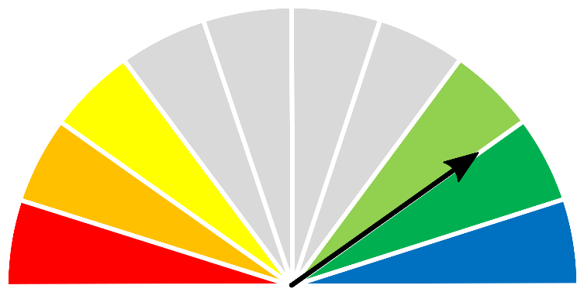



|  |  |  |  |  |
| --- | --- | --- | --- | --- |
| **As at 1 January 2025** | | | | |
| **(% of district)** | **<1,000kg/ha** | **1,000 - 2,000kg/ha** | **2,000 - 3,000kg/ha** | **>3,000kg/ha** |
| 2024/2025  Pasture Growth | 94% | 6% | 0% | 0% |
| Total Standing Dry Matter | 25% | 54% | 17% | 4% |

|  |  |
| --- | --- |
| **Median Pasture Growth (kg/ha)**  **(Running Total)** | **Total Standing Dry Matter at 1 January 2025**  **Relative to Historical Records (1957-now)** |
| Graph showing running total of pasture growth | Map showing total standing dry matter relative to long-term records |

|  |  |
| --- | --- |
| **3-month Pasture Growth at 1 January 2025**  **Relative to Historical Records (1957-now)** | **Chance of Exceeding Median Pasture Growth**  **January 2025 – March 2025** |
| Maps showing current pasture growth relative to long-term records (left) and the chance of exceeding median pasture growth in the next three months (right) | |

# Gulf District

* 2024/2025 pasture growth in the Gulf district is **extremely high** for this time of year, particularly in the western half of the district.
* Relative pasture biomass levels are patchy across the district, varying from **low** where fires have removed standing dry matter, to **extremely high** in the western part of the district.
* The chances of exceeding median growth over the next three months varies across the district from **extremely low** to **well above average**.
* 32% of the district burnt in 2024. 27% burnt between July 1 – December 31 2024.

**2024/25 Pasture Growth**



**516 kg/ha**



|  |  |  |  |  |
| --- | --- | --- | --- | --- |
| **As at 1 January 2025** | | | | |
| **(% of district)** | **<1,000kg/ha** | **1,000 - 2,000kg/ha** | **2,000 - 3,000kg/ha** | **>3,000kg/ha** |
| 2024/2025  Pasture Growth | 90% | 10% | 0% | 0% |
| Total Standing Dry Matter | 22% | 43% | 24% | 11% |

|  |  |
| --- | --- |
| **Median Pasture Growth (kg/ha)**  **(Running Total)** | **Total Standing Dry Matter at 1 January 2025**  **Relative to Historical Records (1957-now)** |
| Graph showing running total of pasture growth | Map showing total standing dry matter relative to long-term records |

|  |  |
| --- | --- |
| **3-month Pasture Growth at 1 January 2025**  **Relative to Historical Records (1957-now)** | **Chance of Exceeding Median Pasture Growth**  **January 2025 – March 2025** |
| Maps showing current pasture growth relative to long-term records (left) and the chance of exceeding median pasture growth in the next three months (right) | |

# Barkly District

* Overall relative pasture growth in the Barkly district is **well** **above average** for this time of year, though cumulative total growth is still low-moderate (less than 500kg/ha) over 93% of the district.
* While fires have removed standing dry matter in some areas, pasture biomass levels are generally **above** **average** to **very high** across most of the district.
* The chance of exceeding median growth over the next three months is generally **average** to **above average** across most of the district.
* 16% of the district burnt in 2024. 14% burnt between July 1 – December 31 2024.

**2024/25 Pasture Growth**

**241 kg/ha**





|  |  |  |  |  |
| --- | --- | --- | --- | --- |
| **As at 1 January 2025** | | | | |
| **(% of district)** | **<500kg/ha** | **500 - 1000kg/ha** | **1000 - 1,500kg/ha** | **>1,500kg/ha** |
| 2024/2025  Pasture Growth | 93% | 7% | <1% | 0% |
| Total Standing Dry Matter | 5% | 27% | 42% | 26% |

|  |  |
| --- | --- |
| **Median Pasture Growth (kg/ha)**  **(Running Total)** | **Total Standing Dry Matter at 1 January 2025**  **Relative to Historical Records (1957-now)** |
| Graph showing running total of pasture growth | Map showing total standing dry matter relative to long-term records |

|  |  |
| --- | --- |
| **3-month Pasture Growth at 1 January 2025**  **Relative to Historical Records (1957-now)** | **Chance of Exceeding Median Pasture Growth**  **January 2025 – March 2025** |
| Maps showing current pasture growth relative to long-term records (left) and the chance of exceeding median pasture growth in the next three months (right) | |

# Tennant Creek District

* Relative pasture growth for the Tennant Creek district is **well above average**,particularly in the northern half of the district.
* While fires have removed some large areas of standing dry matter, relative biomass is still generally **average** to **very high** over the rest of the district.
* Over the next three months, pasture growth is likely to be **average** to **well above average** withhigher growth more likely in the north of the district.
* 28% of the district burnt in 2024. 22% burnt between July 1 – December 31 2024.

**2024/25 Pasture Growth**



**148 kg/ha**



| **As at 1 January 2025** | | | | |
| --- | --- | --- | --- | --- |
| **(% of district)** | **<500kg/ha** | **500 - 1000kg/ha** | **1000 - 1,500kg/ha** | **>1,500kg/ha** |
| 2024/2025  Pasture Growth | 97% | 3% | <1% | 0% |
| Total Standing Dry Matter | 7% | 25% | 27% | 41% |

| **Median Pasture Growth (kg/ha)**  **(Running Total)** | **Total Standing Dry Matter at 1 January 2025**  **Relative to Historical Records (1957-now)** |
| --- | --- |
| Graph showing running total of pasture growth | Map showing total standing dry matter relative to long-term records |

| **3-month Pasture Growth at 1 January 2025**  **Relative to Historical Records (1957-now)** | **Chance of Exceeding Median Pasture Growth**  **January 2025 – March 2025** |
| --- | --- |
| Maps showing current pasture growth relative to long-term records (left) and the chance of exceeding median pasture growth in the next three months (right) | |

# Northern Alice Springs District

* Pasture growth for the Northern Alice Springs district is **well above average** for this stage of the growing season, particularly in the western half of the district.
* Relative pasture biomass levels are generally **average** to **very high** across most the district.
* The chance of exceeding median pasture growth over the next three months is generally **average** to **above average** over most of the district.
* 2% of the district burnt in 2024. 1% burnt between July 1 – December 31 2024.

**2024/25 Pasture Growth**

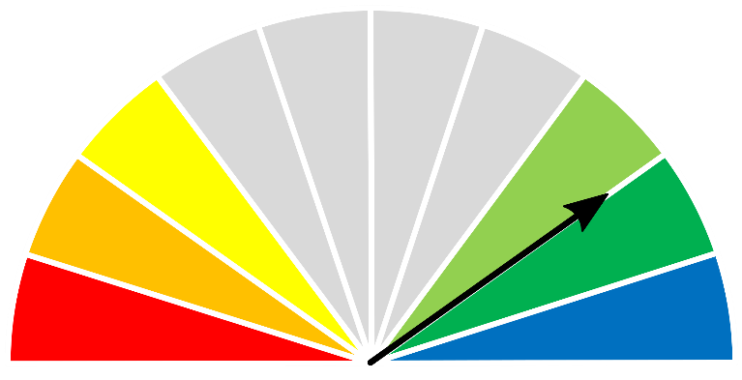

**342 kg/ha**



|  |  |  |  |  |
| --- | --- | --- | --- | --- |
| **As at 1 January 2025** | | | | |
| **(% of district)** | **<500kg/ha** | **500 - 1000kg/ha** | **1000 - 1,500kg/ha** | **>1,500kg/ha** |
| 2024/2025  Pasture Growth | 65% | 25% | 10% | <1% |
| Total Standing Dry Matter | 2% | 13% | 22% | 63% |

| **Median Pasture Growth (kg/ha)**  **(Running Total)** | **Total Standing Dry Matter at 1 January 2025**  **Relative to Historical Records (1957-now)** |
| --- | --- |
| Graph showing running total of pasture growth | Map showing total standing dry matter relative to long-term records |

| **3-month Pasture Growth at 1 January 2025**  **Relative to Historical Records (1957-now)** | **Chance of Exceeding Median Pasture Growth**  **January 2025 – March 2025** |
| --- | --- |
| Maps showing current pasture growth relative to long-term records (left) and the chance of exceeding median pasture growth in the next three months (right) | |

# Plenty District

* Overall, relative pasture growth in the Plenty district is average for this time of year. Cumulative total growth is still low (<250kg/ha) over 93% of the district).
* Pasture biomass levels are still **above** **average** to **well above** **average** across most of the district.
* Over the next three months, pasture growth is likely to be **average** over most of the district with small areas of **above average** growth.
* 1% (622 km²) of the district burnt in 2024. 0.7% (384 km²) burnt between July 1 – December 31 2024.

**2024/25 Pasture Growth**

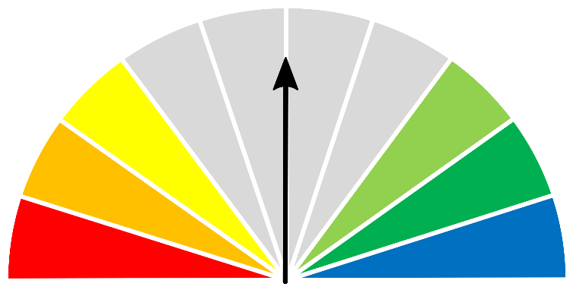

**68 kg/ha**



|  |  |  |  |  |
| --- | --- | --- | --- | --- |
| **As at 1 January 2025** | | | | |
| **(% of district)** | **<500kg/ha** | **500 - 1000kg/ha** | **1000 - 1,500kg/ha** | **>1,500kg/ha** |
| 2024/2025  Pasture Growth | 99% | 1% | 0% | 0% |
| Total Standing Dry Matter | 8% | 26% | 30% | 36% |

| **Median Pasture Growth (kg/ha)**  **(Running Total)** | **Total Standing Dry Matter at 1 January 2025**  **Relative to Historical Records (1957-now)** |
| --- | --- |
| Graph showing running total of pasture growth | Map showing total standing dry matter relative to long-term records |

| **3-month Pasture Growth at 1 January 2025**  **Relative to Historical Records (1957-now)** | **Chance of Exceeding Median Pasture Growth**  **January 2025 – March 2025** |
| --- | --- |
| Maps showing current pasture growth relative to long-term records (left) and the chance of exceeding median pasture growth in the next three months (right) | |

# Southern Alice Springs District

* Relative pasture growth in the Southern Alice Springs district is generally average to **above average** with areas of high growth mainly in southern & western parts of the district.
* Relative pasture biomass levels vary from **below average** to **very high**, with higher levels of standing dry matter in the northern parts.
* Over the next three months the majority of the

district has an average chance of exceeding median pasture growth.

* 0.6% (535 km²) of the district burnt in 2024. 0.003% (3 km²) burnt between July 1 – December 31 2024.

**2024/25 Pasture Growth**

**112 kg/ha**

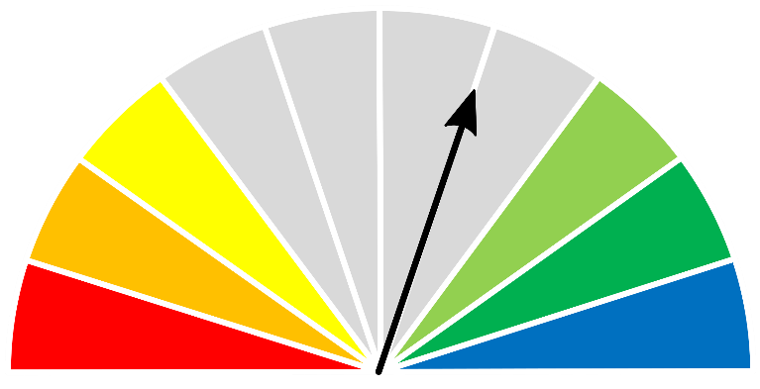



|  |  |  |  |  |
| --- | --- | --- | --- | --- |
| **As at 1 January 2025** | | | | |
| **(% of district)** | **<250kg/ha** | **250 - 500kg/ha** | **500 - 1,000kg/ha** | **>1,000kg/ha** |
| 2024/2025  Pasture Growth | 82% | 14% | 4% | <1% |
| Total Standing Dry Matter | 7% | 27% | 30% | 36% |

| **Median Pasture Growth (kg/ha)**  **(Running Total)** | **Total Standing Dry Matter at 1 January 2025**  **Relative to Historical Records (1957-now)** |
| --- | --- |
| Graph showing running total of pasture growth | Map showing total standing dry matter relative to long-term records |

| **3-month Pasture Growth at 1 January 2025**  **Relative to Historical Records (1957-now)** | **Chance of Exceeding Median Pasture Growth**  **January 2025 – March 2025** |
| --- | --- |
| Maps showing current pasture growth relative to long-term records (left) and the chance of exceeding median pasture growth in the next three months (right) | |

# Pasture information

The pasture and grass fire risk information in this document is derived from AussieGRASS.

<https://www.longpaddock.qld.gov.au/aussiegrass/>

AussieGRASS is a model that simulates pasture growth and standing biomass using climate data, vegetation mapping, fire history and regional estimates of grazing pressure. The model can be used to track simulated pasture growth and total standing pasture biomass at the landscape scale.

Note that the model does not use stocking rate data for individual properties. Where stock numbers are significantly higher or lower than typical for a district, model estimates of total standing dry matter may be not reflect local conditions.

Fire scar data used to calculate percentage of districts burnt is derived from North Australia & Rangelands Fire Information (NAFI)

<https://firenorth.org.au/nafi3/>

**Disclaimer**

While all care has been taken to ensure that information contained in this document is true and correct at the time of production, changes in circumstances after the time of distribution may affect the accuracy of its information. The Northern Territory of Australia gives no warranty or assurance, and makes no representation as to the accuracy of any information or advice contained herein, or that it is suitable for your intended use.

You should not rely solely upon information in this document for the purpose of making business or investment decisions in relation to your particular situation.

The Northern Territory of Australia disclaims any liability or responsibility or duty of care towards any person for loss of damage caused by any use of or reliance on this information.